100506 Quiz 5 Introduction to Polymers

1) Polyurethane in the video shown in class is formed from two liquids that are mixed. After mixing the solution foams and expands fairly rapidly forming a solid foam after a few minutes.
a) One of the liquids contains MDI. Give the full name and structure for MDI.
b) What is the reactant (co-monomer) in the second liquid?
c) Name a catalyst (give acronym) that might be in the second liquid.
d) What role would water play if it were present in the second liquid?
e) What happens if a diamine is used rather than what you listed in part b?

2) a) What are the three main stages of chain growth polymerization?
b) Is an initiator a catalyst?
c) Write an expression for the rate of propagation for chain growth polymerization in terms of the monomer concentration and the initiator concentration.
d) Obtain an exponential expression for the monomer concentration from part c and show that this is linear for early stages of the reaction.
e) Obtain an expression for the kinetic chain length for chain growth polymerization in terms of the monomer concentration and the initiator concentration.

3) a) List and draw the monomer, initiator, reaction temperature, and solvent for bulk polymerization of styrene.
b) When adding solvent to polymerization of MMA, below, the conversion versus time shows several characteristic features. Write an equation that explains the decrease in rate with increasing solvent added to the reacting system.
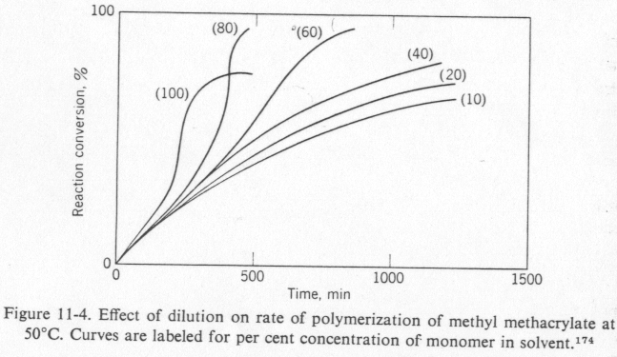 From R. W. Lenz's book.
c) Why does the plot show a change in shape of the conversion vs time curve for 80 and 100% concentrations? (A steep increase after about 1/2 of the reaction time and plateau).
d) How was polystyrene purified after the bulk polymerization?
e) What are the disadvantages of bulk, chain polymerization?

4) Polyacrylamide is soluble in water as is the monomer acrylamide therefore this is a solution polymerization.
a) Use the words ferric and ferrous to describe the initiator system for this polymerization. Why is this called a redox system?
b) When hydrogen peroxide was added to the reaction mixture it turned from a faint bluish green to red (rust color). Later the color seemed to fade. Why did it change color?
c) What temperature was needed to perform this polymerization? Why?
d) How was polymer separated from the viscous reaction mixture after polymerization?
e) Explain the disadvantage of solution polymerization compared to emulsion or suspension polymerization.
ANSWERS: 100506 Quiz 5 Introduction to Polymers
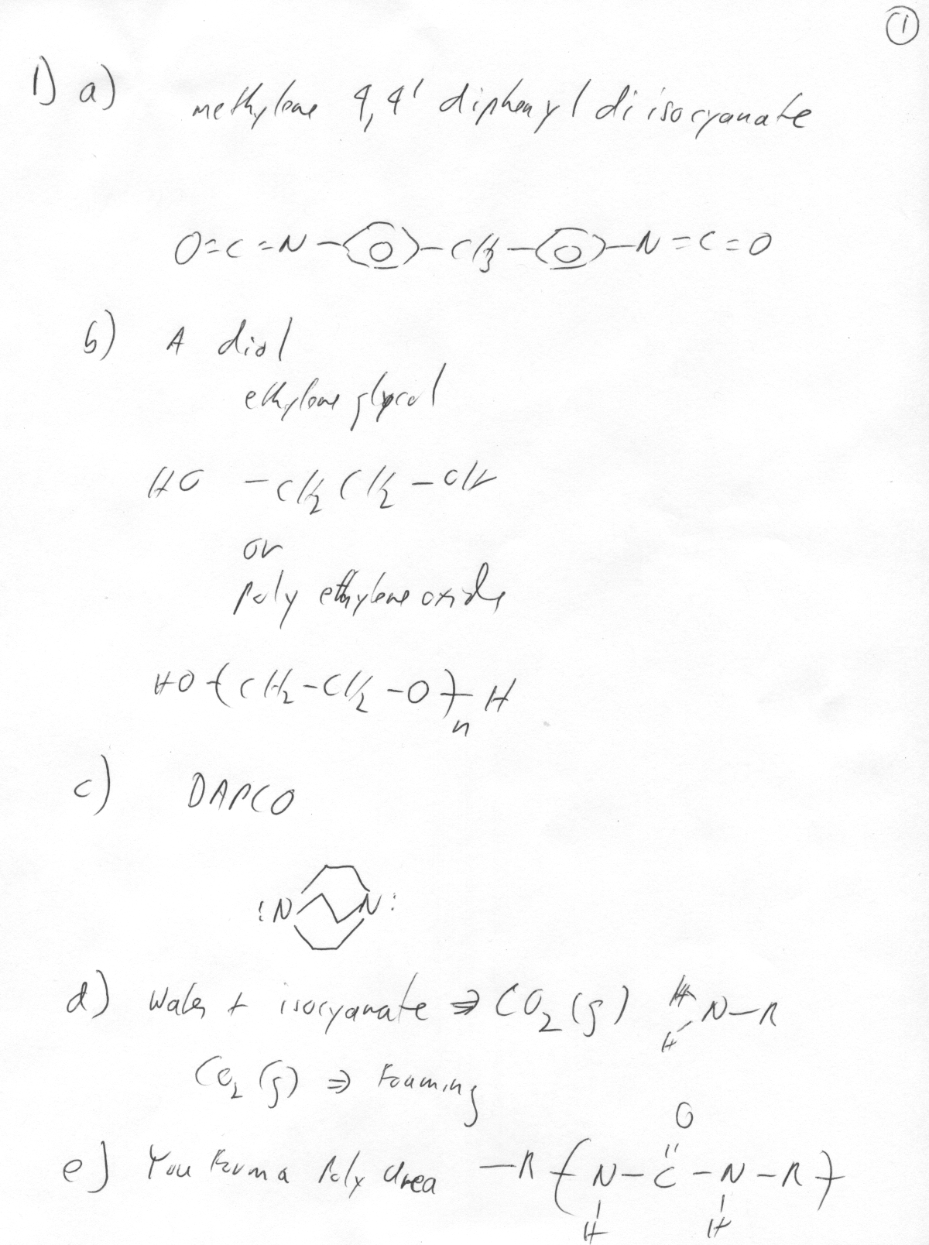

2) a) Initiation, propagation and termination.
b) A catalyst is not consumed in a reaction but plays a part in facilitating the reaction. Initiators are consumed and generally lead to one end group of the chain-polymerized polymer. So an initiator is not a catalyst even though it is used in a small amount to facilitate a reaction.
c) $R_{p}\text{=-}\frac{d\left[M\right]}{\text{dt}}=k_{p}\sqrt{\frac{{\text{fk}}_{d}}{k_{t}}}\sqrt{\left[I\right]}\left[M\right]=K\sqrt{\left[I\right]}\left[M\right]$
d)

The exponential can be expanded, $\text{exp}−x=1−\frac{x}{1!}+\frac{x^{2}}{2!}−\frac{x^{3}}{3!}+\frac{x^{4}}{4!}−\text{.}\text{.}\text{.}$
For short times we can consider only the first two terms so, $\left[M\right]»{\left[M\right]}_{0}\left(1−K\sqrt{\left[I\right]}t\right)$
e) $\overline{u}=\frac{R_{p}}{R_{i}}=\frac{R_{p}}{R_{t}}=\frac{k_{p}\sqrt{\frac{{\text{fk}}_{d}}{k_{t}}}\sqrt{\left[I\right]}\left[M\right]}{{\text{fk}}_{d}\left[I\right]}=\frac{k_{p}\left[M\right]}{k_{t}\sqrt{{\text{fk}}_{d}\left[I\right]}}$

3) a) Monomer: Styrene
Initiator: AIBN Azobisisobutyronitrile
Temperature: 80C (degradation of AIBN at 60C)
Solvent: Bulk polymerization i.e. no solvent
b) $R_{p}=K\sqrt{\left[I\right]}\left[M\right]$ and $\left[M\right]={\left[M\right]}_{0}\text{exp}\left(−K\sqrt{\left[I\right]}t\right)$
c) This is a manifestation of the Trommsdorf (gel) effect. The increase in rate occurs because termination is primarily by combination and two chains cannot reach each other when the system gels so that termination stops. Propagation continues since monmers can still diffuse to the growing chain. The system is viscous so the heat generated by propagation increases the temperature rapidly.
d) The bulk polymerization product was dissolved in a small amount of toluene and this solution was precipitated by adding to an excess of propanol while stirring. The polymer was washed several times with propanol.
e) The disadvantages of bulk polymerization are poor heat transfer from the reaction that leads to overheating of the polymerizing system and the Trommsdorf effect. Polydispersity is high due to backbiting of the radical on the chain. Chain transfer is prominent due to the high density of chains. Reducing [I] increases molecular weight but only at the epense of lowering the rate of polymerization. You can not get high molecular weight and high rate of polymerization.

4) a,b) To deionized water we added ferrous sulfate. Ferrous sulfate is a blue/green crystal so the solution became slightly blue/green. When hydrogen peroxide was added the solution immediately turned redish brown indicating the oxidation of ferrous sulfate, Fe+2 to Ferric sulfate, Fe+3 (or iron (III)). The hydrogen peroxide was reduced to produce two hydroxyl radicals and the iron (II) was oxidized to iron (III), Fe+3, or ferric sulfate. This is called a redox system because hydrogen peroxide is reduced (gains electrons) and iron is oxidized (loses electrons). The rust color fades later due to reduction of Fe+3 by –OH species in the aqueous solution.
c) The reaction occurred at room temperature. Heating was not an issue for this redox catalyst system.
d) Polymer was separated from the viscous polyacrylamide/water solution by pouring the polymer solution in acidified propanol which is a non-solvent for the polymer but is miscible with water. The acid terminates the remaining free radicals. The polymer is then filtered out.
e) The main disadvantage is that copious amounts of solvent are produced. Usually this is a toxic solvent mixture rather than water and propanol. In this reaction 1 gram of polymer was produced using about 300 ml of solvent so a 50-kilogram bag of polymer would produce 15,000 liters of waste solvent. The polymerization rate is much slower in solution polymerization of high molecular weight polymers.

