100518 Quiz 6 Introduction to Polymers

1) Suspension polymerization is similar to emulsion polymerization.
a) Describe the importance of water to emulsion and suspension polymerization. Does water play an identical role in these two polymerizations? Is water a solvent?
b) Describe the initiator that we used in suspension polymerization. What condition is needed to initiate this reaction? Why was a different initiator used in the emulsion polymerization?
c) What is divinyl benzene and why is it included in this reaction?
d) What controls the size of the polymer beads (droplet size) that result from suspension polymerization?
e) What was the advantage of emulsion polymerization (over suspension polymerization) that lead to its development by Goodyear Tire and Rubber in the 1920’s?

2) a) List and draw the monomer, initiator, reaction temperature, solvent for emulsion polymerization of styrene.
b) Describe other materials needed for emulsion polymerization and why they are needed.
c) Obtain an expression for the rate of polymerization and the kinetic chain length for emulsion polymerization.
d) How does emulsion polymerization overcome the disadvantages of bulk polymerization.
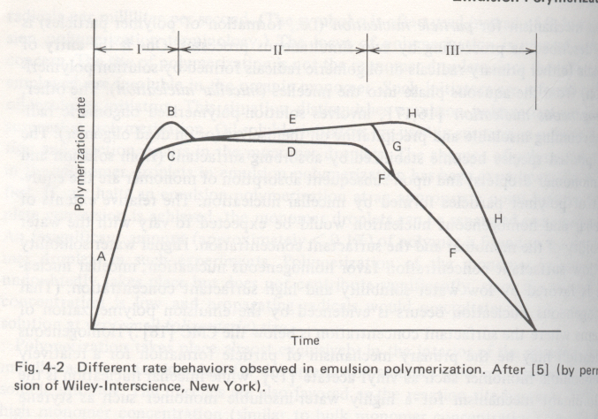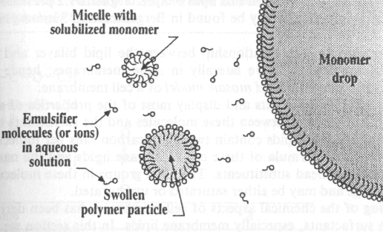
Figures from Heimenz Colloid Science.
e) The figure above (left) shows three regimes for emulsion polymerization and a schematic of the structure of the reaction media. Explain the difference between regimes I, II, and III in terms of the presence of a droplet phase, the change in the number of micelles with time, and the fraction of micelles with an active radical from what you know from class. (Explain the polymerization.)

3) a) Give an expression for the kinetic chain length if the monomer concentration is [M] and the initiator concentration is [I]. The answer should include a function of 3 rate constants, [I] and [M].
b) List the two main mechanisms for termination of chain growth.
How will the molecular weight be related to the kinetic chain length for these two conditions of termination reaction?
c) The enthalpy of polymerization of styrene, ΔH, is -20 kcal per mole.
If the ceiling temperature is observed to be 310 °C, calculate the entropy, ΔS, of polymerization.
d) Comment on the sign, + or -, of ΔS. Is the sign for polystyrene normal for polymerizations?
e) What does chain transfer mean?

ANSWERS: 100518 Quiz 6 Introduction to Polymers
1) a) Bulk polymerization heats up to much so the idea in both emulsion and suspension polymerization is to disperse the bulk polymerization into small droplets where heat transfer is fast to a water phase. In emulsion polymerization the initiator is in the water phase and the water phase also contains reservoirs of monomer that feed the micellar reacting nano-droplets. In suspension polymerization the initiator is in the monomer phase so multiple initiated chains exist in each droplet. The kinetics of polymerization are the same for suspension and for bulk.
b) Benzoyl peroxide was used. It is initiated by heat at about 80C. BP goes into the monomer phase. In emulsion polymerization potassium persulfate was used as the initiator and it was in the water phase so it initiated the micelles only at the interface.
c) Divinyl benzene (below) acts as a tetrafunctional crosslinking agent making a network in the suspension particles.
d) The droplet size is controlled by the rate of mixing, the amount of polymer and the presence of polyvinylalcohol. The size is a balance between coalescence and breakup of the monomer/polymer droplets.
e) Emulsion polymerization allowed the production of sticky polymers such as polybutadiene and polyisoprene rubber.

2) a) monomer: Styrene
initiator: Potassium persulfate
Temperature: ~80C (degradation of Potassium persulfate at ~60C)
Solvent: There is no solvent. The reaction occurs in the bulk within micelles that are suspended in water.

b) Micelles are made from sodium dodecyl sulfate
Water is used to suspend the micelles and as a medium to form free radicals with potassium persulfate.
The micelles are broken with NaCl after the reaction is complete.
c) The micelles are active (growing free radical) half of the time and are dormant (no growing free radical) half of the time. The rate of polymerization depends on the number of micelles, N and the monomer concentration [M].
$$R_{p}=\frac{k_{p}\left[M\right]N}{2}$$
The micelles grow half of the time. The rate of the micelles being turned on and off is given by the rate of initiation, R_{i}, divided by the number of micelles, N, $ρ=\frac{R_{i}}{N}=\frac{2{\text{fk}}_{d}[I]}{N}$. The kinetic chain length is the rate of propagation divided by this rate of switching on and off, $\overline{u}=\frac{k_{p}[M]N}{2{\text{fk}}_{d}[I]}$.
d) By increasing N both the degree of polymerization and the rate can be increased. This can be achieved by adding more SDS. Decreasing [I] will only effect the degree of polymerization. This overcomes the problem with bulk polymerization that for high molecular weight products you need to slow the reaction rate.
e) Droplet phase is present in I and II but not in III this leads to depletion of monomer in the water phase and the decline in polymerization rate in regime III. The number of micelles is very large at the start of the reaction but only a very few are initiated. The initiated growing polymer micelles require more surfactant to stabilize the polymer particles that they obtain from non-initiated micelles. When an equilibrium number of polymer/micelle particles form for the system initiation and termination of micelles offset each other and the micelles are either on or off in terms of growth. This is regime II.

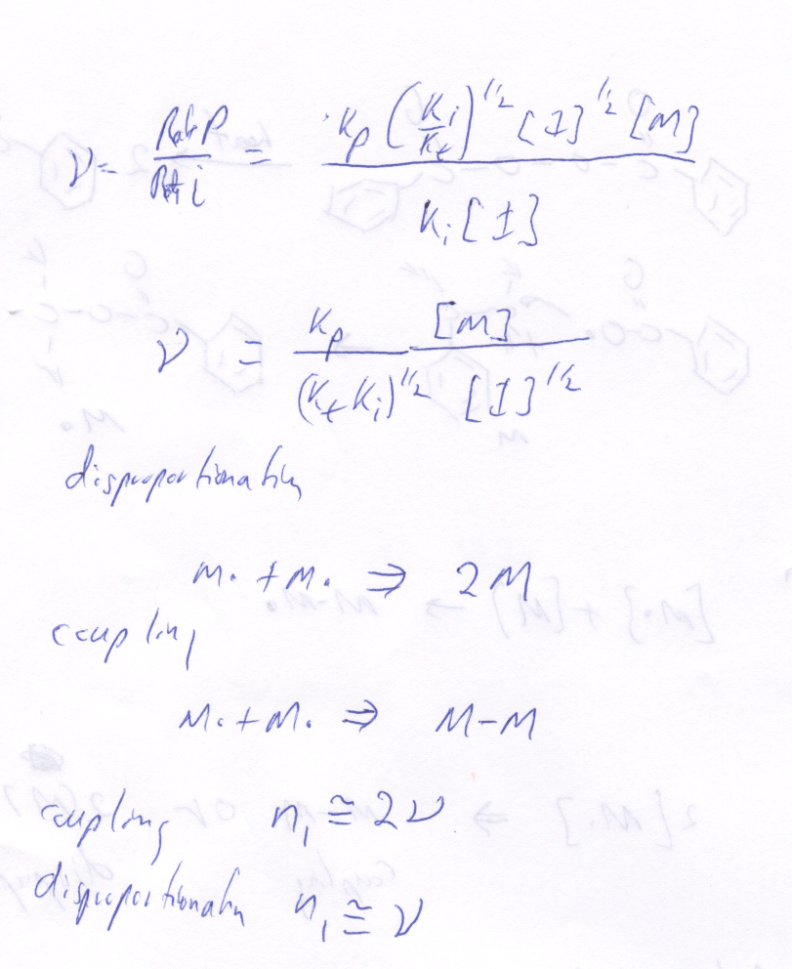
3) a) The kinetic chain length is the rate of propogation divided by the rate of initiation.

b)

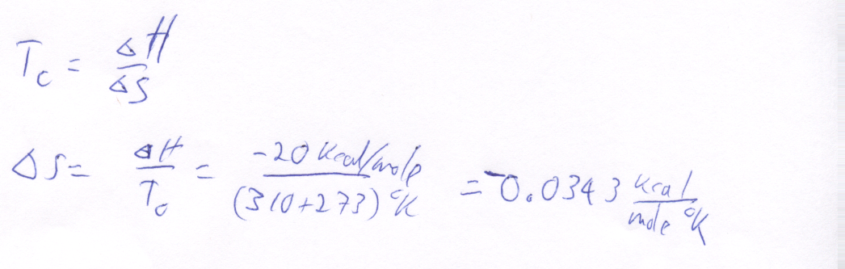
c)

d) The entropy change is negative because the polymer is less random than the free monomer. This is the norm for polymerization.
e) "Chain transfer" is the name for chemical reactions where a radical group is transferred from the propagating chain to another species in the reaction mixture such as initiator, monomer, other polymer chains, and solvent. In chain transfer the radical is not terminated and will proceed to initiate either another polymer chain or a branch on an existing polymer chain.

