1) a) Styrene is less reactive for free radical polymerization when compared with vinyl chloride. Explain two possible reasons that this might be the case and give an explaination using resonance structures to show that one of these two is more likely.
b) There are at least 4 types of copolymers. List these and sketch their structure.
c) Derive an expression for the copolymer composition ratio, M₁/M₂ in terms of the monomer concentrations [M₁], [M₂] and the reactivity ratios r₁ and r₂. (Define r₁ and r₂ in this derivation).
d) Describe 5 special cases for specific ranges of the reactivity ratios as discussed in class.
e) Which case does vinylidene chloride and vinyl chloride copolymers correspond to?

2) a) Give the Flory-Huggins equation for polymer blends and explain which part corresponds to entropy and which to enthalpy of interaction.
b) Sketch this function for χ below the critical point, at the critical point and above the critical point.
c) Show where the binodal and spinodal points are determined in the plot of b.
d) Show how the plot of part c can be used to construct a phase diagram.
e) Explain what an LCST and UCST phase diagram is an how they can be obtained from an interaction parameter of the form A + B/T. Why does PVME/water display an LCST phase diagram.

1) a) Either the monomer is less reactive to attack by a free radical or the propagating free radical is more stable. In all cases it is the stability of the propagating free radical that is the dominant feature governing monomer reactivity. For styrene the propagating free radical has three resonance structures as shown in class.
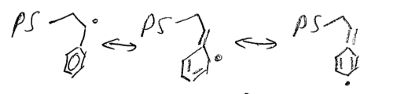
b) Statistical (Random), Alternating, Block, Graft. These are described in the Tirrell/McCarthy notes.

c)

d)
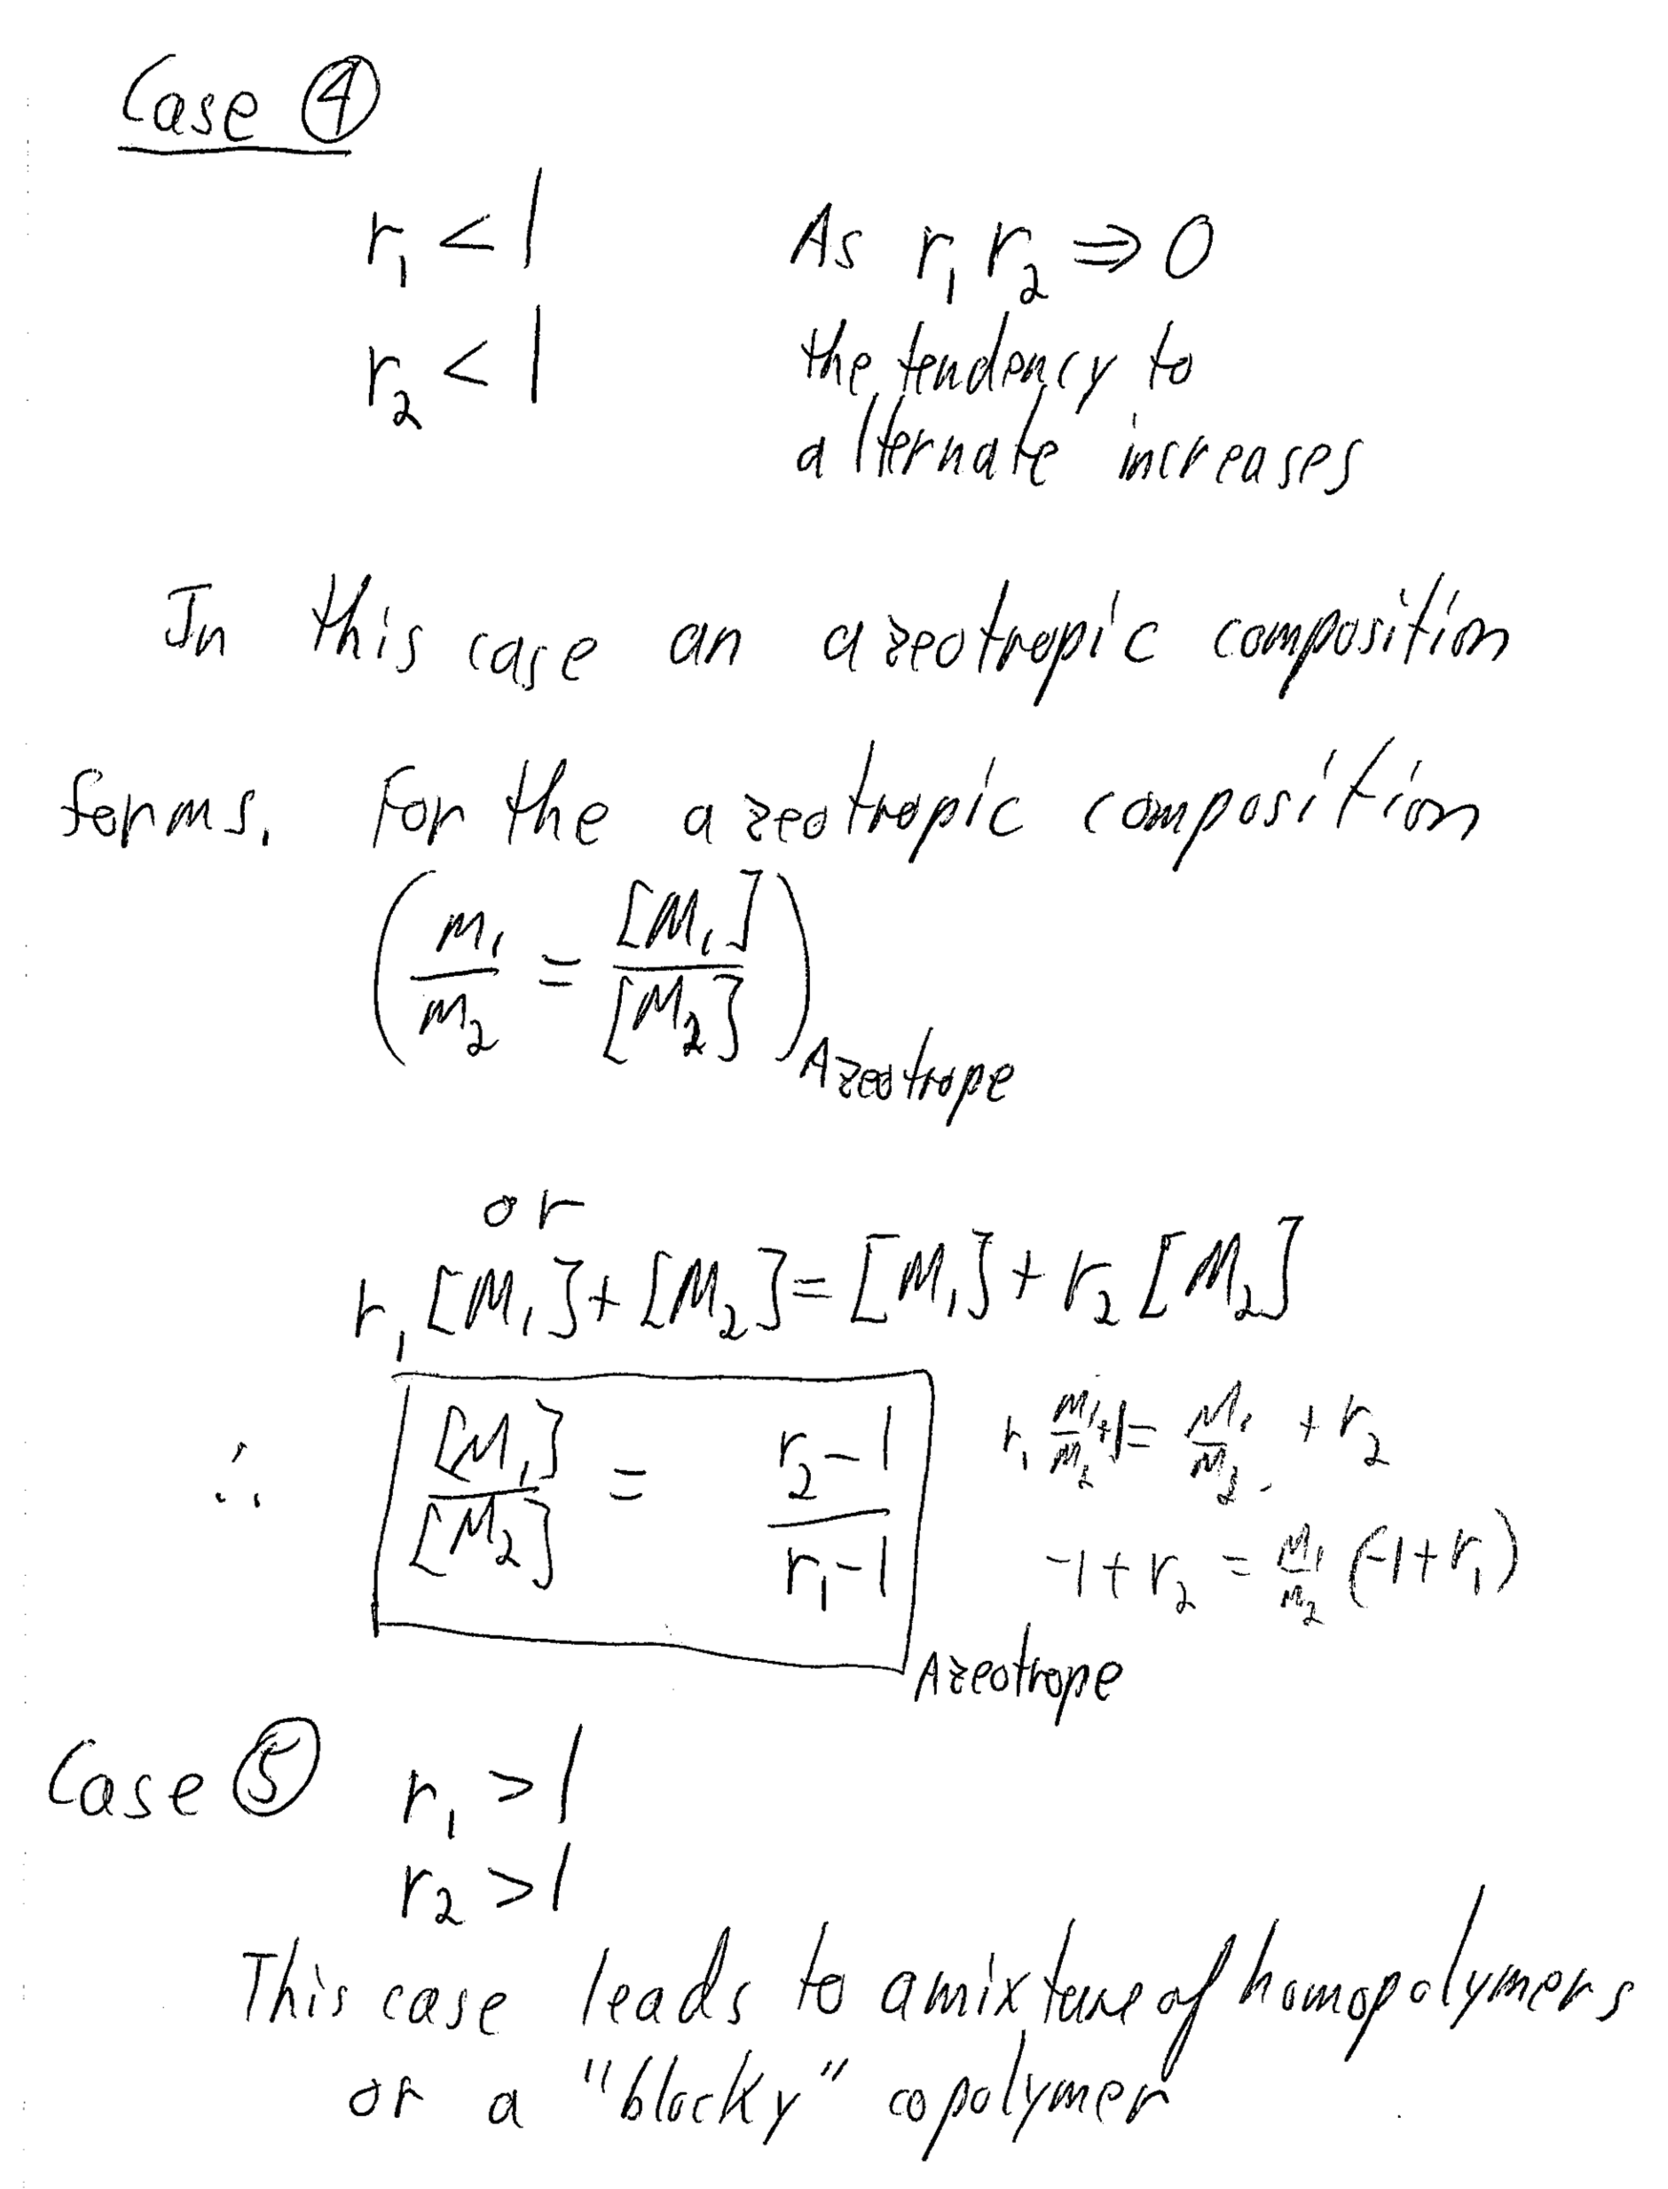

e) Vinilidene chloride has a very low reactivity since it is a double substituted vinyl and the second chloride interferes sterically with propagation according to the Tirrell/McCarthy notes. Vinyl chloride has a high reactivity since chlorine is an electron withdrawing group that serves to destabilize the free radical and make it more reactive. You should draw the structure of these two in your answer showing the partial charge on the vinyl chloride chlorine group in the propagating free radical group. This would correspond to case 2 in answer d.

2) a)
x_{i} is the degree of polymerization of component i.

b) Critical point is chi = 2
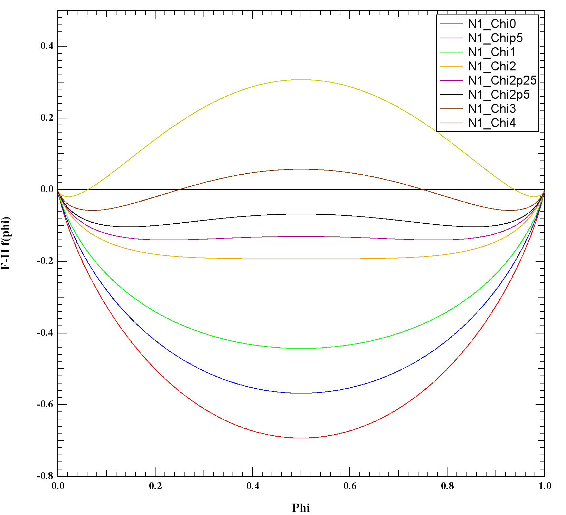
c) Binodal is where the first derivative is equal for two points (circles), this is the miscibility limit. Spinodal is where the second derivative is zero (squares). This defines the metastable region between binodal and spinodal. The critical point is where the third derivative is zero (central maximum).
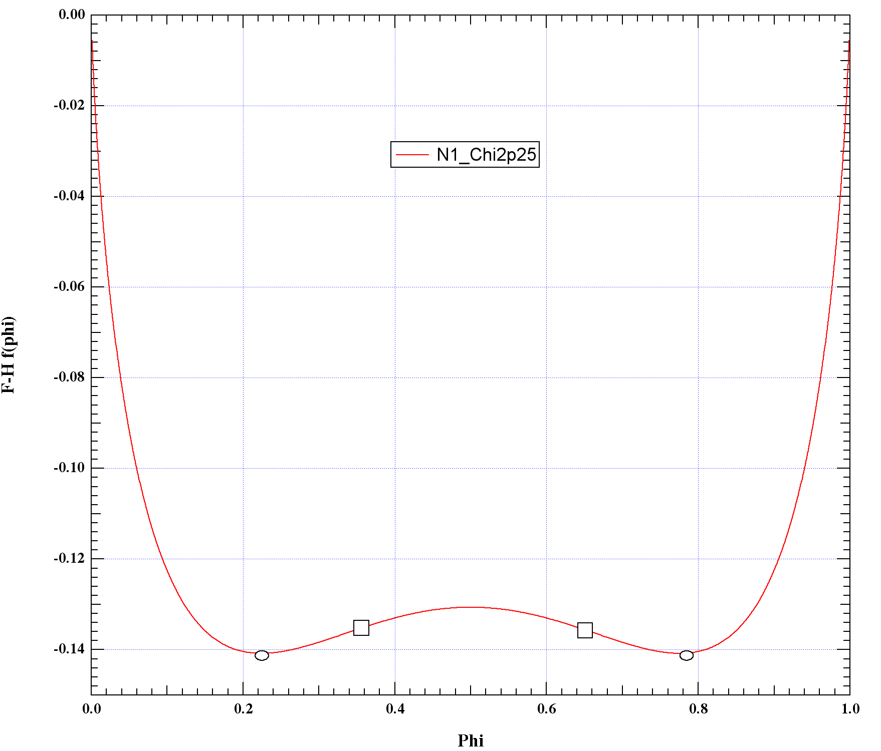
d) The points of part c are plotted on a temperature versus composition plot as shown in the notes and in class. You should sketch out how to do this in your answer to this question.

e) Gone over in class.

