Materials Engineering Undergraduate and Graduate Fair
Department of Chemical and Materials Engineering

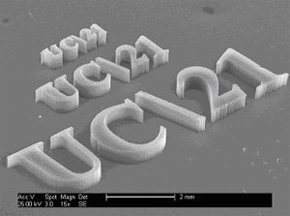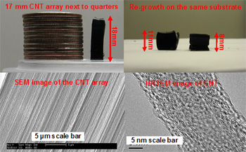

Pizza, Posters, Meet the Faculty and Students
Where: 401 Rhodes Hall
When: 11:00 am to 2:00 pm Wednesday November 14
Please stop by if you are:
INTERESTED IN

- A MINOR IN MATERIALS ENGINEERING
- MAJORING IN MATERIALS ENGINEERING
- GRAD SCHOOL IN MATERIALS SCIENCE AND ENG.

OR IF YOU JUST WANT TO LEARN ABOUT MATERIALS ENGINEERING

Currently there are more than 40 unfilled coop positions in Materials at UC. Our graduates are among the highest paid at UC with many local and national companies recruiting our recent graduates. Our class sizes are small (typically 15 students/year in the major) with many opportunities for interaction with the faculty including work study on research projects. Most recent graduates have received multiple job offers. Graduates of the Materials Program work in the aerospace and automotive industry; polymer and plastics industry; biomedical device manufacturing industry and in microelectronics and the high tech sector. Many students have gone on to Medical and Law School as well as Graduate School at some of the best graduate programs in the world including Cambridge University in England, Berkley, MIT, and ETHZ in Zurich. Materials Engineering is one of the highest demand fields.

