Synthesis of TiO₂ nanoparticle mesoporous films from reverse micelles and application of TiO₂ nanoparticles as photocatalysts.

Abhijit V. Jadhav
Department of Materials Science and Engineering, University of Cincinnati

Abstract:

The following review gives an overview of the synthesis of TiO₂ nanoparticle mesoporous films from reverse micelles and their implications in the field of photocatalysis. Titanium dioxide mesoporous films are deposited on templates (glass slides) by dip-coating in reverse micellar gels which contain titanium isopropoxide. These films are shown to have a high capacity for adsorption which makes titanium dioxide a significant contributor in the field of photocatalysis. As photocatalysts these films are used in applications which involve treatment of wastewater effluents, degradation of adsorbed dyes and acids like pthalic acid, dichloroacetic acid and decomposition of crude oil fractions. Photosensitization which plays an important role in the function of these films is studied. The importance of using a zinc ferrite and TiO₂ nanocomposite is reviewed.

1) Introduction:

Degradation or decomposition by “photocatalysis” is a novel method for the treatment of air and water pollutants [1]. Semiconductor photocatalysis with a primary focus on TiO₂ is widely used. TiO₂ aqueous suspensions offer a major disadvantage in water treatment as the TiO₂ particles cannot be recovered which is an important criterion in water treatment. Thus it is useful to fix TiO₂ particles on a support. The other reason which makes these films useful is that electron hole recombination process which reduces the catalytic effect can be blocked. These films also adjust well to the geometry of the photodegradation installation since they can be deposited on the inside of transparent tubes and electrodes. The reverse micellar route is an efficient route of producing TiO₂ nanoparticles and depositing them as films. The surfactant assemblies used in this process can be used to impart specific particle size and shape and thus this method is popular [2].

Photocatalysis aided by Titanium dioxide nanoparticles is used in removing the organic chemicals which occur as pollutants in wastewater effluents from industrial and domestic sources. There are various “sensitizers” that accelerate the process. This process is a combination of heterogeneous catalysis and solar technology. The Photocatalytic process breaks down the compounds such as alcohols, carboxylic acids, amines, herbicides and aldehydes into carbon dioxide, water and simple mineral acids. The main advantage of photocatalysis is that there is no further requirement for secondary disposal methods. Other treatment methods such as adsorption by activated carbon and air stripping merely concentrate the chemicals present by transferring them to the adsorbent or air and they do not convert them to non toxic wastes. Also as compared to other oxidation technologies, expensive oxidation methods are not required as ambient oxygen is used. Photocatalysis is also used to remove nuisance odours. TiO₂ is the most promising semiconductor used in photolysis since it provides a good compromise between catalytic activity and stability in aqueous media [1].

2) Formation of TiO₂ nanoparticles by reverse micelles:

2.1) Experimental [2]:

The chemicals used in the formation were Titanium (IV) isopropoxide, Triton X-100, AOT, cyclohexane and millipore water. Cyclohexane was used to prepare the micellar solutions. A low water to surfactant ratio is maintained which reduces the alkoxide hydrolysis rate and this aids in forming transparent gels. To this gel Titanium Isopropoxide was added. After alkoxide addition gelation is initiated. The slides were first cleaned in sulfochromic solution and dried in N₂ stream. By dip-coating at early stages of gelation and maintaining a certain withdrawal rate the films are prepared. The films are then dried in air. Care is taken that the film covers only one side and the other side is covered by tape. The films were finally heated in air and left at a maximum temperature for sometime. The AFM image of these films as per figure 2.a depicts that it consists of uniformly sized, quasi spherical nanoparticles of a diameter of a few tens of nanometers. These AFM images are obtained with a Nanoscope III, Digital Instruments.

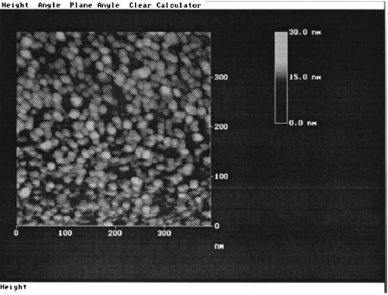

Figure 2.a – Reference: - E. Sthathatos, D Tsiourvas, P. Lianos, J. Colloids and Surfaces A: Physicochemical and Engineering Aspects Volume: 149, Issue: 1-3, April 15, 1999. pp. 49-56.

2.2) Effect of various factors on the formation from reverse micelles [2]:

a) Choice of surfactant:
This is the most important parameter. We need a surfactant which has a very slow hydration and gelation rate. In these context surfactants with a polyethylene oxide polar head are preferred because they are strongly hydrated and they compete with alkoxide hydrolysis. Due to this the rate of alkoxide hydrolysis is suppressed and this leads to inorganic polymerization and formation of oxide. Thus the transformation rate from sol to gel is slow. It is extremely important to obtain the films at early stages of gelation. Triton X-100 serves as a good surfactant in comparison with AOT which leads to faster hydrolysis rates.

b) Water/ Surfactant ratio:
If the water/ surfactant ratio is higher alkoxide hydrolysis rate will be higher and thus the gelation will be rapid. This can be verified by visual inspection of solutions.

c) Temperature and Quiescence:
At higher temperatures, higher rates for gelation were obtained. In the context the temperature should be controlled properly to obtain reproducible films. Quiescent samples gel rapidly when shaken.

d) Waiting Time:
The waiting time from alkoxide until the dipping effects the size of the nanoparticles. This can be seen from Figure 2.b

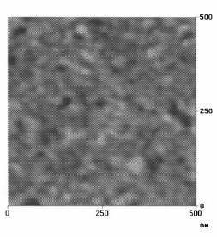  Dipping right after alkoxide addition | 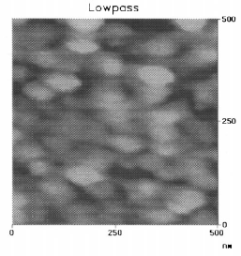  Dipping 5 minutes after alkoxide addition.

Figure 2.b – Reference: - E. Sthathatos, D Tsiourvas, P. Lianos, J. Colloids and Surfaces A: Physicochemical and Engineering Aspects Volume: 149, Issue: 1-3, April 15, 1999. pp. 49-56.

Also the film which was made in the early stage of gelation absorbed more than the film made at later stages of gelation. This was verified by an experiment with Basic Red 46 dye [2].

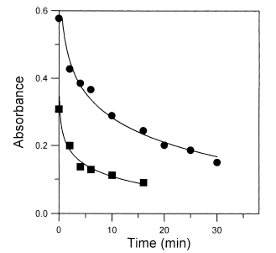

Figure 2.c – Reference: - E. Sthathatos, D Tsiourvas, P. Lianos, J. Colloids and Surfaces A: Physicochemical and Engineering Aspects Volume: 149, Issue: 1-3, April 15, 1999. pp. 49-56. The circular data points indicate gelation at earlier stages and the square data points indicate gelation at later stages.

3) Photosensitization:

A semiconductor photocatalyst absorbs incident photons which have energy equal to or more than its band gap or threshold energy. Any incident photon that hits a an electron in the occupied valence band of the semiconductor atom elevates the electron to unoccupied conduction band and this helps in the formation of excited state conduction band electrons and positive valence band holes. These charge carriers get trapped in shallow traps or deep traps and photoredox reactions are a result of these trapped holes or electrons [1]. A variety of dyes like porphyrins and ruthenium polypyridyl complexes are used as photosensitizers to enhance the wavelength responsiveness of the TiO₂ thin films. But in most cases the stability of the monomeric dyes is less than the TiO₂ film which results in lesser harvesting of light and subsequently reduced photoresponsiveness. On the other hand when a substituted Ru(bpy)₃²⁺ dye is attached to a polyimide backbone then the photoresponsiveness observed is efficient and longer. This improved utility is due to conjuction of high mechanical and thermal stability of the polyimide backbone [3].

3.1) Preparation of nanoparticle TiO₂ thin films modified by polymeric dyes:
The TiO₂ sols are spin coated onto Indium Tin Oxide (ITO) glass plates [3]. By performing this operation several times thick films were obtained. Between every application these plates were heated at a particular temperature. Optically transparent electrodes cut from these plates are then annealed. These electrodes are then soaked in a solution of the polymeric dye in MeCN overnight. These were again washed with MeCN and baked in air.

3.2) Effect of polymeric dye coating on the photosensitization efficiency:

Incident photon to current efficiency is given by the ratio of electrons injected to the number of incident photons.
IPCE (%) = 100(i_{sc} *1240)/ (Iincλ)
Where i_{sc} is the short circuit photocurrent (A/cm2), Iinc is the incident light intensity and λ is the excitation wavelength. A plot of observed IPCE (%) as a function of the incident wavelength is compared with the absorption spectrum of the polymeric dye containing the polyimide backbone. Substantial photocurrent was produced for polymeric dye coated thin films at irradiation above 400 nm. This was not observed in case of non coated thin films wherein the irradiation was negligible. This is shown in figure 3.a.
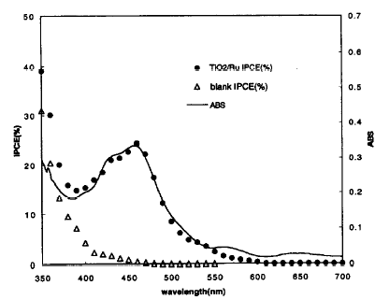
Figure 3.a: Reference: - H.Osora Et Al, J of Photochemistry and Photobiology B: Biology 43 (1998) 232-238. The solid circular data points are for the coated thin films and the triangular data points are for the non coated thin films.

3.3) Effect of polymeric dye coating on Photocatalytic activity:

Photocatalytic activity was observed for the oxidative decomposition of methylene blue [3] by visible irradiation of ITO/TiO₂/polymeric dye, ITO/TiO₂ and commercial TiO₂. Methylene blue normally is stable in air at wavelengths around 300 nm but photo-oxidatively degrades in the presence of TiO2 for the same wavelengths.Small levels of oxidative degradation were observed in all three cases. Photocatalytic activity increased in the order commercial TiO₂, ITO/TiO₂ and ITO/TiO₂/polymeric dye. This can be seen in Figure 3.b.Thus this indicated effective extension of the active wavelength from ultraviolet to the visible range due to the introduction of the polymeric dye.

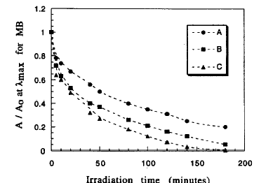

Figure 3.b: Reference: - H.Osora Et Al, J of Photochemistry and Photobiology B: Biology 43 (1998) 232-238. A indicates ITO/TiO₂/polymeric dye; B indicates ITO/TiO₂ and C indicates commercial TiO_{2.}

4) Improvement in the photocatalytic activity of TiO₂ by synthesis of ZnFe₂O₄/TiO₂ nanocomposite [4]:

Fast recombination of photogenerated electrons and holes are thought to be the main cause of reduced photoactivity of TiO₂. Metal ion dopings can aid in the separation of these photogenerated carriers and thus improve the photoactivity. A coupled semiconductor system may be useful in this context. Examples of other semiconductors used are CdS, CdSe, FeS₂ or RuS_{2.} But these are sensitive to photoanodic corrosion. Zinc ferrite (ZnFe₂O₄ ) displays an anomalous behaviour. Zinc ferrite with a small band gap is a useful solar energy material for photoelectric conversion. Its advantages include absorbing visible light and not being sensitive to photoanodic conversion. Zinc ferrite and TiO₂ both have their own advantages and disadvantages and when used together may provide a nanocomposite which provides useful characteristics for photocatalysis.

A phenol solution is irradiated under sunlight in the presence of ZnFe₂O₄/TiO₂ nanocomposite, pure ZnFe₂O₄ and pure TiO₂ and the absorption spectra (Figure 4.a) are observed. As compared to pure ZnFe2O4 nanoparticles, TiO₂ nanoparticles and ZnFe₂O₄/TiO₂ nanocomposite are efficient photocatalysts. 95 % of the phenol disappears in the 3 hours for the nanocomposite. In case of pure TiO₂ 20 % disappears in3 hours. Thus the nanocomposite is more efficient than pure TiO₂. This is mainly because Zinc ferrite extends the photoresponse of TiO₂ to the visible region and thus increases the efficiency of utilizing the solar energy. Also the improvement in photoactivity is due to coupling effect that promotes charge separation of the generated charge carriers. Also the photoactivity decreases with the increasing grain size.
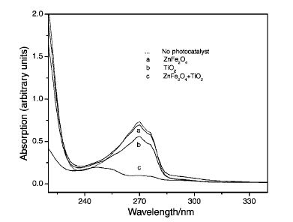

Figure 4.a: Reference: - Zhi-hao Yuan, Li-de Zhang, J of Materials Chemistry, 2001, 11, 1265-1268

5) Application of TiO₂ nanoparticles in decomposition of seawater-soluble crude oil fractions [5].

Shipping operations, accidental spills and corrosion of equipment are possible sources of petroleum contamination. Refinery waste water is another possible source. These sources are usually rich in dissolved organic carbon which is the main cause for chronic toxicity in coastal ecosystems. Conventional technologies like biological treatment and carbon adsorption are limited in emission standards and are not preventive. Advanced oxidation technologies using heterogeneous photocatalysis by semiconductor such as TiO₂ have made remarkable progress. For this crude oil samples are collected from specific sites and besides the DOC concentration parameters such as depth, conductivity, dissolved oxygen, wind direction, sky conditions and visibility were also monitored. These samples are irradiated in a Pyrex reactor in batch experiments using a radiation source and this is done for 7 days in a row.

FTIR spectroscopy [5] is carried out to analyze the crude oil sample after extraction with dichloromethane. These extracts were concentrated under vacuum. The spectra were recorded between 4000 and 500 cm⁻¹. The A spectra was recorded for crude oil sample, the B spectra was recorded for UV-VIS irradiated crude oil, the C spectra was recorded for TiO2 after exposure to UV-VIS irradiation and the D spectra was recorded for blank seawater. The difference in A and B spectra indicates a transformation of the initial compounds although no mineralization occurs without TiO_{2.} On observation of the sample containing the photocatalyst after 7 days it was noticed that there was vast majority of the absorption bands were disappeared. These results indicated that the organic compounds were completely destroyed resembling the spectra D of a blank seawater.

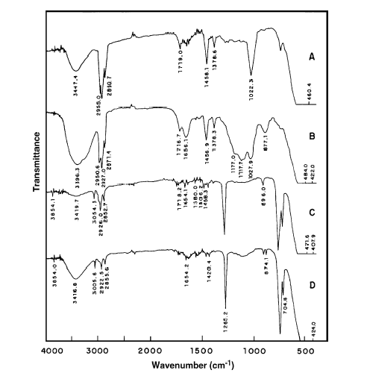

Figure 5.a: Reference: - Ziolli R.L, Jardim W.F., J of Photochemistry and Photobiology A: Chemistry 147 (2002) 205-212.

6) Conclusion:

Uniformly sized, quasi spherical TiO₂ nanoparticles were synthesized from reverse micelles. Thin mesoporous films were formed by dip coating in reverse micellar gels which contain titanium isopropoxide. This formation was influenced by parameters like choice of solvent, water/surfactant ratio, temperature, quiescence and waiting time. Ruthenium with a polyimide backbone was showed to be a useful photosensitizer. The Photocatalytic activity was observed to be enhanced on formation of a ZnFe₃O₄/TiO2 nanocomposite.TiO₂ nanoparticles were shown to contribute significantly in the field of photocatalytic decomposition of crude oil.

References:

1.Beydoun D., Amal R., Low G., S Mcevoy, Role of nanoparticles in photocatalysis, J of Nanoparticle Research 1, 1999, 439-458.

2. Sthathatos E., Tsiourvas D., Lianos P., Titanium dioxide films made from reverse micelles and their use for the photocatalytic degradation of adsorbed dyes, J. Colloids and Surfaces A: Physicochemical and Engineering Aspects Volume: 149, Issue: 1-3, April 15, 1999. pp. 49-56.

3. Osora H., Li W., Fox M.A., Photosensitization of nanocrystalline TiO2 films by a polyimide bearing pendent substituted-Ru(bpy)₃²⁺ groups, J of Photochemistry and Photobiology B: Biology 43 (1998) 232-238.

4. Yuan Z., Zhang L., Synthesis, characterization and photocatalytic activity of ZnFe₂O₄/TiO₂ nanocomposite, J of Materials Chemistry, 2001, 11, 1265-1268

5. Ziolli R.L, Jardim W.F., Photocatalytic decomposition of seawater-soluble crude oil fractions using high surface area colloid nanoparticles of TiO2, J of Photochemistry and Photobiology A: Chemistry 147 (2002) 205-212.

