Project

Zeolites: Synthesis, Characterization and Applications
20-254-689

Sol-Gel Synthesis of Zeolites: Effect of Process Parameters

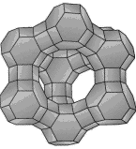

Submitted on:

6/7/2001

Submitted By:

Siddharth Patwardhan
Abstract

One of the important process to carry out zeolite synthesis is sol-gel processing. The product properties depend on reaction mixture composition, pH of the system, operating temperature, reaction time as well as the templates used. In sol-gel process, other elements (metals, metal oxides) can be easily incorporated. The silicalite sol formed by hydrothermal method is very stable. Also the ease of scaling up this process makes it favorite route for zeolite synthesis.

1. Introduction

The synthesis of zeolites is truly an art. The sol-gel process is studied in great depth over large period. The viability and ability to tune according to the product requirements makes this route very important. This means that the process is easy to carryout and by simply varying the process parameters, the product properties and even product, in some case, can be altered.

The sol-gel process is initially described in detail. The application of the process to the synthesis of zeolites is then explained.

  - Sol-Gel processing: General Description¹

Sol is colloidal (~1-1000 nm) suspension of solid particles in a liquid. The solid particles in the colloidal phase are stable due to short-range forces such as van der Waals attraction and surface charges. Gel is defined as a substance that contains a continuous solid skeleton enclosing a continuous liquid phase. Gel consists of continuous solid and fluid phases of colloidal dimensions. In sol-gel processing, a sol of a given precursor is prepared, which undergoes some chemical & physical changes, grows in size and forms gel. This gel when dried under high temperature conditions yields the product. The whole process may take weeks. Metal alkoxides, popular precursors for sol-gel processing due to their reactivity, undergo hydrolysis and condensation reactions to produce highly condensed and branched network polymers (see Figure 1). The networking depends on the functionality of the metal. For example, Si, with coordination number 4, forms highly branched networks.
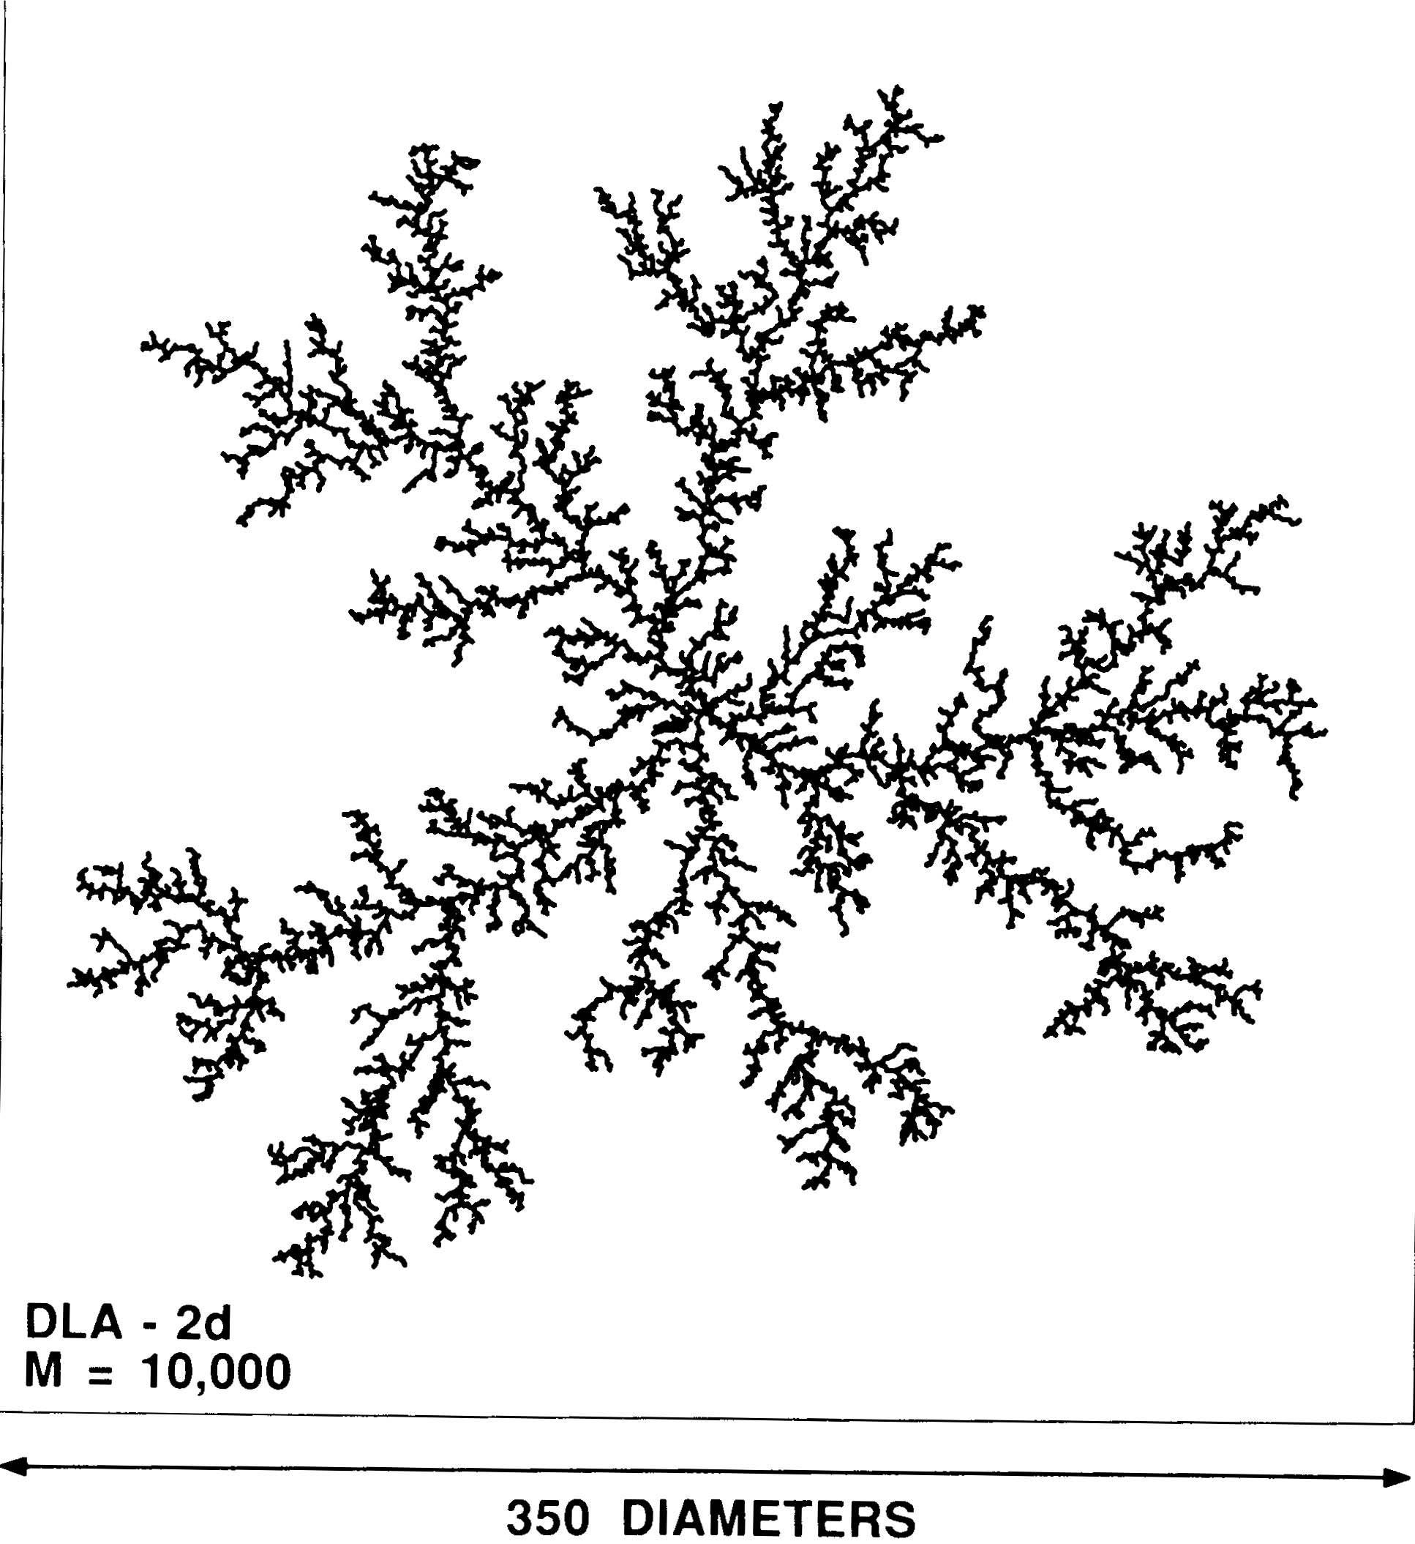
Figure 1. Fractal polymer made by branching of polyfunctional monomer with functionality >2.

The transformation of sol to gel takes place via hydrolysis and condensation reactions of the precursors. The hydrolysis reaction is represented as (taking an example of Silicon):

Si (OR) ₄ + n H₂O → (HO) _{n}-Si (OR) _{4-n} + ROH.

In case of metal alkoxide precursors, R represents an alkyl group. The metal is totally hydrolyzed when n = 4. For any other value of n, partial hydrolysis takes place. In the condensation reaction, the two partially hydrolyzed molecules link together and liberate a small molecule as H₂O or ROH. The general reaction is represented as:

(OR) _{4-n} Si (OH) _{n}+(HO) _{n} Si (OR) _{4-n} → (OR) _{4-n} (OH) _{n-1} Si-O-Si (HO) _{n-1} (OR) _{4-n}+ H₂O

The condensation takes place in such a way as to maximize the number of M-O-M (metal-metal linkage through oxygen) bonds and minimize terminal hydroxyl groups through internal condensation. Initially monomers add to form rings, and creating 3-D structures. These compact structures are formed by leaving the hydroxyl groups outside, as shown in figure 2.

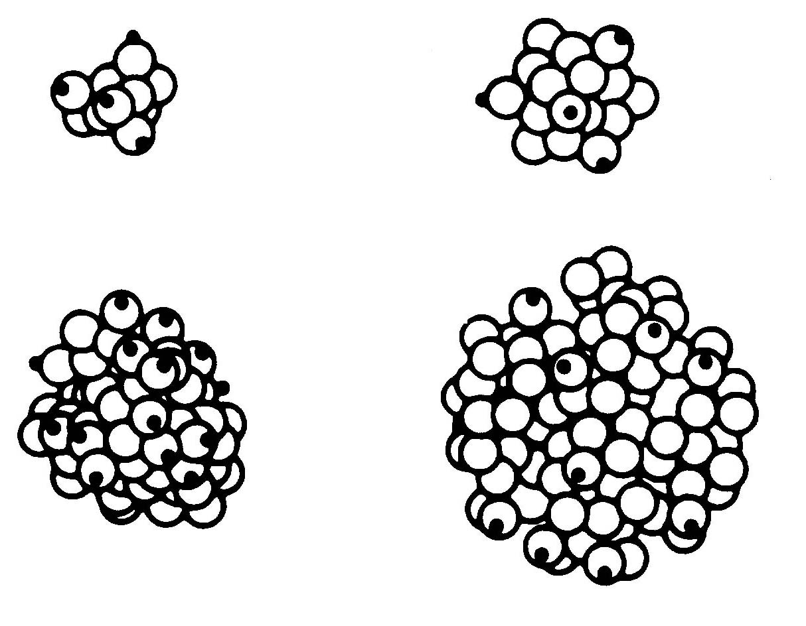

Figure 2. Colloidal particles formed by condensing monomers to form closed rings.

These 3-D structures serve as the nuclei for further particle growth². Further particle growth is by Ostwald ripening mechanism (Figure 3) i.e. particles grow in size decrease in number. The highly soluble small particles precipitate on the relatively larger, insoluble particles.

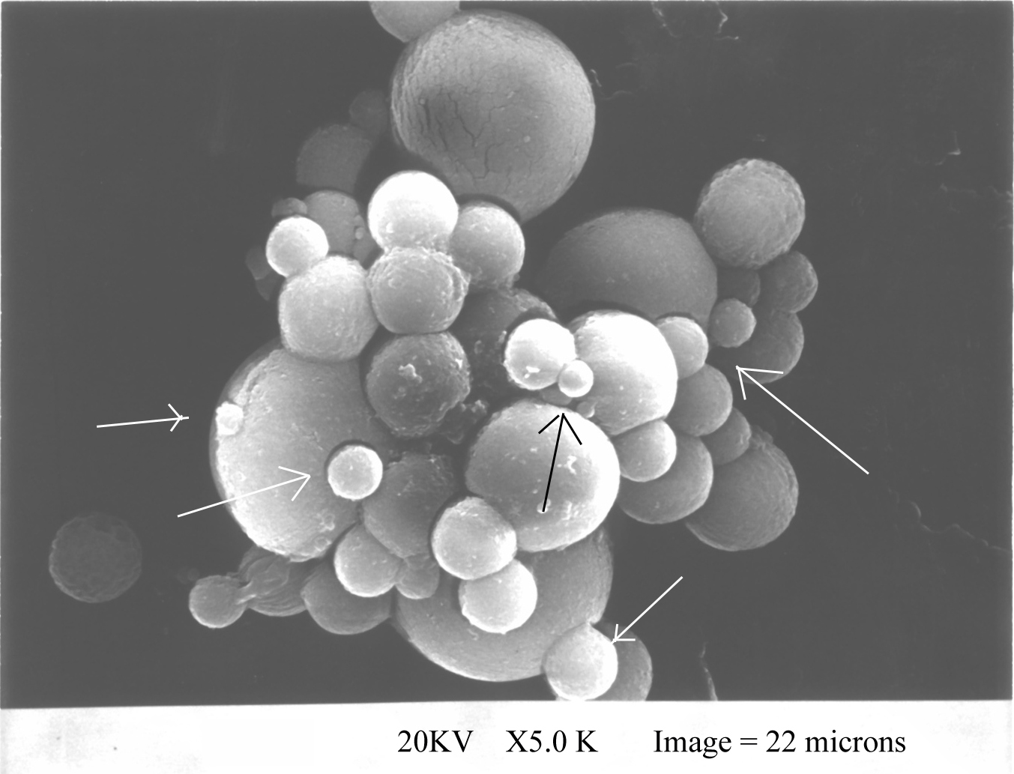
Figure 3: SEM showing Ostwald ripening. The arrowheads indicated the smaller particles precipitated on the larger particles.

The figure 4 shows the general representation of the sol-gel process, carried out at different pH and additives².

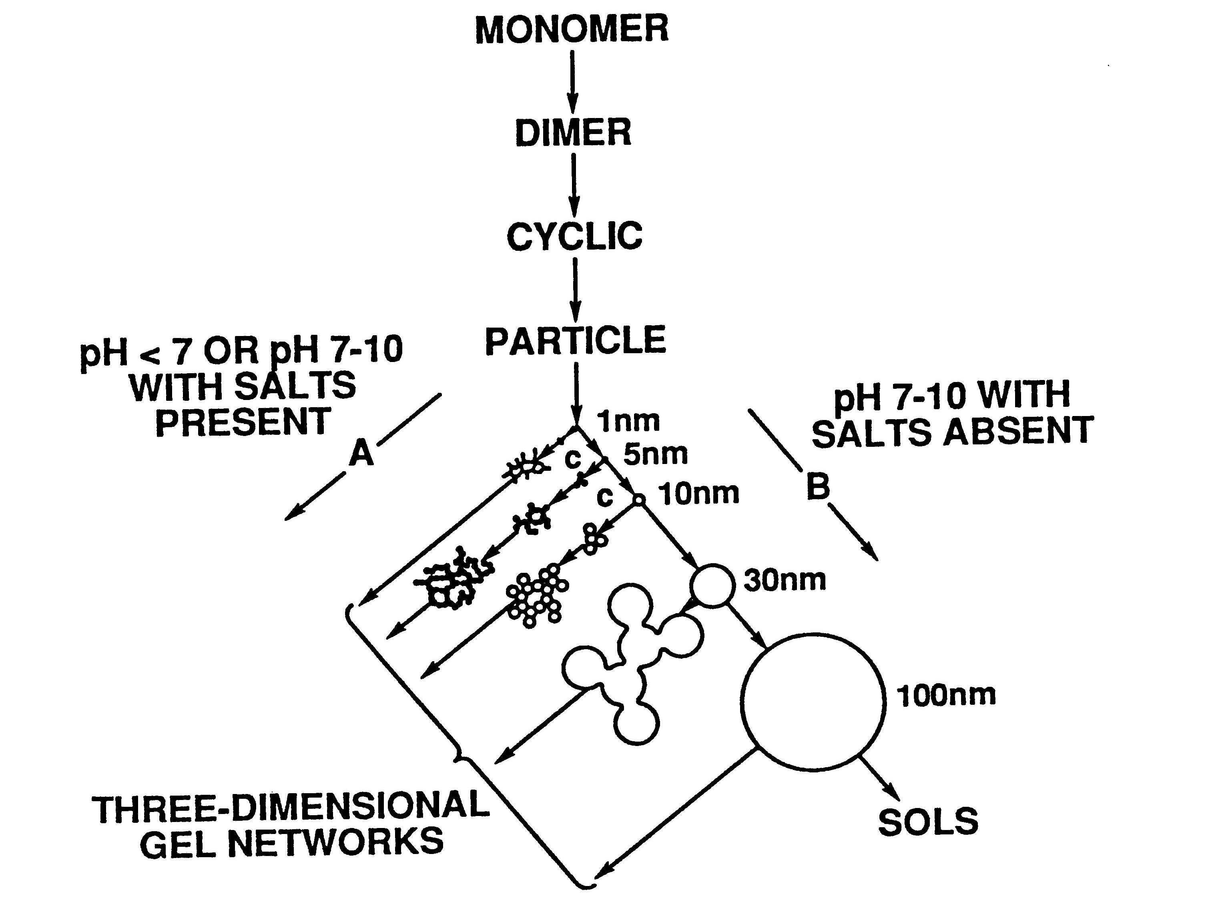
Figure 4: Polymerization behavior of aqueous silica. A = in presence of salts / acidic medium, B = alkaline medium.

  - Sol-Gel processing: Application to Zeolites Synthesis³

In section 1.1 the general sol-gel processing was described in brief. The formation of zeolites will be discussed here. The hydrolysis and condensation proceeds with conversion of tetrahedrally coordinated Al atoms to octahedrally coordinated Al atoms¹. The inorganic polymerization is due primarily to the formation of Al-O-Al linkages, first involving tetrahedrally coordinated Al and later octahedrally coordinated Al, leading to 3-D structure. The polymer growth occurs by chain polymerization mechanism involving tetrahedrally coordinated Al.

The existence of the sol can be verified by measuring the fractal dimension of the solution. This can be achieved by small angle X-ray scattering (SAXS), small angle neutron scattering or small angle light scattering (SALS). The slope of the plot ln (scattered intensity) verses ln ([sin θ]/ λ) gives the fractal dimension (-d_{f}). A slope between –3 and –4 could be used as a defining characteristic of a particulate sol. The aliminosilicates are mass fractals with d_{f} = 1.8.

The zeolite synthesis takes in two steps: nucleation and crystallization. Nucleation is a process where small aggregates of precursors give rise to germ nuclei (embryos), which become larger with time. The formation of these nuclei is discussed earlier. The rate of nucleation of a new phase from a melt increase by decreasing the temperature of the system.

(dN/ dt) = A t^{n} exp (-t^{p})

Crystallization starts by involving nuclei and ingredients from the solution mixture. Following are the characteristics of the zeolite crystallization:

- The deposition on a seed or stable nucleus increases with the extent of stirring and temperature.
- High index faces grow more rapidly and they tend to disappear.
- As the overall rate of crystallization increases, the difference in the growth rate of the various phases tends to decrease.
- Flawed surfaces tend to grow rapidly.
- The yield of the crystals increases at a rate proportional to total free external surfaces of the crystal.

The factors affecting the crystallization are tabulated in Table 1³.
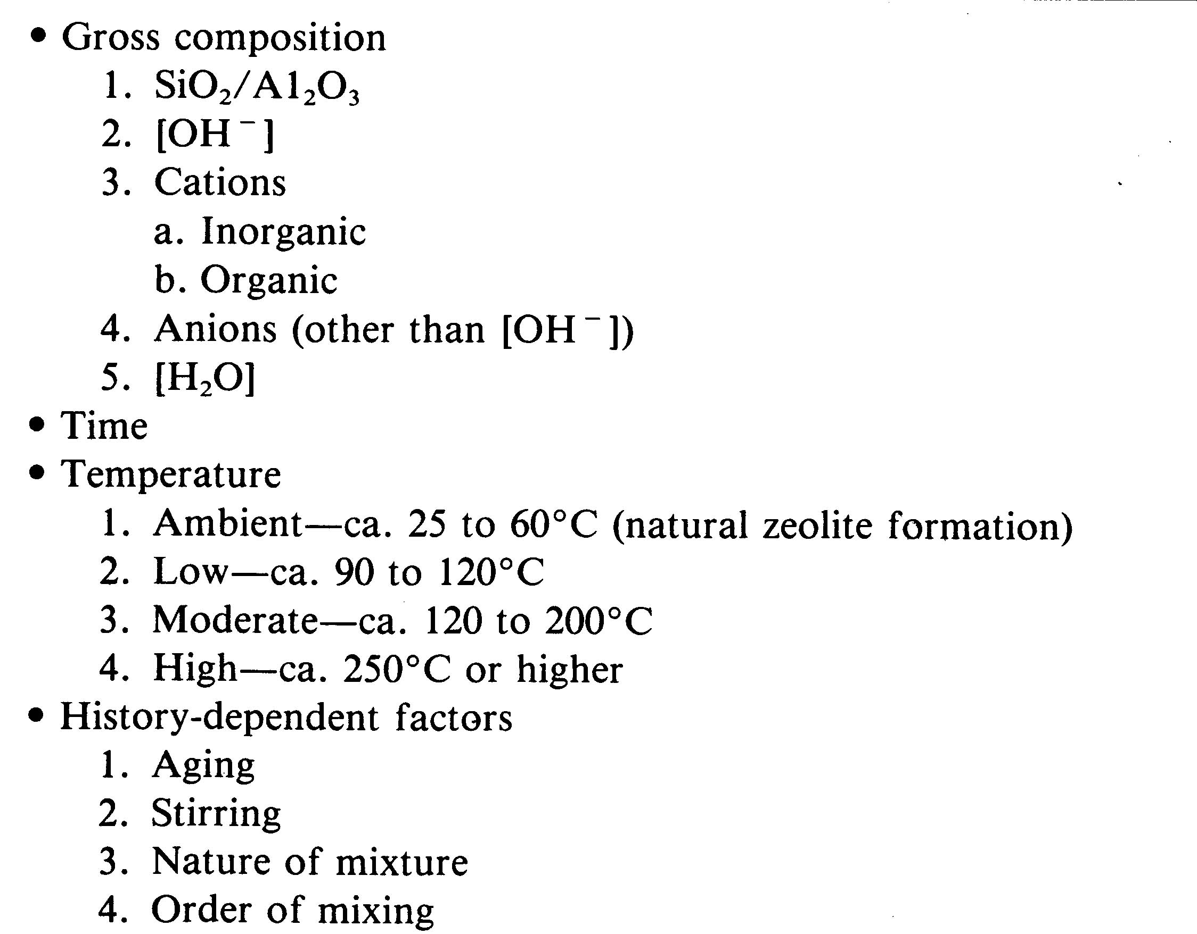
Table 1. Factors affecting the zeolite crystallization.

The crystallization can be split into four stages:

- Formation of water icebergs. These icebergs are ring like structures of water molecules, interconnected by hydrogen bonding.
- Depolymerization of the condensed large molecules of the precursors then takes place.
- These depolymerized molecules start orienting around the water icebergs, thus forming the nuclei.
- These nuclei forms terminated tetrahedral. Thus a crystalline structure is formed.

The particle size as a function of crystallization time and the population growth of the crystals over time are shown figure 5 and 6 respectively¹³.
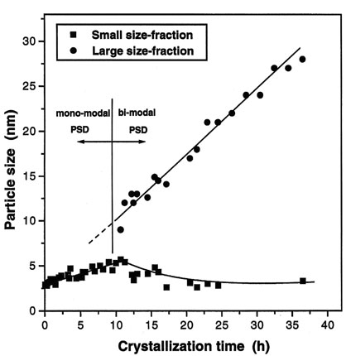
Figure 5. Particle size as a function of crystallization time.
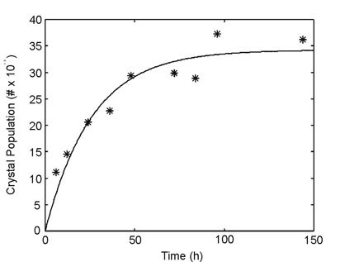
Figure 6. Crystal population verses crystallization time.

2. Factors Affecting the Zeolite Synthesis:

Following factors influences the crystalline zeolite structure (also see Table 1) ^{3, 4}:

- Composition of the reaction mixture.
- Nature of reactants and their pretreatments.
- Initial and final pH of the system.
- Temperature of the process and its variation with time (if any).
- Time allowed for the reaction to take place, including the calcination time.
- Mixture, whether homogeneous or heterogeneous.
- Seeding.
- Template molecules (if any).

2.1 Composition of the Reaction Mixture³:

The composition of the reaction mixture is one of the most important factor governing the product properties. These includes:

- Silica to alumina ratio.
- OH ion concentration.
- Inorganic cations.

i. Si O₂/ Al₂ O₃ in the gel phase constraints the framework composition of the zeolite. The ratio often determines the candidate frameworks in exploratory zeolite crystallization⁵. The hydrophobic / hydrophilic nature of the zeolite is also affected by this ratio as Al is hydrophilic and Si is hydrophobic. Also, high Al contents can give higher acidic sites, which are useful for many applications. Zeolites with higher silica / alumina ratio are used for catalytic applications in cracking and isomerization. As the Al content is increased the acid resistance & thermal stability of the zeolite reduces. These effects can be summarized as follows:

Increasing the silica / alumina ratio affects following physical properties of the zeolite:

  - Increases acid resistance.
  - Increases thermal stability.
  - Increases hydrophobicity.
  - Decreases affinity for polar adsorbents.
  - Decreases cation content.

Decreasing the silica / alumina ratio affects following physical properties of the zeolite:

- Increases hydrophilicity.
- Increases cation exchange properties.
- Decreases the pore size for same numbered ring, as Al has lower atomic radius than Si.

Also depending on the phase diagram, this ratio can vary the nature of the final zeolite.

ii. Hydroxide ion concentration: It functions as structure director through control of the degree of polymerization of silicates in solution. OH ion modifies the nucleation time by influencing transport of silicates from the solid phase to solution. It enhances the crystal growth and controls the phase purity. In a study⁷ it was found that the OH/Si ratio influences the pore size. i.e. higher the ratio, wider were the pores.

iii. Role of Inorganic Cations: Inorganic cations are defined as species, upon addition to the reaction mixture, crystallization is induced of a specific zeolite structure that could not be formed in the absence of the agent. These cations are used in the zeolite synthesis for following reasons:

- They act as structure directing agents.
- They balance the framework charge.
- They govern the morphology of the zeolite.
- They affect the crystal purity
- They also affect the product yield.
- These agents determine which of the competing frameworks is actually formed⁵.

These cations, due to charge and their orientation in the reaction mixture, alter the pore sizes of the zeolites. Most commonly used cations are alkyl ammonium ions such as tetramethyl ammonium (TMA), tetraethyl ammonium (TEA), etc. Apart from silica to alumina ratio and pH, the amine concentration is very important variable⁵. The use of protein as template is also cited¹⁰.
Recently, it was investigated that different amine templates vary the crystallization and produced ZSM 22, 35 and 13 depending on the silica alumina ratio.^{5, 6} In the investigation, for fixed silica to alumina ratio, different amines yielded different zeolites, which were different from the zeolites produced without the presence of amines. It was also shown that for a given amine, varying the silica to alumina ratio formed different zeolites. The amines used in that study were small cyclic and non-cyclic amine such as ethylamine, isopropyl amine, ethylenediamine, pyrrolidine, piperidine, etc. From the data in the table 2, it was understood that the amines affect the zeolite structure through the amine molecule shape and not the primary, secondary or tertiary nature of the amine.

Table⁵ 2. Products and Product Compositions Observed in the Presence of Non-cyclic Small Amines, in Crystallizations at SiO₂/Al₂O₃ = 200.

Amine Zeolite Al/uc Na/uc R/uc

Ethylamine (EA) ZSM-23 0.3 0.2 1.2
Isopropylamine (iPA) ZSM-23 0.3 0.1 0.9
Ethylmethylamine (EMA) ZSM-23 0.3 0.1 0.9
Diethylamine (DEA) ZSM-22 0.3 0.2 0.9
n-propylamine (nPA) ZSM-5 1.1 0.9 7.0
Ethylenediamine (en) ZSM-22/23 0.3 0.5 1.6
en. at high conc. ZSM-48 0.5 0.2 2.4

It was also revealed that the amines were held inside the zeolite. The authors found that the effect of amines, on the structure and physical properties, was secondary to the effect of Al concentration in the reaction mixture.

When cyclic amines were used, it was found that these amines produced zeolites with larger pore sizes (for example, ZSM-12). As the amine size increases, the amine per unit cell of the product decreases. In another investigation⁶, it was found that small amines had exceptionally strong affinity towards ZSM-5, ZSM-35 and ZSM- 22 frameworks, at high pH. Without any amine, lower silica to alumina ratio produces Mordenite while higher ratio produces ZSM-5. But for lower silica to alumina ratio, addition of ethylamine, C₃, C₄ amines and polyamines yielded ZSM-5, ZSM-35 and ZSM-5 respectively, while tertiary butylamine produced Mordenite.

2.2 Nature of Reactants⁸

The sol-gel synthesis is carried out with inorganic as well as organic precursors. It is seen that the properties of the product zeolites are influenced by the precursor⁸. The final compound has approximately the same chemical composition, but the crystalline structures of the two products, using inorganic and organic precursors, were substantially different. The inorganic precursors yielded more hydroxylated surfaces whereas the organic precursors easily incorporated the metals into the network. This is a very important observation from the viewpoint of the catalysis and separations.

2.3 Process Temperature

As discussed, the rate of crystallization is directly proportional to temperature while the rate of nucleation is inversely proportional to temperature. As both the processes undergo simultaneously for large period of time, the operating temperature need to be optimized for maximum zeolite yield. The reaction mixture, being in disordered state, is at higher entropy than the crystalline, ordered state². Usually, zeolites are synthesized below 350⁰ C, with some exceptions³. Higher temperatures generally yield more condensed phase species. Temperature influences several factors in zeolite synthesis; it can alter the zeolite phase obtained as well as change the induction period before the start of crystallization. This induction period decreases with increasing temperature. The reaction temperature seems to influence both the d-spacing and the crystallinity of the zeolite MCM-41, in opposite way⁷.

2.4 Reaction Time³

In the sol-gel processing of zeolites, the reaction mixture forms gel very quickly. This gel, after some time phase separates into two phases, solid and liquid, with increase in the mixture density. The solid precipitates from the gel. This solid is the crystalline material, the zeolite. These observations indicate that the reaction mixture forms a metastable state, which splits into two stable states, one of which is the crystalline solid phase. It is very important to control the time, because the same reactants may yield different products at different times at same process conditions.

The optimization of time is very important in the industrial manufacturing of the zeolites. When only one phase is obtained, optimization is maximization of the crystallization over short period of time. But difficulties arise when more than one metastable zeolite (or non zeolite) phases are observed. Crystallization parameter must be adjusted to minimize the production of the other phases while also minimizing the time needed to obtain the desired crystalline phase.

2.5 pH of the Reaction Mixture

The zeolite synthesis via sol-gel process is carried out in alkaline pH (> 10). The pH of the reaction mixture does not relate directly to the total OH content of the system, but pH does appear as an important parameter in the synthesis of the zeolites in terms of the presence of free OH in the system³.

A marked change in pH is noted to accompany crystal formation. A simultaneous increase in pH of the system can be observed with crystallization. This increase in pH is the indication that the SiOH in colloidal state incorporates in the framework in the form of SiO₂. This is due to SiOH being acidic in nature.

The pH of the system is also very important to stabilize the sol. It also controls the particle size⁹.

2.6 Other Factors

Factors other than those discussed above, also affect the zeolite synthesis. These include:

- Process Conditions
- Other Additives
- Further Processing

2.6.1 Process Conditions

This includes typical chemical engineering approaches, i.e. instead of carrying out the processing in a batch mode, it is carried out on a continuous or semi continuous mode. Which enhances the capacity, making it compatible for industrial applications.

A minor perturbation to the reaction mixture may cause large changes in the product zeolite. This includes degree and method of mixing, flowing the mixture. This basically affects the transport properties of the system.

A semi continuous process has been developed by Lin and coworkers⁹. In this process, the colloidal solution is prepared by usual methods and this solution is passed through a bed of paraffin oil and ammonia solution. The flow of the drops in the oil governs the particle properties.

In another study¹¹ a spray drying technique was adopted for synthesis of mesoporous material. They sprayed the precursor sol with a carrier gas into a vertical tubular reactor having two heating zones.

Thoma and Nenoff¹² carried out vapor phase transport synthesis of zeolites from sol-gel precursors. It was found that the product morphology was a complex function of:

i. Reaction time
ii. Temperature
iii. Amounts of Sodium, Al, Si and quaternary amines, in precursor gel as well as
the type and relative amounts of organic molecules
iv. Water in vapor phase.
The is silica dissolved from the walls of the micro pores and interacts with the organocation, nucleation occurs, and the crystal grow outward toward the surface of the gel. This process lacks in molecular long-range transport.

2.6.2 Additives

The addition of a small quantity of a material may affect the nucleation and crystallization. Addition of seeds to a reaction mixture enhances the crystallization. Also addition of colloidal particles such as Polystyrene¹¹ causes organization of the pores. Here PS acts as a template as well as nucleating agent.

2.6.3 Further Processing

Treating the mixture with paraffin oil and ammonia solution was found to produce spherical consolidated particles⁹. The oil, due to surface tension effects affects the geometry of the particles.

3. Conclusion:

The sol-gel process for the synthesis of zeolites and the effects of various process parameters such as reaction mixture composition, pH, temperature, time and templates used along with secondary variables are considered here.

It was seen that this process is very popular in spite of higher synthesis costs due to following reasons: fine control of product’s physical and chemical properties, control over all stages of processing, ease of incorporation of other elements.

References:

- Brinker, C.J., Scherer, G.W. Sol-Gel Science: The Physics and Chemistry of Sol-Gel Processing. (Academic Press, Boston, 1990).

- Iler, R.K. The Chemistry of Silica: Solubility, Polymerization, Colloid and Surface Properties, and Biochemistry. (John Wiley & Sons, New York, 1979).

- Szostak, R. Molecular Sieves: Principles of Synthesis and Identification. (Van Nostrand Reinhold, New York, 1989).

- Barrer, R. M. Hydrothermal chemistry of zeolites. (Academic Press, New York, 1982)

- Rollmann, L. D. et al. On the Role of Small Amines in Zeolite Synthesis, J. Phys. Chem. B 103, 7175-7183 (1999).

- Rollmann, L. D. et al. On the Role of Small Amines in Zeolite Synthesis. 2, J. Phys. Chem. B 104, 721-726 (2000).

- Terres, E., Influence of the Synthesis Parameters on Textural and Structural Properties of MCM-41 Mesoporous Material, Microporous and Mesoporous Materials 431, 111-116 (1996).

- Diaz, R., Lazo, MA. F., Spectroscopic Study of CuO/CoO Catalysts Supported by Si-Al-Y Zeolite Matrices Prepared by Two Sol-Gel Methods, Journal of Sol-gel Science and Technology, 17, 137-144 (2000).

- Yang, Z., Lin, Y. S., Sol-Gel Synthesis of Silicates/γ-Alumina Granules, Ind. Eng. Chem. Res., 39, 4944-4948 (2000).

- Dave, B. C. et al. Protein Encapsulated in Porous Sol-Gels: Biomolecules as Pore Structure Templates, Microporous and Mesoporous Materials 431, 285-290 (1996).

- Iskandar, F., Mikrajuddin, Okuyama, K., In Situ Production of Spherical Silica Particles Containing Self-Organized Mosopores, Nano Letters, 1(5), 231-234 (2001).

- Thoma, S. G., Nenoff, T. M., Vapor Phase Transport Synthesis of Zeoliets from Sol-Gel Precursors, Microporous and Mesoporous Materials, 41, 295-305 (2000).

- http://www.km.luth.se/kmt/research/zeocrys.htm

