C-Mold Lab - Mold Flow Part Advisor (C-Mold) Program

1. Pick Resin: eg. Quantum GA564

2. Process Conditions:

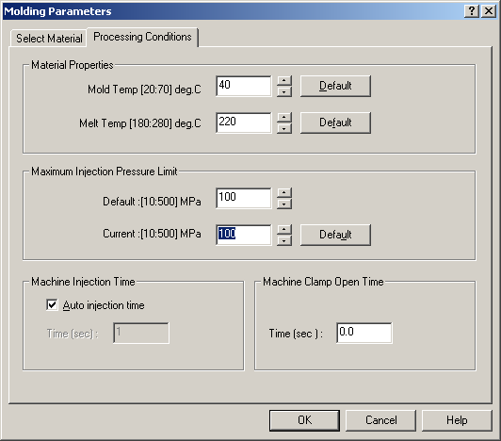

3. Pick Injection Position: (any location you like)

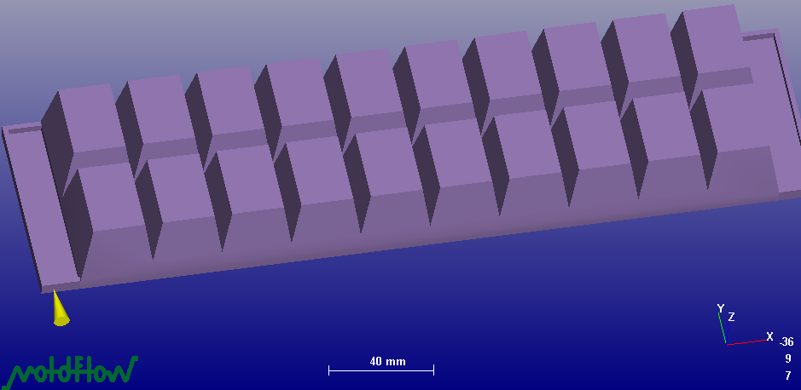

4. Analysis

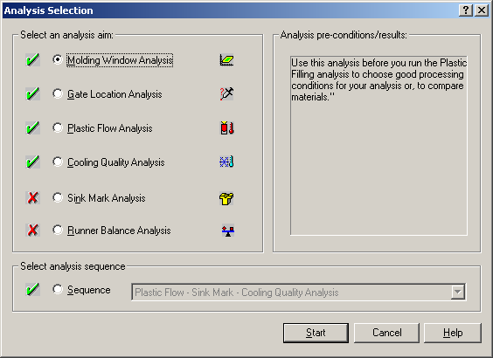

Select “Gloss” & get the Molding Window as below

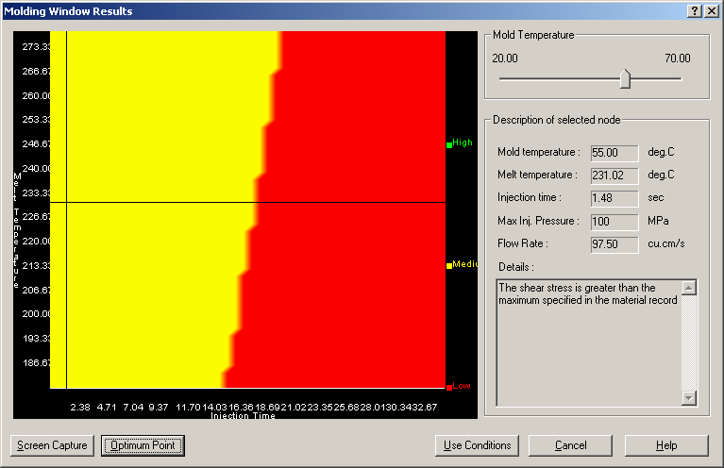

Click “Optimum Point” and Note “Mold Temperature, Melt Temperature, Injection Time and Maximum Injection Pressure”.
5. Run Analysis again and select following:

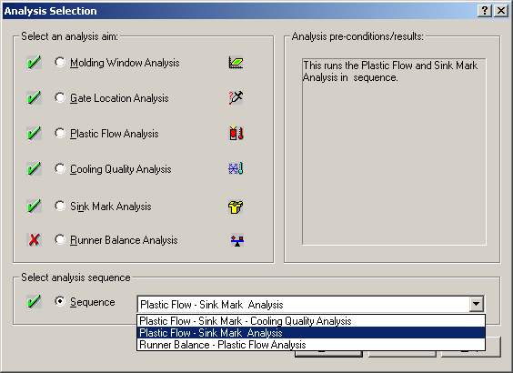

6. Results: Observe the following for the mold. - Flow Front Temperature, Confidence of Fill, Quality Prediction, Weld Line and Air Trap locations, and Sink Marks.

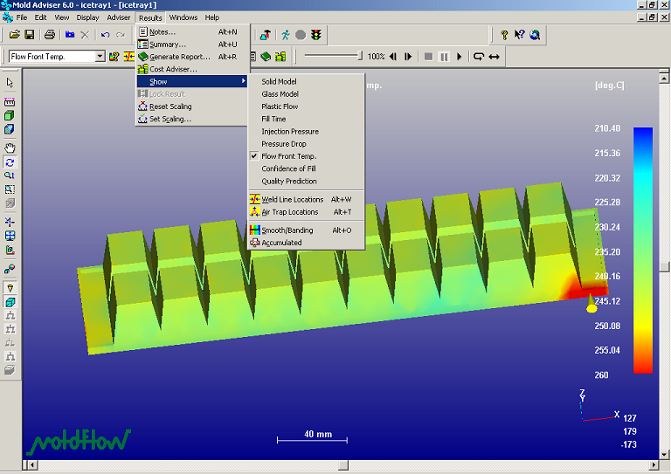
You can export these results to Spreadsheet.
If you have a large amount of areas with low quality (in Quality Prediction), you need to change the Injection location.

7. Repeat Analysis. For any given Mold Temperature, pick different Melt Temperature, Injection Time values from the Molding window (yellow part) to fulfill these conditions:

- The flow front temperature is more than 10 deg C below the melt temperature at the injection location.
- Short stop (Red part)

8. Present results as following (include screen captures, F2).

Material Name | Quantum GA564
Mold Temperature : | deg.C | 30 | 40 | 40
Melt Temperature : | deg.C | 259.59 | 220 | 220
Max Injection Pressure Limit : | MPa | 100 | 100 | 100
Actual Injection Time : | sec | 10.51 | 18.17 | 4.56
Actual Injection Pressure : | MPa | 44.16 | 50.72 | 64.17
Weld lines : |  | Yes | Yes | Yes
Air Traps : |  | Yes | Yes | Yes
Shot Volume : | cu.cm | 143.97 | 143.97 | 143.97
Clamp Tonnage : | tonne | 104.66 | 120.21 | 152.08
Estimated Cycle Time : | sec | 19.94 | 27.64 | 26.56
Material Density | kg/cm3 | 0.000948 | 0.000948 | 0.000948

