Fractal Aggregates in a Rubber Matrix
An example of the use of the connectivity dimension, minimum dimension and mass-fractal dimension.
(From Witten, T. A., Rubinstein, M., Colby, R. H. J. Phys. II France 3 367 (1993).)

Consider a system composed of a rubber with embedded, branched mass-fractal aggregates such as fumed silica or carbon black (Sketch below).

Figure 1.

We can use the connectivity dimension, C, minimum dimension d_{min}, and mass fractal dimension d_{f}, defined by:

(p/a) = z^{1/C} = (R/a)^{df/C} = (R/a)^{dmin} (1)

to estimate the modulus of the reinforced elastomer, G. z is the number of primary units in the aggregate, R is the aggregate size, a is the size of a primary unit, p is the number of primary units in a minimum path across the aggregate (shaded circles in Figure 1). For low volume fractions of aggregates, φ, the first two terms of a power-series expansion are often used in direct analogy to the viral expansion of viscosity to yield the intrinsic viscosity,

G = G₀ (1 + [G] φ) (2)

where [G] is the intrinsic modulus which accounts for the reinforcement due to the mass fractal aggregates. At higher volume fraction, aggregates can touch at a critical volume fraction, φ* (directly related to the primary particle density in the aggregate, ρ(R) = R^{df-3}),

φ* = (R/a)^{df-3} (3)

called the overlap concentration. Above this concentration the characteristic size is no longer related to the aggregate size but to a "screening" size related to the size of aggregates that would be at overlap at a given concentration,

ξ = a φ^{1/(df-3)} (4)

(4) indicates that aggregates with larger mass-fractal dimension, denser aggregates, display a larger screening size and that the screening size decreases with concentration, Figure 2.

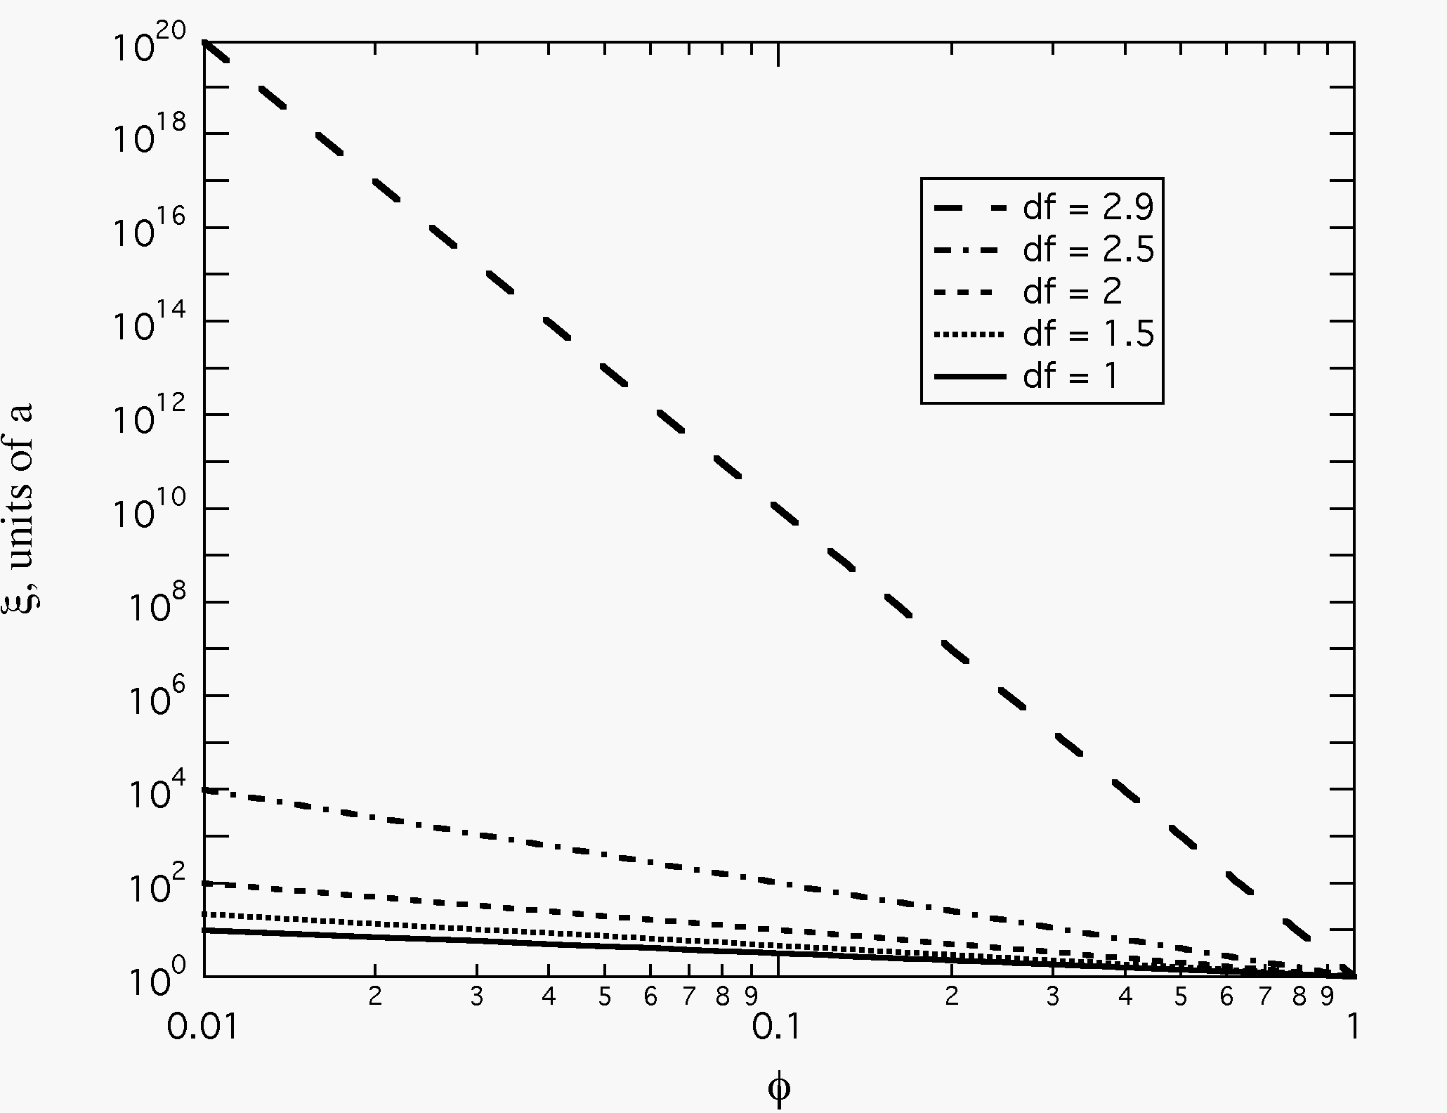
Figure 2.

Next we consider how the distribution of energy between aggregates and the elastomeric matrix in such a composite system can yield the reinforced modulus, following Witten.

Aggregate Mechanics:

The larger an aggregate grows the more flexible it becomes. This is closely related to the primary particle density of an aggregate which goes as,

ρ(R) ~ R^{df-3} (5)

Consider a minimum path across an aggregate, p, see sketch above. If such a path is strained to γ_{a}, we can consider the energy stored in this bent arm per length of the arm as being similar to the energy stored in a bent rod, U_{a},

U_{a} = E a³ γ_{a}²/p

Since the energy is the integral of σ dγ and assuming linear elasticity, σ = Eγ. Most of the energy stored in an aggregate will be stored in such bent minimum paths. The modulus for the aggregate is then related to the energy density per unit strain, per aggregate,

G_{a} = U_{a}/(V γ_{a}) = E (a³/R³) (a/p) = E (a/R)^{3+dmin} (6)

where a/p = (a/R)^{dmin} from (1). In (6), higher branching leads to a smaller d_{min}, and since a/R is a fraction, a larger G_{a} results. At equilibrium the stress on the aggregates must equal the stress on the rubber matrix,

G_{a} γ_{a} = G₀ γ₀ (7)

so the strain on the aggregate is given by,

γ_{a} = G₀/(E (a/R)^{3+dmin}) γ₀ (8)

where a/R is a fraction so a larger d_{min}, lower branching, leads to larger aggregate strain. From (8), small aggregates, small R, with large G_{a}, by equation (6), do not significantly deform and the stored energy is mostly that of the rubber matrix.

At a critical point the stored energy in the rubber matrix and the aggregates is equal, leading to a size-scale above which reinforcement ends, since the aggregates become weaker than the matrix at large sizes. This critical point can be found by setting the energy stored in the rubber, U_{R},

U_{R} = G₀ R³ γ₀³ (9)

equal to the energy stored in the aggregate at the same size scale, for unit strain,

U_{a} = G_{a} R³ γ_{a}³ = E (a/R)^{3+dmin} R³ γ_{a}³ (10)

and solving for R = ξ_{rigidity},

ξ_{rigidity} = a (E/G₀)^{(1/(3+dmin))} (11)

Aggregates larger than this size do not contribute to reinforcement. For higher branching, leading to lower d_{min}, the rigidity size increases. This is because branched aggregates have a higher modulus for a given size.

Above the overlap concentration, the blob size dominates, equation (4), and the reinforced modulus is given by the aggregate modulus at the blob size using (6) and (4), the so called Ball-Brown equation,

G = E (a/ξ)^{3+dmin} = E φ^{(3+dmin)/(3-df)} = G_{BB} (12)

Then the reinforced elastomer modulus is governed by both the fractal and minimum dimension of the aggregates as well as the intrinsic (primary-primary) strength of the aggregates, E.

Equation (12) indicates that the highest degree of reinforcement is seen for branched aggregates, low d_{min}, with low mass-fractal dimension, d_{f}.

