**Homework 14 (Two Questions)**

**Polymer Physics 2023**

**Seniors do not need to do this homework.**

**This homework should be done individually (NOT IN A GROUP)**

**You can choose to do the first problem only; or both problems. If you do both problems, then I will log two grades (unless you get less than a 90 on the second problem)**

**Due Thursday April 27 at noon**

(Please send an email with a **pdf** attachment to [beaucag@uc.edu](mailto:beaucag@uc.edu)

The file should be called: **HW 14 Last Name.pdf**)

**Question 1**

Machine learning (ML) has been proposed as an advantageous tool for dealing with multidimensional space and large data sets. Shen Z-H, Bao Z-W, Cheng X-X, Li B-W, Liu H-X, Shen Y, Chen L-Q, Li X-G, Nan C-W *Designing polymer nanocomposites with high energy density using machine learning* Nature Computational Materials **7** 110 (2021) describes a method for the design of polymer nanocomposite capacitors.

1. What are the advantages of the ML method for Shen’s study in terms of his conclusion in Figure 2 of the supplemental material. Consider that Osada M, Sasaki T *The rise of 2D dielectric/ferroelectrics* APL Materials **7** 120902 (2019) published a review article showing that Ca based perovskite crystals were useful dielectrics due to their sheet structures (Table 1). It is noted in the article by Shen that it was previously known that nanocomposites can overcome some problems with dielectric breakdown and dispersion at low concentrations of nanofiller and that it is known that the higher dielectric constant materials such as Ca perovskites will have better performance as capacitors.
2. Define some of the terms used by Shen on page 2: “inversely-design polymer nanocomposite”, “scoring function”, “back propagation neural network”. Explain in detail the scoring function used by Shen and how it is used in the scheme of Figure 4 (center of figure).
3. Xu H, Sheridan RJ, Brinson LC, Chen W, Jiang B, Papakonstantopoulos G, Polinska P, Burkhart C *Chapter 11 Data-Driven Multiscale Science for Tire Compounding: Methods and Future Directions* 281-312 in “Theory and Modeling of Polymer Nanocomposites” Eds. Ginzburg VV, Hall LM, Springer Series in Materials Science **310** (2021) discusses the use of data analytics and machine learning in the design of tires focusing on the tan *d* peak. Data analytics is used to construct representative volume elements (RVE) reflecting the microstructure and ML is used to reconstruct the interphase structure and the tan *d* peak. Xu first discusses a simple model for the tan *d* peak shown in figure 11.4. Explain how each of the prony series elements has an associated relaxation time, give the shape of G’ and G” and tan *d* in frequency at a fixed temperature from each of these elements and explain how a peak in tan *d* could be shifted with increasing filler content from the overall model.
4. Xu then uses the method of Deng (Deng H, Liu Y, Gai D, Dikin DA, Putz KW, Chen W, Brison LC, Burkhart C, Poldneff M, Jiang B, Papakonstantopoulos GJ *Utilizing real and statistically reconstructed microstructures for the viscoelastic modeling of polymer nanocomposites* Comp. Sci. Tech. **72** 1725-1732 (2012)) to account for microstructure from micrographs and the interphase from shifts in the tan *d* peak. Describe Deng’s method and compare it with X-ray scattering measurements that can generate a correlation function over five orders of size from 1 Å to 5 µm.
5. Xu describes filler in terms of loading percent, “dispersion”, and “geometry”. Consider that carbon black filler is a hierarchical structure composed of primary particles, aggregates, agglomerates, and a carbon agglomerate network on the millimeter scale, and that “dispersion” has different meanings on all these size scales as does “geometry”. Further, consider that the one parameter, tan *d* at a single temperature or frequency, strain amplitude and deformation geometry (shear strain) might not completely describe the behavior of a reinforced elastomer. For instance, how is tear resistance modeled with this approach, or the Mullins or Payne effects? Critique Xu’s simplification. How realistic/feasible is the scheme shown in Figure 11.20 in this context?

**Question 2**

Layered nanocomposites are common in the polymer literature but, so far, fairly rare in application. Volkswagen recently funded a study, published this week, Rolle K, Schilling T, Westermeier F, Das S, Breu J, Fytas G *Large Tg Shift in Hybrid Bragg Stacks through Interfacial Slowdown* <https://dx.doi.org/10.1021/acs.macromol.0c02818> where samples of monolayer and bilayer intercalated polymer in clay were used as shown in the graphic below.

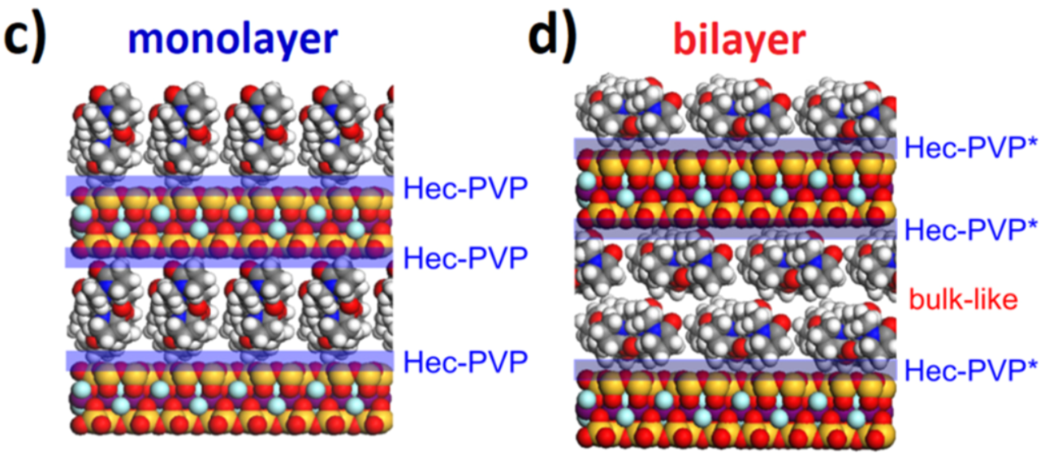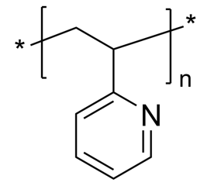

1. In the DSC traces of Figure 2, evidence is given for a single thermal regime in the monolayer sample and two thermal regimes in the bilayer sample. The monolayer thermal regime is referred to as *irreversibly adsorbed* (also called *Guiselin brush* or *bound rubber* for elastomer nanocomposites) and the other, that appears in the bilayer, *bulk-like*. Examine the plots of figure 2 and explain how the one and two regime models are supported.
2. Rolle studied P2VP polymer (shown above) intercalated in a synthetic clay mineral named fluorohectorite (Hec). The polymer has a “*contour length*” of 90nm (360 monomers) with *R*g = 13nm. The galley height for the monolayer is 1.3nm and for the bilayer 2nm. The lateral size of the Hec sheets is 340nm. What is the cause of the large shift in *T*g? Make a cartoon to support your reasoning. Can your cartoon indicate a reason for the observation of two thermal regimes in the bilayer samples?
3. Rolle obtained XPCS data (like dynamic light scattering data for X-rays) which resulted in the following decay curves and relaxation times. The data is taken at a diffraction peak associated with motion of the Hec layers. Explain what *g*2(*t*) is and how it can be used to obtain **.

1. Why is ** plotted against 1000/*T*? What can be obtained from this plot? On what assumptions does it rely? Do you think that the assumptions are appropriate for these clay layers? Rolle uses the following equation  with ** given as an inset to the **-plot above.
2. From the **-plot what can you say about the activation energy for motion in the two cases? Does the difference in ** values correlate with the shifts observed in *T*g?