Homework 1
Polymer Physics 2023
Due Tuesday January 16 at noon
(Please submit one pdf file per group on Canopy)

Li H, Lin Z, Chem Z, Cui Z, Lei L, Song B Wormlike micellar solutions formed by an anionic surfactant and a cationic surfactant with two head groups Soft Mat. Advance article https://doi.org/10.1039/D3SM01416A (2024) proposes the modification of a cationic surfactant by the addition of an extra quaternary amine head group to improve solubility and compounding with an anionic surfactant to achieve the structure shown in Figure 8 (right).
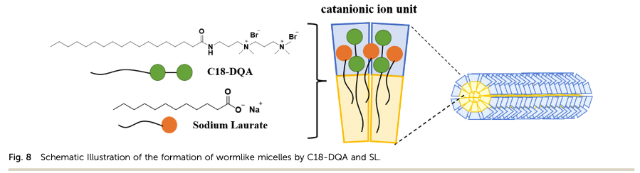
Li successfully produced worm-like micelles (WLMs) which they indicate will be of use in a variety of applications ranging from cosmetics to fracking fluids. (Tertiary amine surfactants have been linked to birth defects and allergic reactions.)

a) The nomenclature for surfactants is confusing. Find the structure for some of the molecules that Li mentions in the introduction and highlight the polar and non-polar parts. N1,N1,N1,N1,N3,N3,N3-pentamethyl-N3-(3- stearamidopropyl)propane-1,3-diammonium
bromide); sodium laurate; Gemini surfactants; tetradecyltrimethylammonium hydroxide; lauric acid; 1-hexadecyl-3- methylimidazolium bromide; sodium toluate; trans-cinnamate; N,N0 -bis(2-(dodecanoyloxy)ethyl)- N,N,N0,N0-tetramethyl-1,3-propane diammonium dibromide;
carboxylate surfactants; cetyltrimethylammonium bromide (CTAB); sodium decanoate; sodium oleate; octyl trimethylammonium bromide. You can paste the structure from a web search. The NIST webbook is a decent source for some of these compounds.

b) The detergent industry is interested in reducing the water in their products by producing highly concentrated detergents. When the detergent concentration is increased it precipitates out and forms various solid phases that cannot be easily dispensed. For this reason, compounds like sodium toluate and sodium benzenesulfonate (Ludigol) are added to maintain water solubility for surfactants like sodium laureth sulfate (an ether of SLS/SDS). Use Li’s scheme of Figure 8 to explain how these low molecular weight molecules might prevent precipitation in concentrated detergent solutions.

c) How does Figure 3 verify the presence of WLMs for ratios of C18-DQA to SL of 1.5 and concentrations above 50 mM? What structure do you expect for 1:1 and 20 mM? What about 1:1 and 50 mM? Many of the curves overlap within experimental error. What does it indicated if the curves overlap at different concentrations and different ratios?

d) Figure 5b shows the dependence of zero-shear rate viscosity on surfactant concentration. How is the zero-shear rate viscosity determined? Compare the observed behavior with that for a normal polymer solution. Speculate on the reason for the differences. Can the entanglement concentration be determined from this plot?

e) Figure 6 shows cryo-TEM micrographs of the WLM state for this system. How do these chains compare with the random walk simulation shown in class http://e.sci.osaka-cu.ac.jp/yoshino/download/rw/. Consider how the samples were prepared. Can you find evidence for chain ends, chain entanglement, and/or chain branching in these micrographs? How would branching impact the viscosity?

