**Homework 3**

**Polymer Physics 2024**

**Due Tuesday January 30 at noon**

**(Please submit one pdf file per group on Canopy)**

The persistence length of polymers can be determined rheologically, in scattering, and by computer simulations. Recently, Chan JM, Cordon JC, Wang M *Investigating the effects of the local environment on bottlebrush conformations using super-resolution microscopy* Nanoscale (in press DOI: 10.1039/d3nr05000a) (2024) have developed a technique to use fluorescent probes and optical microscopy to measure the persistence length of bottle brush polymers. Bottle brush polymers have structures like linear low-density polyethylene which has many short chains attached regularly on a main chain impacting crystallization and processing. More complex bottle brush polymers can be made by RAFT polymerization, Wang MQ, Zou H, LIU WB, Liu N, Wu ZQ *Bottlebrush Polymers Based on RAFT and the “C1” Polymerization Method: Controlled Synthesis and Application in Anticancer Drug Delivery* ACS Macro Lett. **11** 179−185 (2022). Chen uses ring-opening metathesis polymerization (ROMP) of norbornene monomers. One of the main intended applications for bottle brush polymers is drug delivery, where the side chains might contain bioactive units that seek out various cells, such as cancer cells or cells involved in the immune system, to deliver toxic agents specifically to those cells. Bottle brush molecules seem to be more effective than nano particles in this delivery mechanism. One impact of large side chains is a change in persistence length for the chains. This change might be impacted by the degree of solvation of the side chains. Chan is interested in polymers in the melt and in concentrated solutions such as in the biological environment.

a) Explain the microscopy technique discussed by Chan using a cartoon. You should reference another paper by Chan and a Nature review: Chan JM, Cordon JC, Zhang R, Wang M *Direct visualization of bottlebrush polymer conformations in the solid state* PNAS **118** e2109534118 (2021), and *Single-molecule localization microscopy* Nature Reviews (2021).

b) Chan uses a modified exponential function to fit the tangent–tangent correlation function C(s) to obtain the persistence length. Derive the original exponential function by assuming a linear dependence of the change in the chain correlation on the correlation to obtain a linear decay function as was done in class. Show how the persistence length is related to the Kuhn length using this exponential decay function (~slide 73 from the power point notes 1.ppt or .pdf on the webpage).

c) Comment on Chen’s modified persistence exponential function for which he cites: Baschnagel J, Meyer H, Wittmer J, Kulic ́ I, Mohrbach H, Ziebert F, Nam GM, Lee NK, Johner A *Semiflexible Chains at Surfaces: Worm-Like Chains and beyond* Polymers**8**286 (2016) equation 1 page 4. Baschnagel has no citation for equation 1. Equation 1 indicates that the observed chain persistence in 2D is twice the observed chain persistence in 3D for an unperturbed chain, that is the confinement doesn’t change the actual persistence length. Does this make any sense? (“Polymers” is an MDPI publication that is a publish for payment journal, essentially a not reviewed “predatory” journal. <https://www.linkedin.com/pulse/all-mdpi-journals-listed-predatory-christos-kontovas>, the title is close to an Elsevier journal “Polymer” that has been around for some time.)

d) A large part of Chan’s 2024 and 2021 papers argue that the chains are not perturbed by the severe confinement described in the materials and methods sections where they prepare the samples by spin coating 40 nm films on glass. (This issue probably came out in peer review.) They claim that the confined sample enables the 2D microscopy method to obtain the persistence length of a bulk 3D structure. Chains of 400g/mole (the backbone chain) have a contour length of about 0.5 micron and a random coiled size of about 50 nm. Persistence’s of about 250 nm are obtained by Chan for the bottle brush chains in these 40 nm thick samples. *Comment on the appropriateness of this sample preparation approach* considering Chan’s arguments and your own logic. Also, consider the original micrographs (Figure S9 in the 2021 paper supplemental) before removing “artifacts” from Chan’s 2021 supplemental file. He removes all the blue signal and only retains the yellow which he picks by hand before he does his rather elaborate conversion to linear chains and finally a calculation of the C(s) function. (It would have been nice if Chan had noted the fraction of signal that is arbitrarily rejected for all of his samples, i.e. does it change with solvent swelling. For instance, in Figure S9 he has rejected about 90% of the observed signal and chosen 10% to be “real chains”)

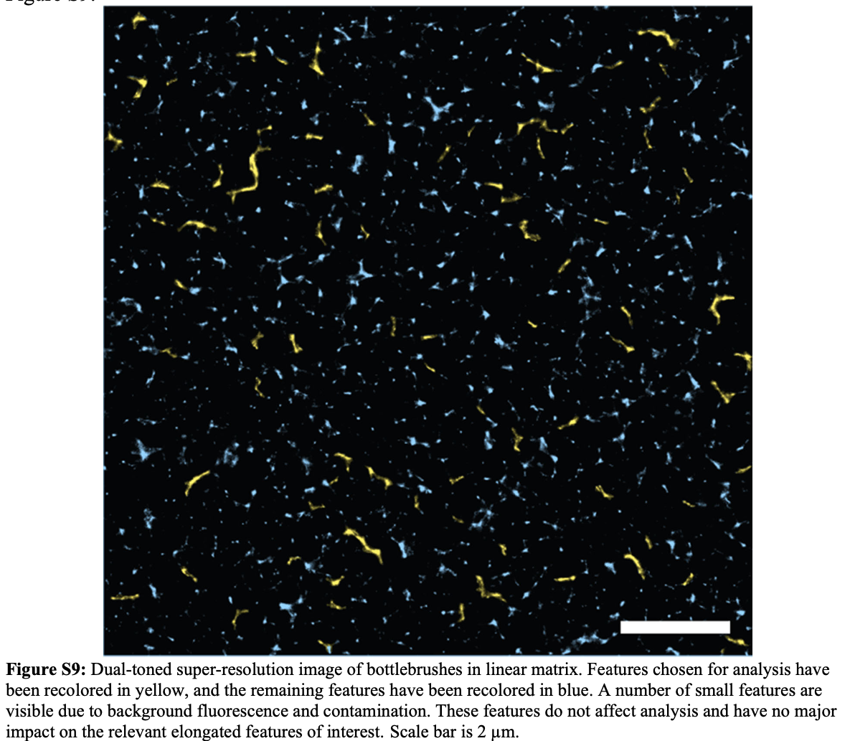

e) Chan observes changes in persistence when the films are swollen with toluene. Comment on the ability of a 40 nm film which is adhered to glass on one side to be uniformly swollen with hydrophobic toluene. Presumably, the films increase in thickness (since the lateral dimension is fixed) by 20 % in the swollen state of Figure 2. If the tagged chains were then more likely to be normal to the glass surface could this account for the observation of a 30 nm (10%) decrease in the observed persistence length? Draw a cartoon using the proper relative dimensions that either support or contradicts this idea.

