Homework 6
February 24, 2025
Polymer Physics

There has been interest in 2D polymers for about 15 years with the “discovery” of simple ways to produce aromatic carbon sheets, graphene, and graphene oxide, and also inorganic sheet structures like molybdenum disulfide (MoS2) or tungsten diselenide (WSe2), as well as more complex 2D structures. In theory, these structures might be used to produce sub-nanometer electronic devices, nano-machines, and special optical and sensor devices among other dreams. There has been some effort in the physics community to draw analogies between the phase and conformational transitions in linear polymers which we have briefly looked at and the transitions that occur in these 2D structures which include spontaneous crumpling and folding. Figure 1 below, from Jiang Y, Wang Y, Xu Z, Gao C Conformation Engineering of Two-Dimensional Macromolecules: A
Case Study with Graphene Oxide Acc. Mater. Res. 1 175−187 (2020) schematically shows the thought process.
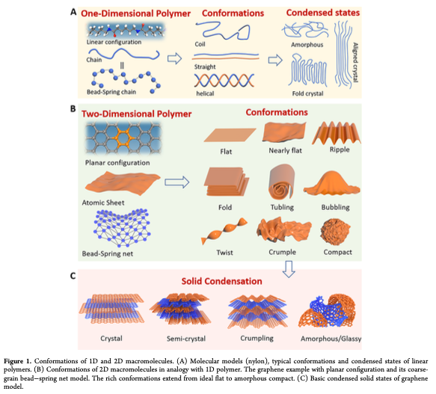
Xu J-Q, Shi R, Zhu Y-L, Lu Z-Y Folding behaviors of two-dimensional
flexible polymers J. Chem. Phys. 161 161101 (2024) use a coarse grain simulation (probably using LAMMPS) and Dissipative Particle Dynamics (DPD) to explore the crumpling and folding behavior of a square grid 2D structure with explicit solvent. Most previous studies have used “implicit solvent”, that is no solvent, to study similar systems and coarse grain molecular dynamics simulations. Xu finds that within a small range of interaction energies predictable, spontaneous, and complex folding behavior can be observed. From this behavior Xu constructs a “phase-diagram”.

- Xu’s supplemental gives an introduction to DPD simulations and Santo KP, Neimark AV Dissipative particle dynamics simulations in colloid and Interface science:a review Adv. Coll. Interf. Sci. 298 102545 (2021) gives more description. Explain why Xu uses DPD rather than MD for this study. Explain the difference between DPD and MD simulations. Why does he use a square grid rather than a hexagonal grid similar to graphene oxide? Does this impact the results? Coarse graining means that he groups many atoms but the thickness of most layered structures is one atom thick not a group of atoms thick, i.e. graphene is one carbon thick. Does this impact the simulation?
- Xu uses a scaling parameter ν and eigenvalues for the radius of gyration tensor to describe the phase behavior for different values of α_{PS}. For “good solvent” conditions, α_{PS}= 25,26,27 calculate the χ-parameter, the mass-fractal dimension, d_{f}, the minimum dimension, d_{min}, and the connectivity dimension, c. Do the same for the intermediate solvent condition, α_{PS}= 28,29,30. For the “poor-solvent” condition, α_{PS}= 31-35, calculate χ, and d_{f}. What are the values of d_{min} and c? (The potential energy between particles in DPD is given by U_{ij} = α_{ij}(r_{ij}²-r_{c}r_{ij}/3) and r_{ij} = 1 is a good rule of thumb so U_{ij} = α_{ij}/6 approximately in units of k_{B}T. α_{ij} is a repulsive force while the interaction energies in the χ-parameter are attractive like the van der Waals “a” so you need to take the negative of U_{ij} to use it in a calculation for χ.)
- In the context of this paper, what are the eigenvalues for the radius of gyration tensor? Are these parameters that could be experimentally determined? Xu uses a parameter “Q” to define six classes of folded and crumpled structures. Explain the value of Q for each of these six classes shown in Figure 3.
- Xu says that Figure 4 is a “phase-diagram”. Figure 4 is based on equation 7 which relates λ₃ to λ₁ λ₂ through k/γ which is related to α_{PS}, A₀ which is L², the size of the original 2D structure, and β = A₀/A where A is the area of the folded structure. The equation results in the curves shown in Figure 4. f in the plot is β. Explain how figure 4 can be used to predict “phase-behavior” in this system.
- For linear polymers three states are observed (so far), the θ or Gaussian state, or random walk, the expanded coil or self-avoiding walk described by Flory-Krigbaum, and the collapsed coil state which is a 3d object. What are the analogous states in Xu’s results? Compare d_{f}, d_{min}, and c for the three linear-polymer states with the values for Xu’s six classes in Figure 3.

