Homework 7
March 3, 2025
Polymer Physics

The study of polymer collapse is primarily motivated by molecular biology where the biological function of select biopolymers is governed by the process of chain collapse. The main examples are transcription of RNA, DNA folding, and protein folding. In the biological environment the collapse phenomena occur in the presence of “crowder” molecules which can be small (ions) or large (proteins) relative to the polymer Kuhn unit or relative to the expanded polymer chain size. This homework primarily involves three papers, a 2024 paper by a European group Chaboche Q, Campos-Villaobos M, Scolari VF A mean-field theory for predicting single polymer collapse induced by neutral crowders Soft Matter 20 3271-3282 (2024); a 2015 paper by a US/Korean group Kang H, Pincus PA, Hyeon, Thirumalai D Eﬀects of macromolecular crowding on the collapse of biopolymers Phys. Rev. Lett. 114 068303 (2015); and a 2016 Korean/Canadian paper Jeon C, Jung Y, Ha B-Y Eﬀects of molecular crowding and confinement on the spatial organization of a biopolymer Soft Matter 12 9436-9450 (2016) aka the “Ha Paper”. Kang proposed that the main feature that governs the influence of crowders on coil collapse is the ratio of the expanded coil radius of gyration R_{g}(0) and the distance between crowders, D = ≈(4π/3)^{1/3}σ_{c}φ^{−1/3} with σ_{c} the radius of the crowder. A term λ = R(0)/σ_{c} is the main parameter of Kang. Ha, on the other hand, indicates that the influence of crowders is local so that the main parameter of interest is a φ_{c}/a_{c}, where a is the Kuhn unit size of the chain, a_{c} is the crowder diameter (Kang’s 2σ_{c}), and φ_{c} is the crowder concentration (Kang’s φ) as shown in the figure below.
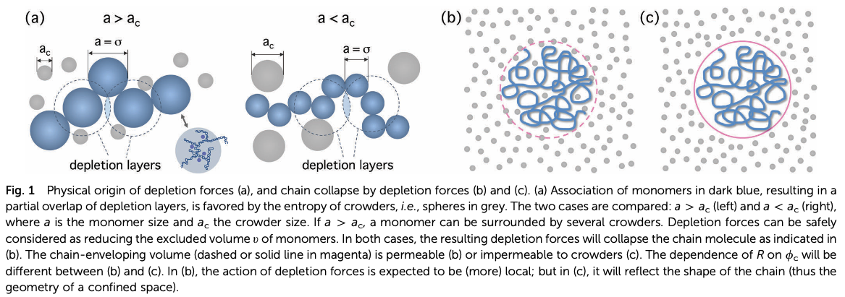
From Jeon et al. (“Ha paper”)
Chaboche intends to improve on the work of Ha by including the polymer molar mass, N, dependence on the collapse transition. Ha contends that there is a molecular weight dependence on the extent of collapse, R(φ)/R(0) = α, but not on the concentration of collapse, φ_{c}. Ha deals with this molecular weight dependence for free space, cylindrical space (like a chromosome) and in the space between two plates (annular space) the latter of which is the original theoretical basis for the “depletion effect”.

- Power Point slides 46 to 63 from class derive the description of coil collapse that is featured in two of the three papers, Jeon (Ha) equations 10-14, Chaboche’s equations 5 and 7. Derive equation 11 on slide 54 and relate it to the equations of Jeon and Chaboche noting and explaining the differences. Explain how these equations can explain first and second order transitions for coil collapse. In Jeon (Ha)’s Figure 5 explain how polymer molecular weight might impact the order of the collapse transition in crowded systems.
- Explain the “depletion effect” of the of the “Asakura–Oosawa theory”. What is osmotic pressure and what role does it play in polymer chain collapse. Why is this important to molecular biology? Explain Figure 1 from Ha which is shown above.
- Equation (2) of Chaboche has a log term that is absent from our discussion of the Hookean elasticity of a single chain. What is the origin of this term, why is it ignored in elasticity but included in coil collapse by Chaboche? Why is the D/b term included in equation (6)?
- Figure 3 of Ha shows almost perfect agreement for chain collapse as a function of the Ha parameter, x_{Ha}. Ha also describes the molecular weight dependence of coil collapse in Figure 5. The main point of Chaboche’s paper is to explain the molecular weight dependence that he shows in Figure 2. Does this seem to be a significant feature in these systems? Ha already describes the molecular weight dependence in his paper. What is Chaboche’s contribution beyond what was shown by Ha?
- Chaboche discusses “jammed solvent” at high crowder concentrations in Figure 5. Explain what a jammed solvent making note of Parisi G, Zamponi F Mean-field theory of hard sphere glasses and jamming Ref. Mod. Phys 82 789-845 (2010) (a paper with 850 citations). Does solvent jamming of crowders have any importance in biological systems?

