**Polymer Physics**

**HW 7**

**February 25, 2022 (Due March 1)**

Poly n-isopropyl acrylamide (PNIPAM) is a water-soluble polymer that displays an LCST. Fumihiko Tanaka made this polymer famous by producing gels which thermally collapsed at around body temperature (F. Tanaka *Polymer Physics Applications to Molecular Association and Thermoreversible Gelation* Cambridge University Press, Cambridge UK (2011)). In 1991 Howard Schild discovered that adding moderate amounts of methanol to PNIPAM in water caused linear chains of PNIPAM to collapse (similar to the ternary non-solvent from last week) while at higher concentrations of methanol it returned to an expanded coil (Schild H, Muthukumar M, Tirrell DA *Cononsolvency in Mixed Aqueous Solutions of Poly(iV-isopropylacrylamide)* Macromolecules **24** 948-952 (1991)). Tanaka later developed a theory to describe this co-nonsolvency depicted in Figure 1.17 of his textbook. In this figure, water and methanol hydrogen bond to the chain in separate regions isolated by hydrophobic collapsed globules. The model is almost identical to Tanaka’s model (in his book) for the helix to coil transition and draws strong resemblance to Grossberg’s later description of the coil to globule transition discussed in class though predating it by about 10 years.

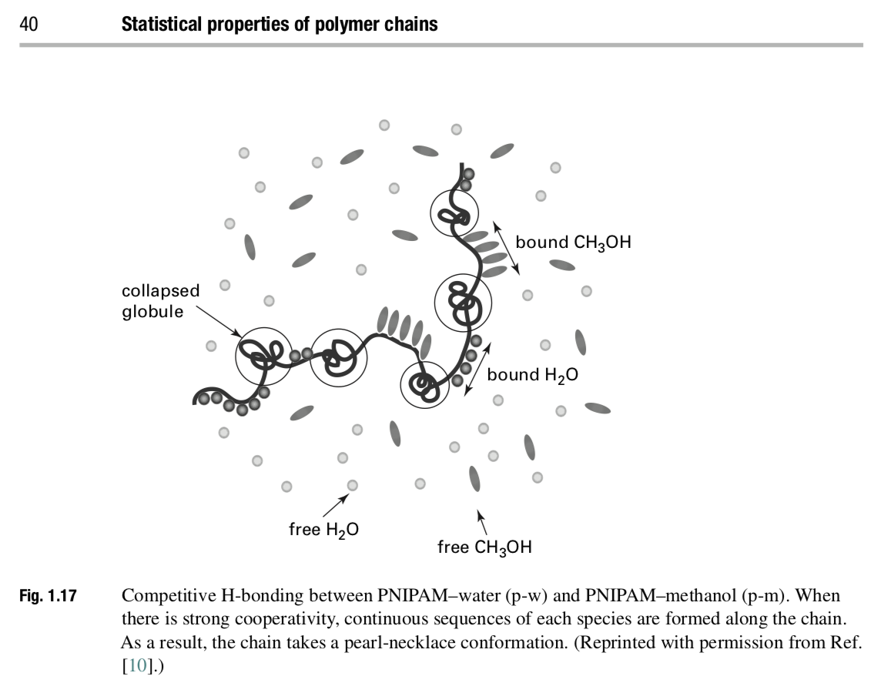 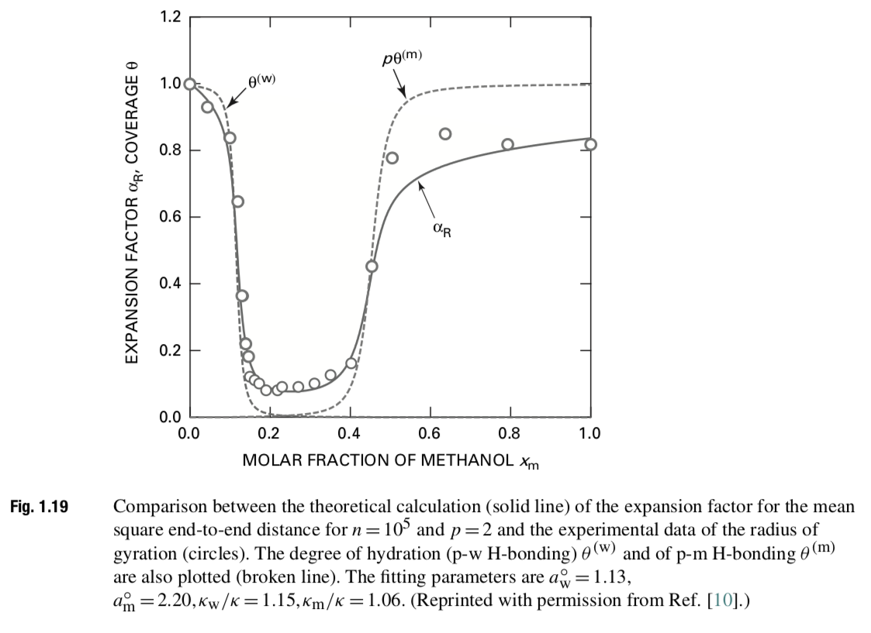

Recently Grinberg VY, Burova TV, Grinberg NV, Moskalets AP, Dubovik AS, Plashchina IG, Khokhlov AR *Energetics and Mechanisms of poly(N-isopropylacrylamide) Phase Transitions in Water−Methanol Solutions* Macromolecules **53** 10765−10772 (2020), performed high resolution DSC, and static and dynamic light scattering measurements on the PNIPAM/water/methanol ternary system in order to test Tanaka’s model. They formulate some new concepts associated with this system including the impact of the hydrophobic effect and water/methanol clathrate structure (things that Schild mentioned in 1991 as well as in his extensive review article of 1992 Schild H, *Poly(N-isopropylacrylamide): experiment, theory and application* Prog. Polym. Sci. **17** 163-249 (1992)).

1. Grinberg uses a microcalorimeter and references Privalov PL, Potekhin SA *Scanning microcalorimetry in studying temperature-induced changes in proteins* Methods in Enzymology **131** 4-51 (1986). Explain how a microcalorimeter works and explain the difference between a DSC and a DTA. Is Figure 1 of Privalov a DTA or a DSC? You can reference lab 5 of my Characterization class for more information on DSC.
2. Define the coil expansion factor shown in Tanaka’s Figure 1.19. How is the coil expansion factor expected to behave in the coil to globule transition region? Is the transition shown in Figure 1.19 first order or second order and why? What are first order and a second order transitions?
3. What is LCST phase behavior and what could cause it? How can it be described in the context of the Flory-Huggins equation and the Flory chi parameter?
4. Grinberg mentions several papers that introduce the concept of the organization of water. For instance, Zhang G, Wu C *The Water/Methanol Complexation Induced Reentrant Coil-to-Globule-to-Coil Transition of Individual Homopolymer Chains in Extremely Dilute Solution* J. Am. Chem. Soc. **123** 1376-1380 (2001) discusses in Figure 6 special stoichiometric structures that water and methanol can make. Comment on how these special structures could influence the free energy, particularly, in the context of the Flory-Huggins equation and the Flory chi parameter.
5. Zhang also shows a plot of *R*h/*R*g and density versus methanol content (Figure 5). Explain the importance of Figure 5 to demonstrating that a coil to globule transition occurs with changes in methanol content. Use Zhang’s text as a guide.
6. Grinberg mentions the hydrophobic effect as part of the PNIPAM/water/methanol story and cites section 5.2, p. 11-14 of Scheraga HA *My 65 years in protein chemistry* Q. Rev. Biophys. 48 117–177 (2015). Based on Scheraga’s paper and what is mentioned in the Grinberg paper explain what the hydrophobic effect is and what importance it has to the behavior of this system.

A book on clathrates and other gas hydrates is included in the references for this quiz on the webpage as are links to the other books that are mentioned.

**ANSWERS: Polymer Physics**

**Quiz 8**

**March 5, 2021**

1. *Define the coil expansion factor shown in Tanaka’s Figure 1.19. How is the coil expansion factor expected to behave in the coil to globule transition region? Is the transition shown in Figure 1.19 first order or second order and why? What are first order and a second order transitions?*

There are two definitions for the coil expansion factor that was used in class. Flory’s definition is similar to the characteristic ratio,  = R2/R02 where R2 is the squared end-to-end distance for an expanded coil due to long-range interactions and R02 is the same for a Gaussian coil. For Grosberg this is defined as 2.

For a first order transition there is a rapid decline,  is like density so there is a discrete step at a first order transition. For a second order transition there is a continuous change in  but a discrete change in d/dT. First and second order refer to the first and second order derivatives of thermodynamic parameters like enthalpy (heat of fusion) or volume.

1. *What is LCST phase behavior and what could cause it? How can it be described in the context of the Flory-Huggins equation and the Flory chi (or Hildebrandt omega) parameter?*

LCST is phase separation on heating. In the Hildebrandt/Flory approach it is observed when the interaction parameter,  or , displays an entropic part so it goes from B/T to A + B/T. For LCST B favors miscibility and is negative while A favors demixing and is positive. As temperature rises the contribution of B drops and the mixture separates. B is the enthalpic contribution and A is entropic. The entropic part is due to some type of organization or ordering of the material on mixing, such as the hydrophobic effect.

1. *Grinberg mentions several papers that introduce the concept of the organization of water. For instance, Zhang G, Wu C The Water/Methanol Complexation Induced Reentrant Coil-to-Globule-to-Coil Transition of Individual Homopolymer Chains in Extremely Dilute Solution J. Am. Chem. Soc.* ***123*** *1376-1380 (2001) discusses in Figure 6 special stoichiometric structures that water and methanol can make. Comment on how these special structures could influence the free energy, particularly, in the context of the Flory-Huggins equation and the Flory chi (or Hildebrandt omega) parameter.*

Chi is defined as z/kT so the average enthalpy of interaction of a lattice site per kT. The other part of the free energy of mixing is the entropy of mixing minus the sum of x/N ln(x) which is the combinatorial entropy of mixing, the entropy of arranging things randomly on mixing. There are other kinds of entropy that change on mixing. Here you have significant ordering of water and methanol, also the arrangement of water and methanol along the chain. So, the free energy needs another change in entropy term. That is called the non-combinatorial entropy. Usually it is a vague concept, here it is well defined in terms of the formation of a clathrate structure of methanol and water and the detailed structures shown in the JACS paper. Then Chi goes from the form B/T to the form A + B/T. where A is positive and increases the free energy on mixing so favors demixing and B is negative so decreases the free energy change on mixing and favors mixing. As temperature rises, the contribution of B decreases at some point -B = AT + DST and you have phase separation with heating or an LCST.

1. *Zhang also shows a plot of Rh/Rg and density versus methanol content (Figure 5). Though we haven’t discussed this in class, try to explain the importance of Figure 5 to demonstrating that a coil to globule transition occurs with changes in methanol content. Use Zhang’s text as a guide.*

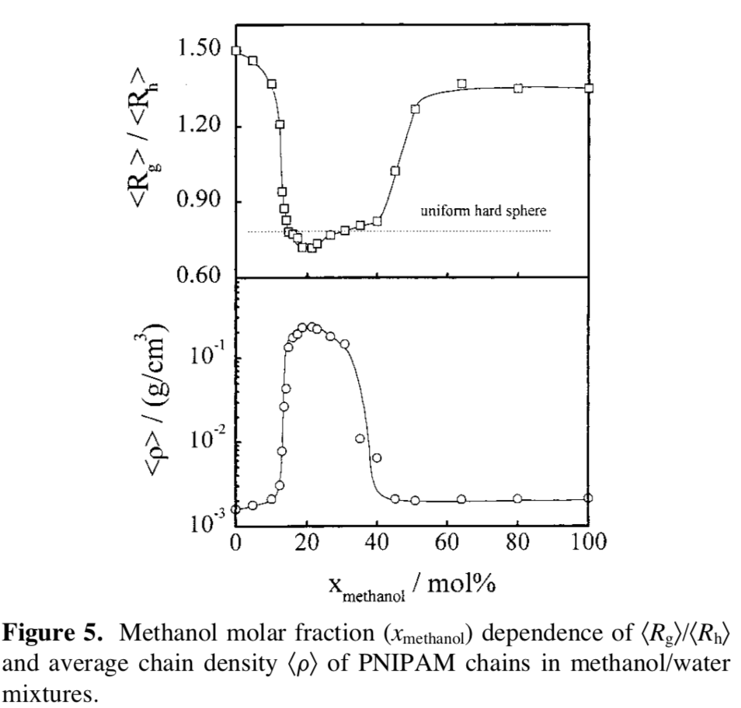

Rg and Rh have different dependencies on the actual size of a polymer chain. For a solid sphere Rh = Rsphere and Rg = √(3/5) Rsphere so the ratio is 0.775. For a Gaussian or expanded chain the calculation is more complicated. But the more expanded the fractal structure the larger the value. Zhang lists 1.5 as a value for the expanded coil. The coil is expanded in both water and methanol but the values differ, but are always larger than 1.

1. *Grinberg mentions the hydrophobic effect as part of the PNIPAM/water/methanol story and cites section 5.2, p. 11-14 of Scheraga HA My 65 years in protein chemistry Q. Rev. Biophys. 48 117–177 (2015). Based on Scheraga’s paper and what is mentioned in the Grinberg paper explain what the hydrophobic effect is and what importance it has to the behavior of this system.*

The part of this that could be confusing is that thermodynamics depends on the number of things that have kT energy not their size, and the number of things that have an interaction enthalpy. So you can think about a relatively large oil droplet and ignore the relatively small water molecules while the miscibility is largely determined by the organization of many little things in response to the oil droplet not by the large droplet. The presence of a protein or a PNIPAM macromolecule results in the organization of the water which reduces the entropy. The free energy is G = H -TS so a decrease in S makes G increase which is a bad thing in terms of miscibility. H in this case actually favors miscibilization. The normal case is that S is negative and given by minus R times the sum of xlnx where x is the mole fraction and lnx is always negative (or 0 for a pure component when x = 1). In this case the organization of water and methanol in clathrate structures complicates things a bit more. Anyway, it is good to have some idea of what is involved in these systems, for instance, to understand why ignoring water in simulations of proteins, polymers, and micelles could lead to large errors.