**Polymer Physics**

**Quiz 1**

**January 15, 2021**

In class it was mentioned that polymers can be defined in different ways from the perspective of chemists, rheologists (engineers), and physicists. Additionally, different aspects of polymers are observed in different arenas of application, chain folded crystals, shear thinning and normal force in flow, a large number of random conformations in simulations and modeling. Flory considered that all of these aspects relate back to a polymer’s “ability to assume an enormous array of configurations” (Flory PJ *Polymer Chemistry* Cornell University Press (1955)). This was demonstrated in class by running simulations of random walks.

1. Consider a program that generates random walks by taking random steps of equal length on a Cartesian lattice.   
   Plot the probability of an end-to-end distance, R, as a function of R.   
   What are the largest and smallest values of R?   
   What function describes this 2d curve to a fair degree accuracy?   
   What part of the actual curve does this function not describe?  
   What is the value for <R>?  
   What would be a reasonable measure of the average size of a polymer?
2. Polymer crystals differ from oligomers (intermediate molecular weight chains) due to chain folding. Lauritzen JI and Hoffman JD J. Res. Nat. Bur. Std. 64A 73 (1960) *Theory of Formation of Polymer Crystals with Folded Chains in Dilute Solution* derived a function that determines the thickness of polymer crystals based on their crystallization temperature. Hoffman and Lauritzen used an expression for the Gibbs free energy that included a surface term for the two surfaces of a lamellar crystal, where the last term is for the surface area and surface tension and the first term is for the bulk enthalpy of crystallization. At equilibrium for an infinite thickness crystal there is no surface and *G* = 0 so *S* = *H*/*T*∞. Derive the Hoffman-Lauritzen equation for polymer crystal thickness by setting *G* = 0 at the quasi-equilibrium point for a crystal crystallized at a temperature T (assume lateral size L (and A) is constant).
3. Sketch the log of viscosity versus log of rate of strain for a polymer melt and explain the behavior based on Flory’s statement concerning an enormous array of configurations. How can the viscoelastic relaxation time be determined from this plot?
4. Polymers form the basis of all known forms of life. Dimarzio (in Structure and Dynamics of Confined Polymers Eds. Kasianowicz JJ, Kellermayer MSZ, Deamer DW NATO Science Series Series 3 Vol 87 (2002) *Profound implications for biophysics of the polymer threading a membrane transition*) mentions that chemists consider that this is the case because, using the example of proteins, 20 amino acids arranged in a polymer of N units can display 20N arrangements, and “*the complexity of life lies in this arrangement*”. Dimarzio points out that,

*This argument is part of the answer, but the chemist is speaking of the variety contained in a homogeneous, isotropic bag of stuff. To get the variety of the spatial and temporal structures that one sees in life-forms one has to do some physics. We shall see that what is special about polymers are the 5 classes of phase transitions that occur only in polymers. They are the:*

*1) polymer threading a membrane transition,*

*2) helix to random-coil transition,*

*3) isolated polymer molecule attracted to a surface transition,*

*4) polymer collapse transition, and the*

*5) equilibrium polymerization transition.*

*These 5 transitions, unique only to polymers, along with the 5 other classes of transitions common to all materials (both polymeric and non-polymeric) provide a basis for understanding the self-assembled structures of biology.*

Consider DNA which is a polymer in the famous double helix conformation which folds into a chromosome with the assistance of various cellular apparatuses. DNA is read in the process of transcription where it is unfolded by enzymes in a transcription bubble of about 14 unzipped base pairs to produce messenger RNA which travels through the nuclear membrane to the ribosome to form proteins (very roughly). Try to mesh Dimarzio’s paragraph with the statement of “chemists” concerning 20N to explain the importance of a physical view of polymers.

1. Dimarzio goes through a complicated discussion of the importance of connectedness to the physical properties of polymers in the context of a polymer (such as a messenger RNA strand) transporting through the nuclear membrane compared to gas atoms leaking through a hole in the membrane. This is shown in Figures 1 to 3. For the polymer, transport across the membrane is a first order transition, that is the chain instantly ports through the membrane once two parts of the chain on either side can be identified, while the gas slowly leaks. Discuss why this might be important to transport of messenger RNA from the nucleus, where DNA resides, to the cytoplasm where ribosomes exist to manufacture proteins.

***ANSWERS: Polymer Physics***

***Quiz 1***

***January 15, 2021***

1. *Consider a program that generates random walks by taking random steps of equal length on a Cartesian lattice.   
   Plot the probability of an end-to-end distance, R, as a function of R.*

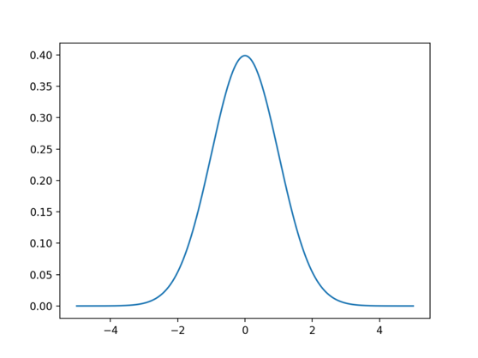

https://www.google.com/imgres?imgurl=https%3A%2F%2F3qeqpr26caki16dnhd19sv6by6v-wpengine.netdna-ssl.com%2Fwp-content%2Fuploads%2F2018%2F04%2FLine-Plot-of-the-Gaussian-Probability-Density-Function-1024x768.png&imgrefurl=https%3A%2F%2Fmachinelearningmastery.com%2Fstatistical-data-distributions%2F&tbnid=gGgY-PUpd9YbbM&vet=12ahUKEwjYodbp6KXuAhWaRc0KHdlBCCEQMygDegUIARDXAQ..i&docid=2RWXdBPRhjHagM&w=1024&h=768&q=gaussian&client=safari&ved=2ahUKEwjYodbp6KXuAhWaRc0KHdlBCCEQMygDegUIARDXAQ

*What are the largest and smallest values of R?*   
Largest is Nl, smallest and most probable is 0.  
*What function describes this 2d curve to a fair degree accuracy?*P(R) = K exp(-3R2/(22)) Gaussian function (Bell-shaped curve)  
*What part of the actual curve does this function not describe?*

It describes between -Nl and Nl. The Gaussian has a finite probability at R = ∞  
*What is the value for <R>?*  
<R> = 0  
What would be a reasonable measure of the average size of a polymer?  
<R2> which is 2 in the Gaussian function. RMS = <R2>1/2

1. Polymer crystals differ from oligomers (intermediate molecular weight chains) due to chain folding. Lauritzen JI and Hoffman JD J. Res. Nat. Bur. Std. 64A 73 (1960) *Theory of Formation of Polymer Crystals with Folded Chains in Dilute Solution* derived a function that determines the thickness of polymer crystals based on their crystallization temperature. Hoffman and Lauritzen used an expression for the Gibbs free energy that included a surface term for the two surfaces of a lamellar crystal, where the last term is for the surface area and surface tension and the first term is for the bulk enthalpy of crystallization. At equilibrium for an infinite thickness crystal there is no surface and *G* = 0 so *S* = *H*/*T*∞. Derive the Hoffman-Lauritzen equation for polymer crystal thickness by setting *G* = 0 at the quasi-equilibrium point for a crystal crystallized at a temperature T (assume lateral size L (and A) is constant).
2. *Sketch the log of viscosity versus log of rate of strain for a polymer melt and explain the behavior based on Flory’s statement concerning an enormous array of configurations. How can the viscoelastic relaxation time be determined from this plot?*

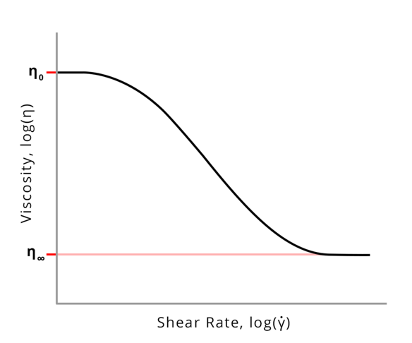https://en.wikipedia.org/wiki/Shear_thinning#/media/File:Shear_thinning_2.png

The polymer chain deforms in a shear field, it relaxes to the most random state driven by thermal fluctuations. When it is random the coil can be visualized as a symmetric object on average. The orientation of any asymmetry is in a random direction. Under shear any asymmetric polymers align with the shear field and symmetric chains deform. This reduces the number of entanglements in the melt and reduces the viscosity. The deformation and orientation of the chains that impacts the viscosity takes an average time, the viscoelastic relaxation time. This corresponds with the inverse of the rate of strain where the viscosity deviates from the Newtonian plateau at low strain rates.

1. Polymers form the basis of all known forms of life. Dimarzio (in Structure and Dynamics of Confined Polymers Eds. Kasianowicz JJ, Kellermayer MSZ, Deamer DW NATO Science Series Series 3 Vol 87 (2002) *Profound implications for biophysics of the polymer threading a membrane transition*) mentions that chemists consider that this is the case because, using the example of proteins, 20 amino acids arranged in a polymer of N units can display 20N arrangements, and “*the complexity of life lies in this arrangement*”. Dimarzio points out that,

*This argument is part of the answer, but the chemist is speaking of the variety contained in a homogeneous, isotropic bag of stuff. To get the variety of the spatial and temporal structures that one sees in life-forms one has to do some physics. We shall see that what is special about polymers are the 5 classes of phase transitions that occur only in polymers. They are the:*

*1) polymer threading a membrane transition,*

*2) helix to random-coil transition,*

*3) isolated polymer molecule attracted to a surface transition,*

*4) polymer collapse transition, and the*

*5) equilibrium polymerization transition.*

*These 5 transitions, unique only to polymers, along with the 5 other classes of transitions common to all materials (both polymeric and non-polymeric) provide a basis for understanding the self-assembled structures of biology.*

Consider DNA which is a polymer in the famous double helix conformation which folds into a chromosome with the assistance of various cellular apparatuses. DNA is read in the process of transcription where it is unfolded by enzymes in a transcription bubble of about 14 unzipped base pairs to produce messenger RNA which travels through the nuclear membrane to the ribosome to form proteins (very roughly). Try to mesh Dimarzio’s paragraph with the statement of “chemists” concerning 20N to explain the importance of a physical view of polymers.

1. Dimarzio goes through a complicated discussion of the importance of connectedness to the physical properties of polymers in the context of a polymer (such as a messenger RNA strand) transporting through the nuclear membrane compared to gas atoms leaking through a hole in the membrane. This is shown in Figures 1 to 3. For the polymer, transport across the membrane is a first order transition, that is the chain instantly ports through the membrane once two parts of the chain on either side can be identified, while the gas slowly leaks. Discuss why this might be important to transport of messenger RNA from the nucleus, where DNA resides, to the cytoplasm where ribosomes exist to manufacture proteins.