**Polymer Physics**

**Quiz 11**

**March 26, 2021**

In a recent paper, Li P, Wang S, Meng F, Wang Y, Guo F, Rajendran S, Gao C, Xu Z, Xu Z, *Conformational Scaling Relations of Two-Dimensional Macromolecular Graphene Oxide in Solution* Macromolecules **53** 10421-10430 (2020), used capillary viscometry to investigate the structure of graphene oxide in solution. Graphene is a 2d sheet of carbon which can be formed by chemical or mechanical exfoliation of graphite, or can be chemically synthesized. The first reported graphene was removed from graphite using scotch tape (Nobel Prize 2010 Geim and Konstantin https://www.bbc.com/news/science-environment-11478645). In chemical exfoliation a strong acid is used to partially oxidize the graphene layers making them soluble in water and in N, N-dimethylformamide (DMF) 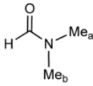 which is a common solvent for graphene oxide and other carbon materials. Li measures the solution viscosity of graphene oxide in DMF.

1. Li mentions the dimensional aspects of sheet structures and refers to them as 2d manifolds with reference to Nelson, Piran, Weinberg *Membranes and Surfaces* ref. [20, available on the webpage]. A manifold is a topological term referring to a structure that locally can be graphed or mapped in the same dimension as the object, for instance, a spherical surface, e.g. the globe, can be mapped with a 2d map for every point, even though the entire globe cannot be mapped with a 2d map without distortion. (This isn’t true at junction point of sheets such as in soap bubbles which are not 2d manifolds.) The contour length, *L*, for a sheet structure is similar to the contour length of a linear chain, the length walked along the contour of the sheet from one edge to the other. Li notes that reference [20] indicates that for a sheet, the radius of gyration is given by *R*g ~ *L*, and ** can have values of 1 for a rigid structure and 2/3 for fully crumpled structure. **Explain this statement.** For good solvents, * * = (2+*D*\*)/(2+*d*), where *D*\* is the connectivity dimension, *D*\* = 2 for a sheet, *D*\* = 1 for a linear polymer, and *d* is the spatial dimension. **Using this equation, what is *d*f for a sheet in a good solvent? Verify that df = 5/3 for a linear chain in a good solvent according to this equation.**
2. Li uses an Ubbelohde viscometer to determine the intrinsic viscosity. Describe how you would build an Ubbelohde viscometer, how the measurement is conducted, and how the intrinsic viscosity is determined from the measurements.
3. Figure 2b shows a linear plot of the specific viscosity versus concentration (below left). The figure below middle is a log-log plot of specific viscosity versus concentration for a polymer in a good solvent (from Colby, see class Power Point). *c*e is the entanglement concentration. Explain the difference between these two plots.
4. Figure 2c shows a plot of *c*\* versus *L* where *L* is the contour length of the graphene sheet. Relate *L* to the molecular weight of the sheet and *c*\* to the molecular weight of the sheet then find the relationship between the slope in the plot and the mass fractal dimension. Does the slope make sense?
5. Figure 3a, next page bottom, shows the behavior of intrinsic viscosity with molecular weight. Explain the value of the slope in this plot. What is *d*f for this material?

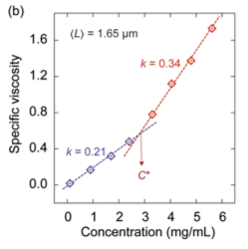 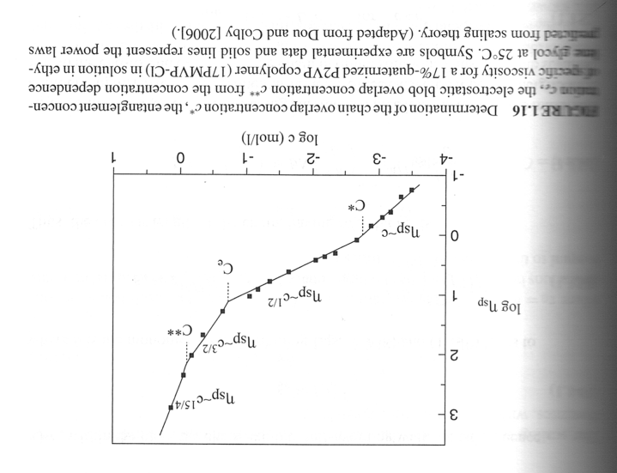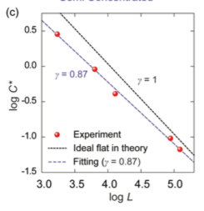

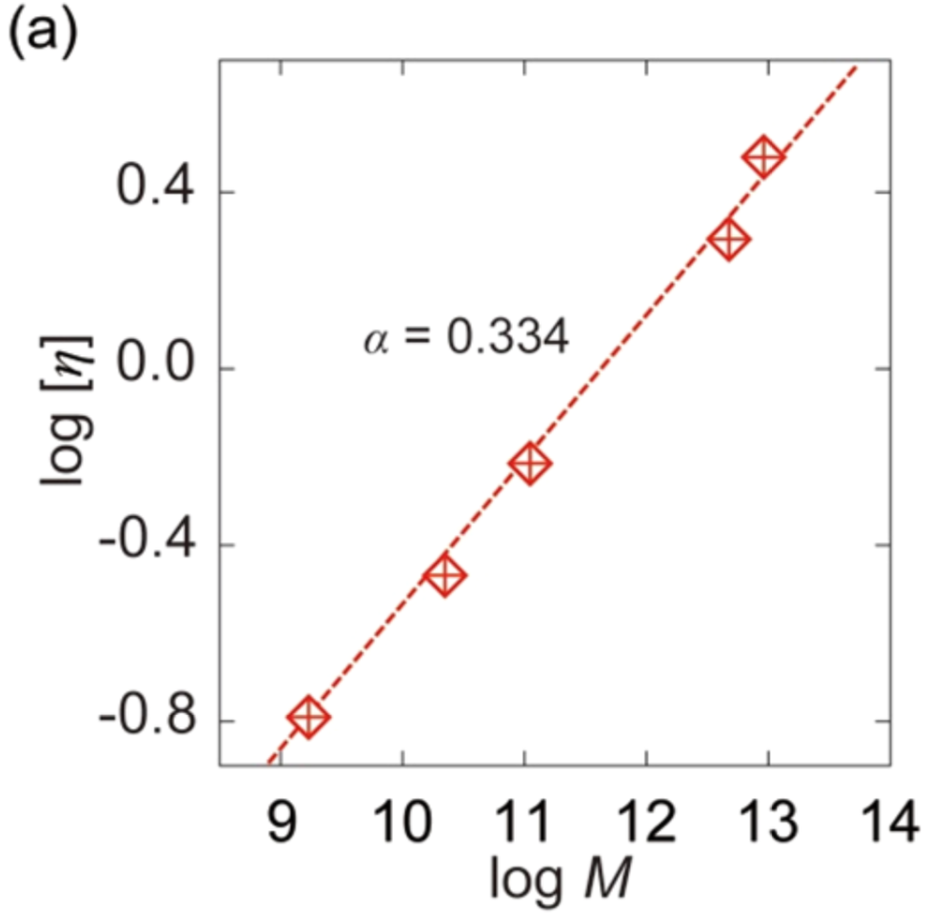

Figure 3a.

**ANSWERS: Polymer Physics**

**Quiz 11**

**March 26, 2021**

1. *Li mentions the dimensional aspects of sheet structures and refers to them as 2d manifolds with reference to Nelson, Piran, Weinberg Membranes and Surfaces ref. [20, available on the webpage]. A manifold is a topological term referring to a structure that locally can be graphed or mapped in the same dimension as the object, for instance, a spherical surface, e.g. the globe, can be mapped with a 2d map for every point, even though the entire globe cannot be mapped with a 2d map without distortion. (This isn’t true at junction point of sheets such as in soap bubbles which are not 2d manifolds.) The contour length, L, for a sheet structure is similar to the contour length of a linear chain, the length walked along the contour of the sheet from one edge to the other. Li notes that reference [20] indicates that for a sheet, the radius of gyration is given by Rg ~ L, and  can have values of 1 for a rigid structure and 2/3 for fully crumpled structure.* ***Explain this statement.*** *For good solvents,   = (2+D*)/(2+d), where D* is the connectivity dimension, D* = 2 for a sheet, D* = 1 for a linear polymer, and d is the spatial dimension.* ***Using this equation, what is df for a sheet in a good solvent? Verify that df = 5/3 for a linear chain in a good solvent according to this equation.***

For a rigid sheet, *R*g ~ *L* because the size of the sheet is *L*, *N* = *L*2, *R*g ~ *N*1/df ~ *L*2/df, and *d*f = 2 for a rigid sheet. For a collapsed sheet *d*f = 3 and *R*g ~ *N*1/3 ~ *L*2/3. For a sheet in good solvent the Flory equation yields 4/5. For a linear chain the equation yields 3/5 which agrees with the Flory-Krigbaum equation. However, the 3/5 is an approximation of 1/1.70 so, most likely, the 4/5 value is also an approximation.

1. *Li uses an Ubbelohde viscometer to determine the intrinsic viscosity. Describe how you would build an Ubbelohde viscometer, how the measurement is conducted, and how the intrinsic viscosity is determined from the measurements.*

To build an Ubbelohde viscometer you start with a glass tube, Blow out a bulb on each end, bend the tube into a U and draw out one side into a thin uniform and long capillary to diminish end effects. Two marks are made on the capillary above and below the bulb near the capillary. The capillary bulb is filled with solvent and the time to flow from the first line to the second line is measured. A solution of about 5 mg/ml is then used to fill the capillary bulb, just enough to fill the bulb. The time is measured again, then the solution is diluted 50% with solvent and the time is measured. If the second bulb is sufficiently large 5 dilutions can be made for 5, 2.5, 1.25, 0.625 and 0.3125 mg/ml. The reduced viscosity is calculated from (*t*-*t*solvent)/(*c* *t*solvent) and it is plotted as a function of concentration and extrapolated to *c* = 0 where the value is that of the intrinsic viscosity.

1. *Figure 2b shows a linear plot of the specific viscosity versus concentration (below left). The figure below middle is a log-log plot of specific viscosity versus concentration for a polymer in a good solvent (from Colby, see class Power Point). ce is the entanglement concentration. Explain the difference between these two plots.*

For the polymer the entanglement concentration and overlap concentration are different values. This may have to do with the types of interaction involved in entanglements (percolation across the bulk sample) versus local overlap for *c*\*. For the sheet structures, once there is local overlap, a network already forms that leads to a dramatic increase in viscosity, similar to the entanglement concentration.

1. *Figure 2c shows a plot of c* versus L where L is the contour length of the graphene sheet. Relate L to the molecular weight of the sheet and c* to the molecular weight of the sheet then find the relationship between the slope in the plot and the mass fractal dimension. Does the slope make sense?*

*c*\* ~ *N*/*R*3 ~ *N1*-3/*d*f and *N* = *L*2 so *c*\* ~ *L2*-6/*d*f

The plot shows *c*\* ~ *L*-0.87 so 2-6/*d*f = -0.87 or *d*f = 2.09. For the slope -1, *d*f = 2. *d*f = 2.09 is reasonable for a crumpled sheet.

1. *Figure 3a, next page bottom, shows the behavior of intrinsic viscosity with molecular weight. Explain the value of the slope in this plot. What is df for this material?*

The plot shows [**] ~ *N*0.334. [**] ~ 1/c* ~ *N*3/*d*f-1, so 3/*d*f-1 = 0.334 or *d*f = 2.25 which is also reasonable for a crumpled sheet structure. Neither of these values for *d*f agree with the expected value for a good solvent of 2.5.