**Polymer Physics**

**Quiz 12**

**April 2, 2021**

Orski SV, Kassekert LA, Farrell WS, Kenlaw GA, Hillmyer MA, Beers KL *Design and Characterization of Model Linear Low-Density Polyethylenes (LLDPEs) by Multidetector Size Exclusion Chromatography* Macromolecules **53** 2344-2353 (2020) synthesize model linear low-density polyethylene (LLDPE) which has no long-chain branching and regularly spaced short branches of controlled length by ring-opening metathesis polymerization. These polymers have exactly one branch for eight main-chain carbons since they are synthesized from cyclic octene with substituents such as ethylene-stat-1-octene for a C2 branch. They make linear PE, C1, C2, C4, C6 and C10 polymers. The process involves hydrogenation of double bonds after polymerization. The materials are characterized by size-exclusion chromatography using multiple detectors: index of refraction (concentration); viscosity ([**]); light scattering (*R*g, *M*w); IR (number of CH3 end groups reflecting branch ends).

1. The introduction discusses various techniques that are used to characterize topology and chemical composition in high pressure chromatography. A referenced paper [12] by Chatterjee et al. (Chatterjee T, Rickard MA, Pearce E, Pangburn TO, Li Y, Lyons JW, Cong R, DeGroot AW, Meunier DM, *Separating effective high density polyethylene segments from olefin block copolymers using high temperature liquid chromatography with a preloaded discrete adsorption promoting solvent barrier* J. Chrom. A **1465** 107-116 (2016).) describes a new technique to separate olefin block copolymers (such as octane branched and linear PE) in a mixture of linear HDPE and BCPs using a plug of fluid in the chromatograph stream that was impenetrable to HDPE but allowed the BCP to pass. Chatterjee’s introduction gives a good description of the difference between SEC and HPLC. Read that introduction and the introduction of Orski et al. and describe the difference between SEC and HPLC in terms of entropic and enthalpic selection.
2. Figure 3 of Orski et al. shows a plot of [**] versus molecular weight. For each sample a large number of molecular weights can be studied since, due to size-exclusion, the SEC separates chains by size in the time of elution. Each measurement at a given elution time is for a monodisperse fraction, so *M*v = *M*w = *M*n. Figure 3’s main point is that the intrinsic viscosity drops with the length of the branches. Explain why this might be the case. Write a function that could describe this dependence. Comment on the slope “a” in these curves which are listed in Table I.
3. The slopes in Figure 3 indicate that short chain branching does not impact long-range interaction, i.e chain scaling. We know that short chain branching does affect short-range interactions, i.e. Kuhn length, from experiments and from many computer simulations, some of which we have looked at in previous quizzes. Does the Kuhn length impact: the coil density; [**]; *R*h; *R*g; *M*w; *c*\*?
4. Figure 4 shows the “viscometric contraction factor” *g*’. (This term is better described in a paper by De Luca E, Richards RW, *Molecular Characterization of a Hyperbranched Polyester. I. Dilute Solution Properties* J. Polym. Sci. B **41** 1339-1351 (2003).) Explain what *g*’ reflects. For instance, what does a value of 0.6, seen in Figure 4, indicate?
5. In Figure 5 of Orski et al., and in Figure S19 of the supporting information file, the high molecular weight fractions at high branch lengths of 4, 6 and 10 show a negative deviation from the power-law. What causes this deviation? Does it make sense that this deviation would only appear at high molecular weights and for long branches?

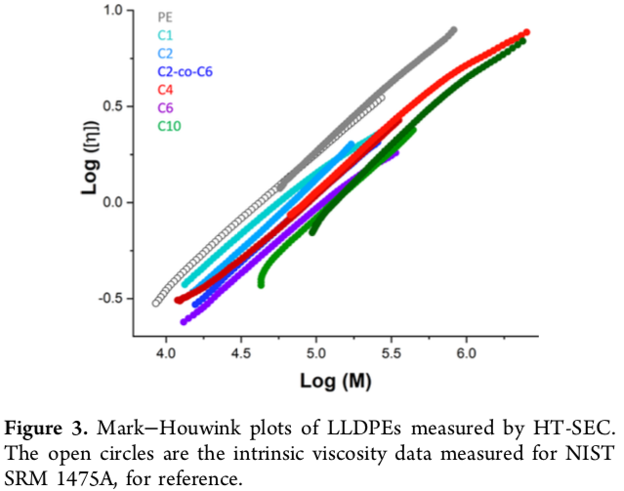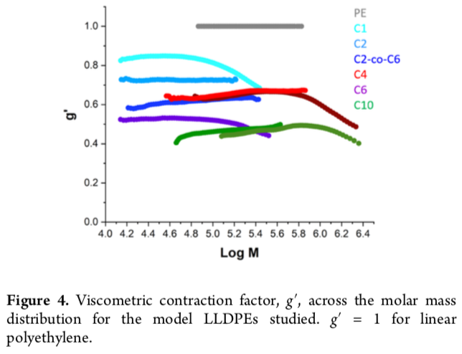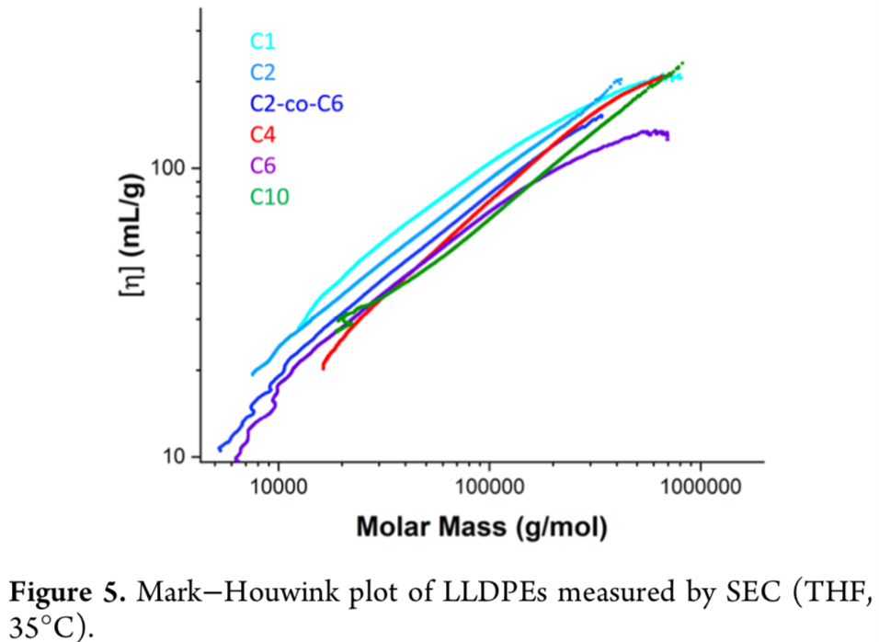 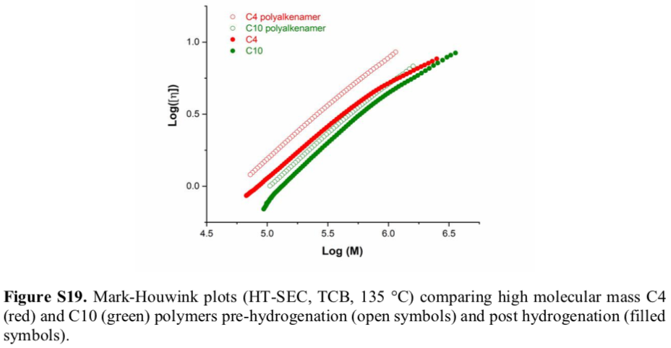

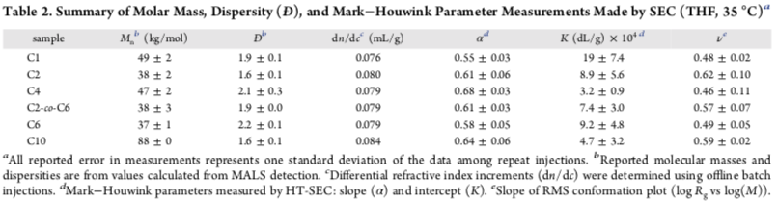

**ANSWERS: Polymer Physics**

**Quiz 12**

**April 2 2021**

1. *The introduction discusses various techniques that are used to characterize topology and chemical composition in high pressure chromatography. A referenced paper [12] by Chatterjee et al. (Chatterjee T, Rickard MA, Pearce E, Pangburn TO, Li Y, Lyons JW, Cong R, DeGroot AW, Meunier DM, Separating effective high density polyethylene segments from olefin block copolymers using high temperature liquid chromatography with a preloaded discrete adsorption promoting solvent barrier J. Chrom. A* ***1465*** *107-116 (2016).) describes a new technique to separate olefin block copolymers (such as octane branched and linear PE) in a mixture of linear HDPE and BCPs using a plug of fluid in the chromatograph stream that was impenetrable to HDPE but allowed the BCP to pass. Chatterjee’s introduction gives a good description of the difference between SEC and HPLC.* ***Read that introduction and the introduction of Orski et al. and describe the difference between SEC and HPLC in terms of entropic and enthalpic selection.***

SEC means size-exclusion chromatography. It involves a porous material on the size scale of the molecules which are being separated. Small molecules fit in the pores and follow a diffusive path through the column structure emerging from the column at long retention times, large molecules do not fit and follow a ballistic path through the column emerging in short retention times. There is no interaction between the molecules and the column except for the random diffusive motion. This random motion is a signature of thermally driven diffusive motion associated with entropy. Liquid chromatography involves some type of enthalpic interaction between the column material and the molecules which slows their passage through the column. This kind of enthalpic interaction is selective by chemical species and not by size. Many other types of interaction are mentioned in the introductions such as crystallization of a polymer in the column followed by raising the temperature to release low melting then higher melting point polymers (temperature rising elution fractionation TREF) and the use of a plug of non-solvent for HDPE to slow the elution of HDPE compared to block copolymers enabling their separation even if they have similar molecular weights.

1. *Figure 3 of Orski et al. shows a plot of [] versus molecular weight. For each sample a large number of molecular weights can be studied since, due to size-exclusion, the SEC separates chains by size in the time of elution. Each measurement at a given elution time is for a monodisperse fraction, so Mv = Mw = Mn. Figure 3’s main point is that the intrinsic viscosity drops with the length of the branches.* ***Explain why this might be the case. Write a function that could describe this dependence. Comment on the slope “a” in these curves which are listed in Table I.***

[**] is proportional to the inverse of the density of a polymer coil, 1/*c*\*. For a chain that has the same scaling (slope of the lines in Figure 3) adding short chain branches would make the chains denser so [**] should drop. If we can assume that the chain scaling remains constant, then an expression for [**] with branch length can be written,

[**] = *V*/*Mass* = *M*3/*d*f-1. Here the volume is constant since the slope is constant in Figure 3 so only the mass is changing, not the scaling. So   
[**]SCB = [**]Linear MLinear/(MLinear + {MLinear/(8 MMonomer)} (C#)MMonomer)  
 = [**]Linear/(1 + C#/8)  
where {MLinear/(8 MMonomer)} is the number of branches in a chain, C# is the number of carbons in a branch. Here a monomer is a single methylene unit.

|  |  |  |  |  |  |  |
| --- | --- | --- | --- | --- | --- | --- |
|  | C0 | C1 | C2 | C4 | C6 | C10 |
| Enhancement Calculated | 1 | 0.889 | 0.8 | 0.667 | 0.571 | 0.444 |
| Enhancement Measured From MH K values | 1 | 1.53 | 0.67 | 1.24 | 0.724 | 0.36 |
| Estimated From  Figure 4 | 1 | 0.84 | 0.71 | 0.65 | 0.53 | 0.44 |

There isn’t a very good correlation between the model and the measurement for the Mark Houwink K values. These measurements seem to be fluctuating with no trend. The ratio of intrinsic viscosity plotted in Figure 4 is more monotonic in branch length and the values are almost exactly what the model suggests.

1. *The slopes in Figure 3 indicate that short chain branching does not impact long-range interaction, i.e chain scaling. We know that short chain branching does affect short-range interactions, i.e. Kuhn length, from experiments and from many computer simulations, some of which we have looked at in previous quizzes.* ***Does the Kuhn length impact: the coil density; []; Rh; Rg; Mw; c*?***

In the extreme that the chain becomes a rigid rod compared to a flexible coil everything except the molecular weight would be impacted by persistence. Further, it is simple to measure the persistence length using neutron scattering or viscometry. So it is rather odd that the persistence length wasn’t examined here given that NIST has its own neutron scattering facility and ample rheometry equipment. In any case, the results from Figures 3 and 4 mentioned in question “b” seem to indicate that there is no impact on the persistence length due to these branches every 8 carbons. Possibly, there is sufficient space to accommodate the branches which are 10 or shorter carbons in this space. This would seem to be something worth noting.

1. *Figure 4 shows the “viscometric contraction factor” g’. (This term is better described in a paper by De Luca E, Richards RW, Molecular Characterization of a Hyperbranched Polyester. I. Dilute Solution Properties J. Polym. Sci. B* ***41*** *1339-1351 (2003).) Explain what g’ reflects. For instance, what does a value of 0.6, seen in Figure 4, indicate?*

The analysis of part “b” shows that *g*’ reflects the mass added to the chain by the branches in this case. Normally it would reflect changes in the chain scaling and size due to addition of branches. The concept of *g*’ was developed for long chain branches so it is not really appropriate here, though it seems useful for the proposed equation in part “b”.

1. *In Figure 5 of Orski et al., and in Figure S19 of the supporting information file, the high molecular weight fractions at high branch lengths of 4, 6 and 10 show a negative deviation from the power-law. What causes this deviation? Does it make sense that this deviation would only appear at high molecular weights and for long branches?*

This is described in the text. Polyethylene is subject to hydrogen abstraction, which means that hydrogens are removed from the chain leaving free radicals. Free radicals search out double bonds or other free radicals forming long chain branches. This is common in polyethylene, even in a melt extruder or pelletizer. Here, the authors note that they have put in a sizable amount of anti-oxidant which scavengers free radicals (just like vitamin C and other free radical scavengers in our bodies). So they are surprised to see this increase in density, decrease in [**] at high molecular weights. The behavior is more prominent in the supplemental Figure S19.