**Polymer Physics**

**Quiz 13**

**April 9, 2021**

Polycarbonate is used for bullet proof windows and for windows in airplanes where a transparent material that can withstand a high velocity impact is needed.

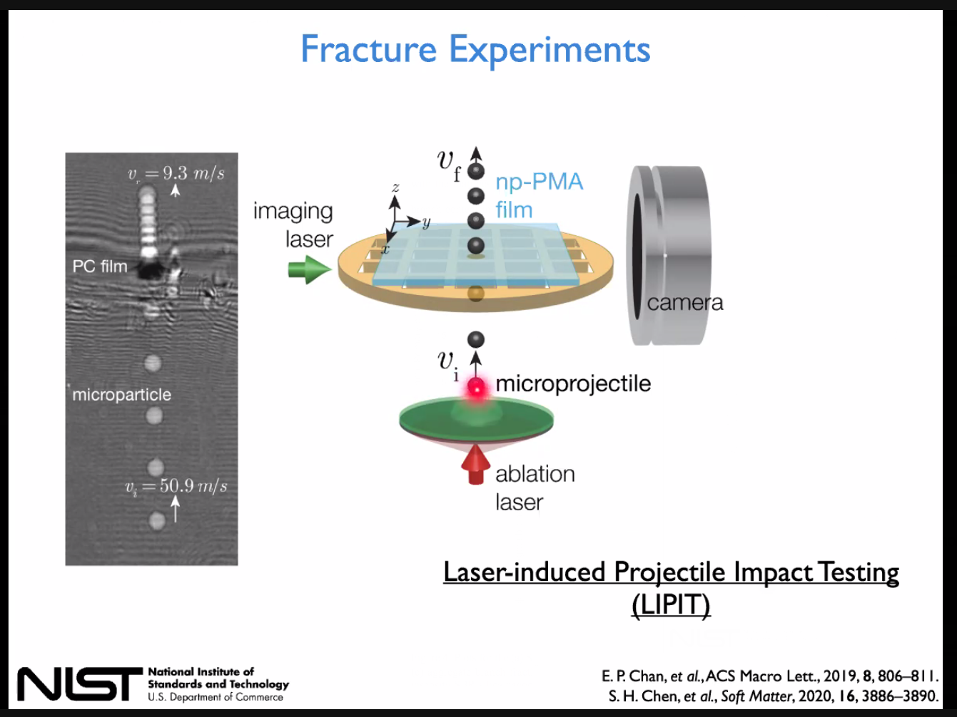

1. b)

*a) Diagram showing layers of surface treated (polyvinyl butyral) glass and polycarbonate. Polyvinyl butyral prevents the formation of surface cracks in the glass layers. b) High speed impact tests are preformed using laser-induced projectile impact testing (LIPIT) where a pulsed laser ablates (vaporizes) a substrate supporting a microprojectile which is launched at 100m/s (225 mph) at the sample and strobe photographs are taken to determine the speed of the projectile before and after impact. Analysis of the plastic sample post impact are used to determine the mechanism of failure.*

Chris Soles form the National Institute of Standards and Technology (NIST) presented a paper at the ACS Spring Meeting using quasi-elastic neutron scattering to relate molecular relaxation to the impact energy observed in LIPIT measurements for polycarbonate. [Soles CL, Burns AB, Ito K, Chan EP, Douglas JF, Wu J, Yee AF, Shih Y-T, Huang L, Dimeo RM, Tyagi M, *Why Enhanced Subnanosecond Relaxations Are Important for Toughness in Polymer Glasses*, Macromolecules **54** 2518−2528 (2021). This paper was presented at the ACS Spring meeting 2021 as *Polymers for impact mitigation: New measurements provide insights into an old problem.* In the session *Fundamentals of Polymer Mechanics.*]

Soles used quasi-elastic (QENS) and inelastic (IENS) neutron scattering to correlate observed relaxations with the brittle to ductile transition (BDT) observed in the LIPIT measurement. Brittle behavior below the BDT is associated with the so called “Boson” peak related to inelastic interactions (quantized absorption of energy) from glassy vibrational modes in IENS which can also be observed in heat capacity versus temperature (reflecting deviations from the Einstein *T*3 behavior) and from optical Raman/Brillouin scattering. Above the BDT, ductile behavior is associated with quasi-elastic broadening of the elastically scattered peak (no energy loss). Figure 1 from Soles shows the three components to the quasi-elastic/inelastic scattering, the elastic peak, red, the inelastic broadening, purple dashed, and the inelastic quantized Boson peak, blue.

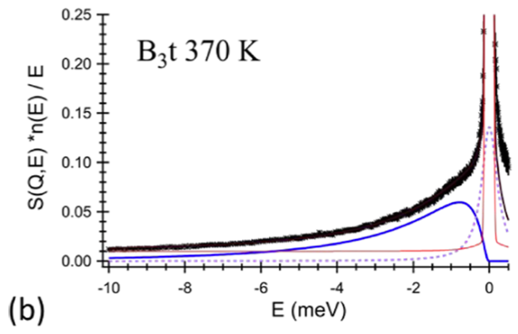 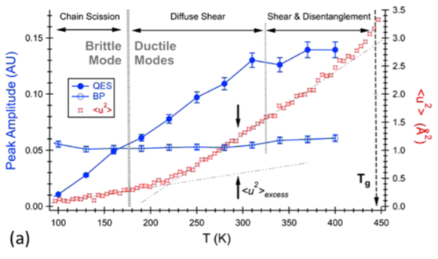

Figure 1 b Figure 3a

1. Soles studied the Boson vibration using Brillouin light scattering (BLS) which supports the QENS and IENS measurements. BLS and Raman scattering both measure quantized (fixed energy) atomic-scale vibrations (phonons). Briefly describe what these two techniques (BLS and Raman) are and how they differ. A Google search is probably sufficient. Soles also gives some description.
2. Soles equation (1) is of the same form as Guinier’s Law, a Gaussian curve in q.   
   In this case *q* reflects the energy since 1/** ~ h** ~ *E* (for light but similar for neutrons), and *q* = 4**/** sin(**/2). Look at the Wikipedia page for Debye-Waller Factor and explain the origin of the Debye-Waller Factor and how this equation differs from Guinier’s Law.
3. When dynamic light scattering (DLS) was developed it was in direct competition with quasi-elastic light scattering (QELS). Explain how these two techniques differ (QELS is similar to QENS used in this paper but for colloidal motion rather than molecular motion). How is the relaxation time, ** (or diffusion coefficient *D* or hydrodynamic radius, *R*H), from DLS related to the mean square displacement <*u*2> from QELS?
4. Soles Figure 3a shows the relative contribution of inelastic and quasi-elastic vibrations in polycarbonate compared to LIPIT mechanical observation of the brittle to ductile transition. How does this plot explain the behavior in polycarbonate?
5. In Brillouin scattering, longitudinal vibrations involve compression and transverse modes involve shear. From the velocities of these vibrations from the Brillouin scattering measurement Soles determines Poisson’s ratio which is the ratio of the lateral to the axial deformation in compression. For an incompressible material like a gel or a liquid ** = 0.5, for a compressible material like a foam or cork or an accordion ** = 0. * *increases from about 0.375 (similar to glass) to about 0.4 (similar to gold) in Figure 3b. Explain why ** correlates with mean square displacement, <*u*2>.

**ANSWERS: Polymer Physics**

**Quiz 13**

**April 9 2021**

1. *Soles studied the Boson vibration using Brillouin light scattering (BLS) which supports the QENS and IENS measurements. BLS and Raman scattering both measure quantized (fixed energy) atomic-scale vibrations (phonons). Briefly describe what these two techniques (BLS and Raman) are and how they differ. A Google search is probably sufficient. Soles also gives some description.*

Both techniques look at the spectrum (intensity versus wavelength, wavenumber, or energy) for a scattered wave at a value of *q* or **. Light scattering is related to the polarizability (mobility of electrons). This differs from absorption (IR spectroscopy) which is related to polarity. For instance, aromatic or conjugated materials like graphene are highly polarizable (Raman and Brillouin scattering sensitive) but have no signal for IR absorption, while water, being polar, has a strong IR signal but no signal in Raman or BLS. Both Raman and BLS look at the doppler effect, where a scattered wave can have energy removed (Stokes line) or added (anti-Stokes line) due to a quantized vibration of the material on the order of the energy of the scattered beam. For Raman the quantized energy is absorbed/added from bond vibrations in a material like an organic molecule. For BLS the quantized energy is absorbed/added from lattice vibrations (phonons) in a crystal. So the techniques are essentially identical but the samples differ. If you apply BLS to glassy materials that don’t have a lattice the distinction between the two techniques becomes blurred. They are both inelastic techniques since there is an energy change in the beam, and they are quantized techniques, so you get a peak rather than a broadening of the beam’s spectrum as you see in quasi-elastic light scattering (QELS).

1. *Soles equation (1) is of the same form as Guinier’s Law, a Gaussian curve in q.   
   In this case q reflects the energy since 1/ ~ h ~ E (for light but similar for neutrons), and q = 4/ sin(/2). Look at the Wikipedia page for Debye-Waller Factor and explain the origin of the Debye-Waller Factor and how this equation differs from Guinier’s Law.*

For atoms in a lattice that vibrate harmonically and obey a Boltzmann distribution such that their probability *p* for a given vibrational state scales with exp(-**/k*T*) where ** is the energy of the state, it is implied that *q*•*u* is normally distributed where *q* is the scattering vector and *u* is the atomic displacement probability exp(-(*q*•u)2/2), for isotropic vibrations (same in x, y and z) the mean square displacement is used <*u*2> and the Debye-Waller factor is DWF = exp(-*q*2<*u*2> /3), where *q* is the magnitude of the scattering vector.

1. *When dynamic light scattering (DLS) was developed it was in direct competition with quasi-elastic light scattering (QELS). Explain how these two techniques differ (QELS is similar to QENS used in this paper but for colloidal motion rather than molecular motion). How is the relaxation time,  (or diffusion coefficient D or hydrodynamic radius, RH), from DLS related to the mean square displacement <u2> from QELS?*

The two techniques are describing the motion of colloidal particles subject to Brownian motion. The solution of the diffusion equation for Brownian motion is **(*x*,*t*) = *N*/√(4*Dt*) exp(-*x*2/(4*Dt*)) which is a Gaussian with <*x*2> = 2*Dt*. **(*x*,*t*) is the density of particles at a position *x* and time *t*. *D* is the diffusion coefficient which is given by the Einstein-Stokes equation as *D* = k*T*/(6*R*H**0). The relaxation time is given by ** = 1/(*Dq*2) in DLS for the pairwise correlation function *g*(1)(*t*) = exp(-*t*/**). So the two techniques are observing the same phenomena, Brownian motion, from an energy (QELS) and time (DLS) perspective. Both rely on laser radiation with monochromatic, columnated, coherent radiation.

1. *Soles Figure 3a shows the relative contribution of inelastic and quasi-elastic vibrations in polycarbonate compared to LIPIT mechanical observation of the brittle to ductile transition. How does this plot explain the behavior in polycarbonate?*



Figure 3a shows on the left axis the peak amplitude for quasi-elastic broadening of the scattered peak and for the inelastic/glassy Boson quantized vibration associated with a more rigid lattice type vibration. You could say that the Boson peak is a rigid contribution and the quasi-elastic is a more fluid like vibration with a relaxation time associated with Brownian motion. As the temperature increases the contribution of the liquid relaxation increases while the quantized Boson rigid relaxation remains about constant. We have more viscous behavior when the QE contribution is larger than the Boson peak. This is the point where a transition from brittle to ductile behavior is observed. At the same time a linear increase in the mean square displacement (from the broadening of the elastically scattered peak) gives way to a stronger increase meaning that the mean square displacement is somehow freed from a constraint at the BDT. Soles relates these features to different mechanisms of chain motion/scission at the top of the plot.

1. *In Brillouin scattering, longitudinal vibrations involve compression and transverse modes involve shear. From the velocities of these vibrations from the Brillouin scattering measurement Soles determines Poisson’s ratio which is the ratio of the lateral to the axial deformation in compression. For an incompressible material like a gel or a liquid  = 0.5, for a compressible material like a foam or cork or an accordion  = 0.  increases from about 0.375 (similar to glass) to about 0.4 (similar to gold) in Figure 3b. Explain why  correlates with mean square displacement, <u2>.*

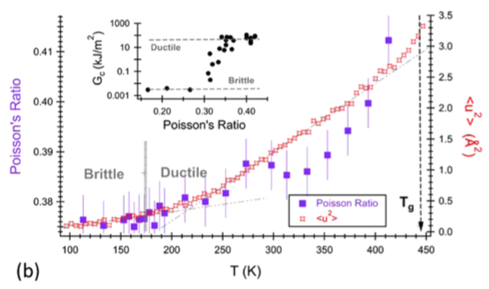

This is directly relating the Brillouin scattering to the QENS measurement. The two curves in Figure 3b are very similar allowing Soles to make the assessment that at low temperature the relaxations are due to tensile chain scission, at intermediate temperatures diffuse shear and slip between chains occurs, while at high temperatures disentanglement and shear occur allowing for a higher mean square displacement. The mean square displacement correlates with Poisson’s ratio because they are both quantifying the relationship between lateral and transverse motion, the mean square displacement looking at the isotropic motion, the Poisson ratio to the relative contribution. When new mechanisms occur the mean value increases.