**Polymer Physics**

**Quiz 2**

**January 22, 2021**

Wang Y; Wang W; Hong K; Do C; Chen W-R *Quantitative examination of a fundamental assumption in small-angle neutron scattering studies of deformed polymer melts* Polymer **204** 122698 (2020) discuss the suitability of assuming a Gaussian chain as a structural basis for deformed polymer samples, and the appropriateness of assuming that deuterated chains in a melt of hydrogenous chains deform identically to the hydrogenous chains.

1. Figure 3 of Wang shows five scattering curves from undeformed polystyrene samples with a small number of deuterated chains where the deuterated chains are observed. Explain the shape of the scattering curves in Figure 3, identify the power-law scaling regime, estimate the slope and indicate why the curve tails over at low-q.
2. Figure 4 shows the stress strain plot for the same samples shown in figures 2 and 3. The sample is stretched in the melt and then is quenched below the glass transition at a strain of 0.8 for study of oriented samples in Figure 5.   
   For a Hookean elastic,  = E  yields a straight line in a stress-strain plot like figure 4, while the data in figure 4 is not linear and therefore non-Hookean. Hookean elastic materials, like copper, deform at low strains due to reversible elastic stretching of atomic bonds in the crystal. Hookean elastic materials are compressible meaning that tensile loading in the x-direction yields strain in the x direction but leaves the y and z directions unstrained. Materials like Jell-O, human skin, rubbers are not Hookean elastics. These materials display a modulus increasing with the cross-link density and with temperature, C1 = xRT where x is the crosslink density. These materials are ideally incompressible and because of their incompressiblity they follow the Moony-Rivlin equation,   2C1 + 2C2/ rather than Hooke’s Law where C1 is a modulus due to crosslinks between chains.  is the elongation ratio, L/L0 =  + 1. The data of Wang for polystyrene melts is digitized and replotted in a Moony-Rivlin plot below. The linear part follows the Mooney-Rivlin equation.  
   Explain the high and low strain behavior.   
   Why is the modulus C1 = 0?

Why are the low elongation points higher than expected? (You might think about this in terms of the relaxation time and the distance of relaxation for the chain at low elongations.)  
From this plot, do you think that quenching the material to a glass at the highest elongation will result in orientation of the chains?



Mooney-Rivlin plot of Wang’s data as digitized from Figure 4.  = L/L0 =  + 1 is the elongation ratio.

1. Figure 2 of Wang shows the linear viscoelastic spectra for the polymers. Explain all of the features in these curves especially specifying where the material is a fluid and where it is rubbery and how this can be determined. What happens at the highest frequency?
2. The entanglement molecular weight, Me, is determined in Figure 2 from the rubbery plateau modulus using G0’ = eRT where e is the entanglement density (number of entanglements per volume). The equation is a similar to the definition of the Mooney-Rivlin modulus, C1. The entanglement molecular weight is the molecular weight between entanglements of the chains along one chain so e = /Me. Explain the similarity between the equations for G0’ and C1.
3. We know from our simple simulations in class that most polymer chains will have asymmetry that could be oriented under tensile or shear strain, that is, it is not necessary for the chain to deform in order to display orientation under strain in Figure 5. Figure 5 shows the 2d scattering pattern from deformed chains (the undeformed chains would show isotropic scattering patterns with no orientation). Comment on how you might distinguish between orientation of asymmetric chains and deformation of chains in the experiments conducted by Wang.

***ANSWERS:***

**Polymer Physics**

**Quiz 2**

**January 22, 2021**

1. *Explain the shape of the scattering curves in Figure 3, identify the power-law scaling regime, estimate the slope and indicate why the curve tails over at low-q.*

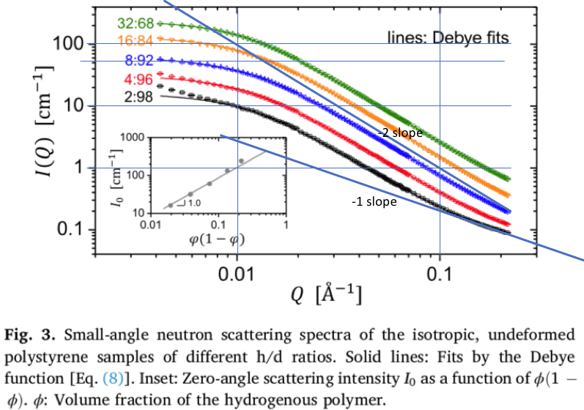

At low-q the intensity is constant, this is for sizes much larger than the coil and the material blurs into a uniform field. Near the knee the coil becomes visible as a spot with a radius of gyration. This is followed by a power-law decay of -2 indicating a Gaussian chain of dimension 2 since Mass ~ Size2, R2 = nl2. At the highest q for the black curve a region of power-law decay -1 indicates linear structure, the persistence length is about 2/q for the transition between -2 and -1 slopes.