**Polymer Physics**

**Quiz 3**

**January 29, 2021**

Habibi M, Adda-Bedia M, Bonn D, *Effect of the material properties on the crumpling of a thin sheet* Soft Matter **13** 4029 (2017) investigate the force-size relationship for crumpled sheets and find that there is a scaling relationship, *F* ~ *R*-.

1. For a Gaussian polymer chain obtain the force-size scaling relationship from an expression for the energy of a single Gaussian coil.
2. Habibi’s measurement is based on a 3d force like pressure acting on a crumpled ball.

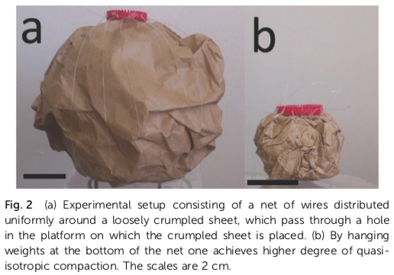

Could this force still result in an expression for energy? (V ~ R3, P = F/A ~ F/R2)

From Habibi’s force-size scaling relationship obtain an expression for the energy of a crumpled sheet as a function of size.

1. Habibi finds a value for ** of from 3 to 6 depending on the “plasticity” of the sheet with less plastic (moldable) sheets showing a larger **. With a value of ** of 3 to 6 how does the energy change with size of the sheet? Does this make sense?
2. How does the modulus of the sheet change with size of the crumpled ball? Does this make sense?
3. Habibi finds that the number of folds of the sheet decreases with the size of the crumpled ball, less crumpled sheets have fewer folds. The behavior follows another power-law dependence, *N* ~ *D*-*  * has a value from 1 to 2.It is found that ** is proportional to ** such that ** = 3.44 **. Explain what the number of folds might have to do with the energy of a crumpled sheet and why ** might reflect the same information as **.* *

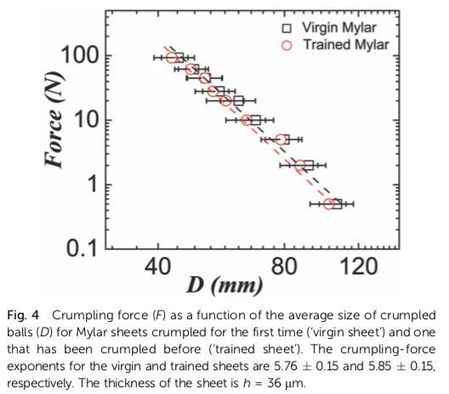 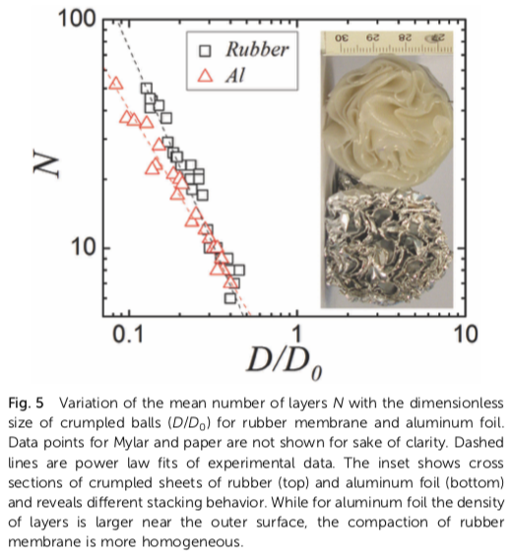 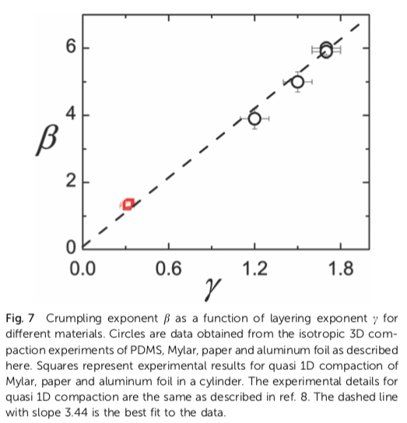

**Answers: Polymer Physics**

**Quiz 3**

**January 29, 2021**

***ANSWERS:***

**Polymer Physics**

**Quiz 3**

**January 29, 2021**