**Polymer Physics**

**Quiz 4**

**February 5, 2021**

Mitra D, Chatterji, *A Transient helix formation in charged semiflexible polymers without confinement effects.* J. Phys.: Condens. Matter **33** 044001 (2021) report on coarse grain Brownian dynamics simulations of a semi-flexible bead and spring model polymer chain. In the model, the beads on the chain are separated by a distance **r**. The bonds have a bending energy   
ub = b cos() where  is the angle between the bond vectors **r**i and **r**i+1. The beads have binary interactions with a harmonic spring potential energy uH = (r - a)2 where a is the separation distance between two beads. The spring constant is (A)  = 20kT/a2 or (B)   = 10kT/a2. In addition to bending energy and spring energy the beads have a repulsive Coulomb potential (charge repulsion) between beads, uc = c(a/r) with c = 87.27kT. The beads have a time dependent drag force F =  dx/dt where which in combination with the spring constant leads to a relaxation time constant for bead motion,  = a2 /kT, which is the time for an isolated bead to diffuse a distance a. Case (B) includes excluded volume (long-range interactions) between beads at long index differences with two additional repulsive and hard-core potentials, notably   
ud = d (a/r)3 with d = 107.70/kT and a hard-core cutoff at rc = 4a for long-range repulsive interactions. The simulation proceeds with: 1) random thermal motion of a monomer; 2) calculation of the total energy for the chain and; 3) using this total energy in a weighted decision to accept or reject the motion (lower chain energy is better). This is repeated for all beads randomly for many iterations in the hope of finding a steady state energy. In most of the simulations the initial chain state is fully extended. The process is to relax the chain from the initial extended conformation. The point of the simulation is to observe the formation of transient helical structures associated with the Coulombic potential, uc, which appear at about simulation time = . Mitra also studies the chains under stress and finds that the helical structures are stabilized when the chain is end-tethered.

1. In the simulation the bending energy magnitude, b, is used to tune the persistence length, lp (eqns. 1 and 2). **Explain the origin of eqn. 2** by looking at the Strobl book p. 58 eqn. 2.138. Would you expect the persistence length to decrease with T? Why?
2. **Explain the origin of the harmonic spring potential** energy uH = (r - a)2. How does the force depend on the change in position r = (r - a)? How does this and the spring constant  = 20kT/a2 compare with our calculations for a Gaussian chain?
3. **Explain why the equation  = a2 /kT reflects diffusive motion.** Obtain the mean square displacement for a Brownian particle and write it in terms of time = mean square distance. How does this compare with this expression? What is the diffusion coefficient from this equation? Does the functionality in temperature and with the drag coefficient make sense?
4. Figure 1 shows a time sequence of a chain starting with (a) a rigid rod, then (b) showing “kinks” due to random thermal motion, then (c) relaxing the bending strain by forming a helix at a time t = , then (d) relaxing the helix through thermal motion. **Explain how the three energy terms and the drag term for Case B control these stages** of the transitory helix formation.

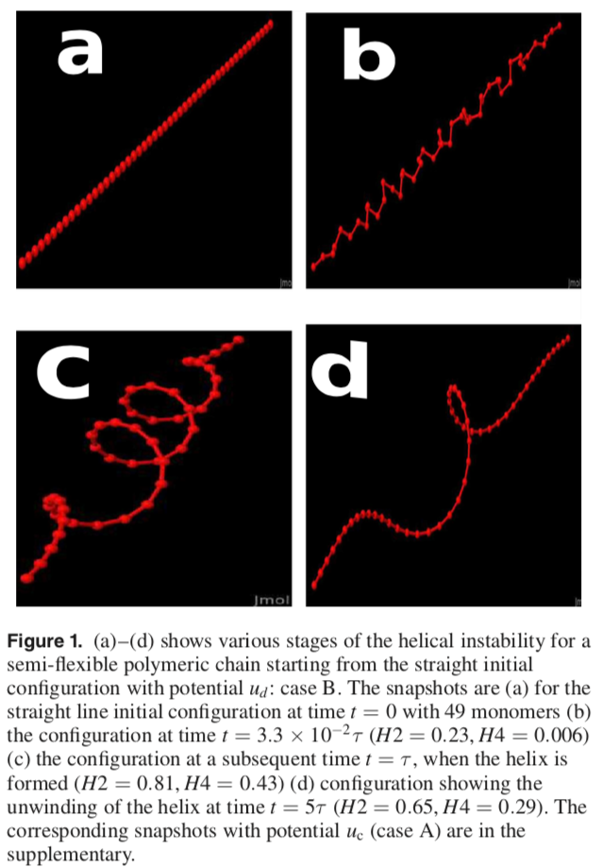

1. Mitra interprets his results using global and local order parameters H4 and H2. They are based on the average cross product of the vectors **r**i x **r**i+1. The cross product has direction orthogonal to the two vectors (normal to the plane made by the vectors) following the right-hand rule and having the magnitude of the sin of the angle between the vectors. For parallel vectors it is 0 and for orthogonal vectors it is maximum. The sum of **u**i (H4) would be 0 for a rod and maximum for a kinked chain with right angles between all bead vectors. The dot product of **u**i • **u**i+1 (H2) is maximum if the cross products are parallel for neighboring beads and zero if they are orthogonal. **Explain how H4 reflects global ordering and H2 reflects local ordering of the chain in the context of transitory helix formation.**

**ANSWERS: Polymer Physics**

**Quiz 4**

**February 5, 2021**

1. In the simulation the bending energy magnitude, b, is used to tune the persistence length, lp (eqns. 1 and 2). **Explain the origin of eqn. 2** by looking at the Strobl book p. 58 eqn. 2.138. Would you expect the persistence length to decrease with T? Why?
2. **Explain the origin of the harmonic spring potential** energy uH = (r - a)2. How does the force depend on the change in position r = (r - a)? How does this and the spring constant  = 20kT/a2 compare with our calculations for a Gaussian chain?
3. **Explain why the equation  = a2 /kT reflects diffusive motion.** Obtain the mean square displacement for a Brownian particle and write it in terms of time = mean square distance. How does this compare with this expression? What is the diffusion coefficient from this equation? Does the functionality in temperature and with the drag coefficient make sense?
4. Figure 1 shows a time sequence of a chain starting with (a) a rigid rod, then (b) showing “kinks” due to random thermal motion, then (c) relaxing the bending strain by forming a helix at a time t = , then (d) relaxing the helix through thermal motion. **Explain how the three energy terms and the drag term for Case B control these stages** of the transitory helix formation.
5. Mitra interprets his results using global and local order parameters H4 and H2. They are based on the average cross product of the vectors **r**i x **r**i+1. The cross product has direction orthogonal to the two vectors (normal to the plane made by the vectors) following the right-hand rule and having the magnitude of the sin of the angle between the vectors. For parallel vectors it is 0 and for orthogonal vectors it is maximum. The sum of **u**i (H4) would be 0 for a rod and maximum for a kinked chain with right angles between all bead vectors. The dot product of **u**i • **u**i+1 (H2) is maximum if the cross products are parallel for neighboring beads and zero if they are orthogonal. **Explain how H4 reflects global ordering and H2 reflects local ordering of the chain in the context of transitory helix formation.**