**Polymer Physics Quiz 5**

**February 12, 2021**

Blanco PM; Madurga S; Mas F; Garces JL *Effect of Charge Regulation and Conformational Equilibria in the Stretching Properties of Weak Polyelectrolytes* *Macromolecules* 52 8017-8031 (2019) consider the impact of stretching a polyelectrolyte chain on the charge state of the chain. It was discussed in class that the charge can impact both the short-range persistence length and the long-range excluded volume and chain scaling. The premise of this work is that stretching the chain to change short and long-range interactions can have the inverse impact of altering the charge state of the chain, , as well as the normalized persistence length, lp/l0. Blanco conducts Metropolis method Monte-Carlo simulations. Figure 2 shows an outline of the Metropolis/Monte Carlo algorithm. The chain begins with a random conformation and the free energy for the entire chain is calculated based on the potential equations (1) to (11). In the Monte Carlo simulation, either (A), (B) a single monomer conformation, (D) rotational position, or (C) charge state is altered (according to the specified probabilities for these choices) and the new free energy is calculated for the whole chain. If the free energy is lowered the change is accepted, if the free energy is increased it can still be accepted if the Boltzmann probability, exp(-E/kT) is larger than a randomly chosen probability (a Monte Carlo roll of the dice). This process is iterated until a steady state conformation is reached (such as a stable structural size or constant density).This algorithm was first used for the Ising model of ferro/para magnetic transitions. The Metropolis algorithm differs from the Brownian dynamics simulation we looked at last week which was based on chain motion controlled by a force balance.

1. The Blanco simulation includes many contributions to the free energy that were used in the molecular dynamics simulation from last week. Compare the two spring constant expressions for tension and bending with those used by Mitra D, Chatterji, J. Phys.: Condens. Matter **33** 044001 (2021) from last week. How do these terms relate to the Gaussian spring constant mentioned in class?
2. Both Blanco and Mitra also mention short and long-range Coulombic energies. For short-range interactions Blanco uses Flory’s rotational isomeric state model with some simplifications to speed the simulation. The term **** reflects the potential for a gauche bond conformation rather than trans with **** = 1 meaning an equal probability and **** = 10 meaning that gauche is favored. Draw a butane molecule using a Newman projection to show the meaning of trans and gauche, and sketch the bond rotational energy versus rotation angle for butane noting the trans and gauche + - conformations. Why does Blanco use the all trans state as the “ground state”? How is this reflected in equation (7)?
3. The short-range potential for charge involves the pH, pKi and ionization state of each charged unit as well as the rotational state (trans, gauche +-). Explain how this term couples chain conformation with charge. Why is this important to the paper?
4. Compare the long-range Debye-Hückel potential with what was discussed in class for charge interactions in polyelectrolytes. What is the Debye screening length and how does it differ from the Bjerrum length?
5. In Blanco’s results he shows that the degree of protonation, , depends on the pH (Figure 3) and on the applied force F (Figure 8). Explain how the degree of protonation might depend on these two parameters, especially on the applied force in the context of the potentials Blanco has setup in equations (1) to (11).

**ANSWERS: Polymer Physics**

**Quiz 5**

**February 12, 2021**

1. *The Blanco simulation includes many contributions to the free energy that were used in the molecular dynamics simulation from last week. Compare the two spring constant expressions for tension and bending with those used by Mitra D, Chatterji, J. Phys.: Condens. Matter* ***33*** *044001 (2021) from last week. How do these terms relate to the Gaussian spring constant mentioned in class?*

From Blanco we have:

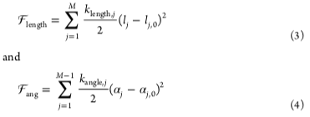,

and from Mitra we have:

 **

** 

From class we have:

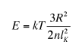

Blanco’s expressions are the traditional Hookean spring equations where F = dU/dx = kspr x and U = (kspr x2)/2. The spring constant doesn’t have a temperature dependence and is just an adjustable parameter. So these are like metal bars connecting beads following Hooke’s law. For Mitra’s harmonic equation the springs are Gaussian chains with a modulus adjusted by temperature and molecular weight, the same as the expression in class. Mitra’s bending function is tied directly to the persistence length. The energy is linear in bond length, but this is a shear deformation so the shear strain is sin() ~  (in radians) for small strains. Also,   
cos() = √(1 - 2), so this is the square root of Blanco’s dependence. This is because Mitra is considering a bead as a sub-chain, so it has persistence, while Blanco is considering a bead as a steel rod that just has a bending moment expressed by his equation (4). Basically, the two monomer units differ, Blanco has rigid monomer units and Mitra has polymeric monomer units. Mitra is using a method called coarse graining where he composes his sub-units of nanoscale structures with know properties, here polymer chains.

1. *Both Blanco and Mitra also mention short and long-range Coulombic energies. For short-range interactions Blanco uses Flory’s rotational isomeric state model with some simplifications to speed the simulation. The term* ****** *reflects the potential for a gauche bond conformation rather than trans with* ****** *= 1 meaning an equal probability and* ****** *= 10 meaning that gauche is favored. Draw a butane molecule using a Newman projection to show the meaning of trans and gauche, and sketch the bond rotational energy versus rotation angle for butane noting the trans and gauche + - conformations. Why does Blanco use the all trans state as the “ground state”? How is this reflected in equation (7)?*

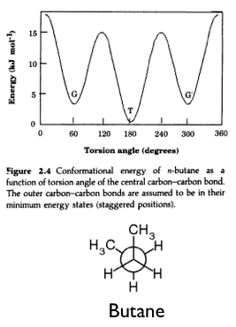 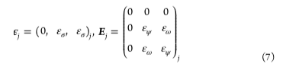

Trans is at  = 180°, the gauche + and gauche – states are the other two minima at 60° and 300°. The states are separated by 120°. Blanco uses the all trans state as a reference state since this is the lowest energy state for butane. This will change with different side-groups and charges.

Equation (7) is the matrix of interaction energies between neighboring bonds j and j+1. There are three possibilities for two neighboring bonds those involving trans  = 0; (g+g- or g-g+), ; (g+g+ or g-g-), . The trans states have energy 0, as the reference state.

1. *The short-range potential for charge involves the pH, pKi and ionization state of each charged unit as well as the rotational state (trans, gauche +-). Explain how this term couples chain conformation with charge. Why is this important to the paper?*

This term is the main point of the paper and the reason that Blanco finds a change in charge with strain. The first term in equation (1) introduces an external force to the chain energy. Force times distance is energy where the distance is the end-to-end distance for the chain, that is the chain is deformed by the force. A change in end-to-end distance relies partly on changes to the gauche/trans equilibria. Equations (6) and (9) contain the c vector which describes the rotation of bonds and is multiplied by the energy of the different rotational isomers. The first term in equation (9) links the energy to the charge on the chain and the second term relates the charge on the chain to the gauche/trans distribution which is related to the external force on the chain by equation (1). He has built a machine that will give him the answer he wants, that the charge changes with external force, then he finds that the charge changes with external force. On the other hand, his model is reasonable. It might seem that he could have saved some time by just saying that it is a reasonable model to think that the charge would change with external force.

1. *Compare the long-range Debye-Hückel potential with what was discussed in class for charge interactions in polyelectrolytes. What is the Debye screening length and how does it differ from the Bjerrum length?*



The long-range interaction depends on the Debye screening exponential where dij is the distance between charged chain units at i and j and  is the inverse of the Debye length,  where I is the ionic strength.  = 1/kT and lB is the Bjerrum length, 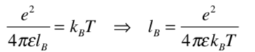, the distance beyond which an isolated charge is felt as a mean field potential because it is randomized by thermal motion. For shorter distances than lB the charges feel like specific interactions that lead to ordering like crystallization or liquid crystal structures. From class we had:



It is the same as equation (11).

The Debye screening length is for two charges in the presence of counter ions or other polyelectrolyte chains. Beyond the Debye screening length charges are not felt due to screening from other charges, there is no mean field interaction or specific interaction, it is as if the charges don’t exist whatsoever. Generally, rD >> lB so the Coulomb interactions can be dealt with using a mean field, that is you don’t need to worry about liquid crystalline or crystalline phases.

1. *In Blanco’s results he shows that the degree of protonation, , depends on the pH (Figure 3) and on the applied force F (Figure 8). Explain how the degree of protonation might depend on these two parameters, especially on the applied force in the context of the potentials Blanco has setup in equations (1) to (11).*

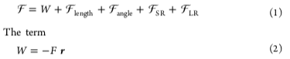

The applied force impacts the chain energy through the work term W. W changes if the force is changed, this increases the net free energy. Through a series of random motions of the chain units with the A,B,C,D paths in Figure 2 and assessment of the chain energy a reduction in the net free energy will be achieve until a minimum is found. One of the parameters that is changed is the protonation of a unit of the chain that holds charge.

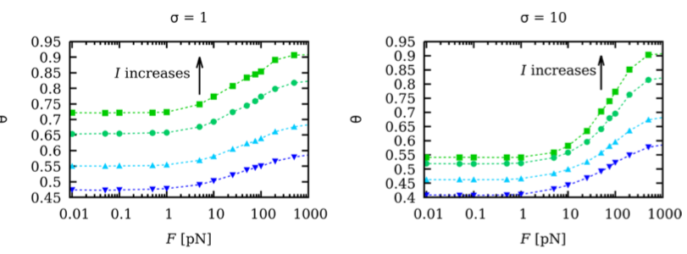

Similarly, a change in pH changes the state of ionization in equation (9) which increases the overall chain free energy. Through random iterative changes to the A,B,C,D paths in Figure 2 and assessment of the chain energy a reduction in the net free energy will be achieve until a minimum is found. This leads to an equilibrium state that can be assessed.

