**Polymer Physics**

**Quiz 6**

**February 19, 2021**

Bobbili SV and Milner ST *Simulation Study of Entanglement in Semiflexible Polymer Melts and Solutions* Macromolecules **53** 3861-3872 perform molecular dynamics simulations of ring polymers in solutions and melts to determine the behavior of the entanglement molecular weight, Ne, with concentration and polymer architecture. Ne = number of monomers (beads) in an entanglement strand (a chain between entanglements), NK = number of monomers in a Kuhn unit (made up of one or more beads). ‘a’ is the reptation tube diameter, LK is the Kuhn length, R is the root-mean-square chain end to end distance, p is the packing length, d is the chain diameter, Le is the “arc length” or contour length between entanglements. The Ne depends on the relationship between ‘a’ and LK. If LK is much smaller than ‘a’ then the chain is flexible and the Lin-Noolandi (LN) theory applies, equations (1) to (3). Other behaviors are possible for stiffer chains.

1. Why does Bobbili use cyclic chains rather than linear chains? What impact might this have on the results?
2. Explain the origin of equation (4) following the logic of Bobbili but in your own words. What is the difference between p and d? You will probably need to reference Milner ST *Predicting the Tube Diameter in Melts and Solutions Macromolecules* **38** 4929-4939 (2005).
3. Bobbili uses a 6-12 potential with a cutoff for the bead-bead interactions. Is this a short-range or a long-range interaction? Explain your logic.
4. Explain why Ne and ‘d’ decrease with NK in figure 12. Why is there a transition in slope?
5. Why does Bobbili introduce branches to his chains on page 3869?

(*Before going to Penn State Scott Milner worked at Exxon Central Research in Annandale NJ with Dave Loshe and Lou Fetters. Tom Witten was a frequent visitor to the Exxon lab.*)

**ANSWERS: Polymer Physics**

**Quiz 6**

**February 19, 2021**

1. *Why does Bobbili use cyclic chains rather than linear chains? What impact might this have on the results?*

It is difficult to observe entanglements in a 3d mat of meandering chains. Bobbili uses a “chain shrinkage” algorithm that straightens out the chains so that they become freely jointed rods between entanglement points, the sharp turns can be easily found and enumerated. For a linear chain the ends must be tethered so that the chain doesn’t shrink into a single spot. Cyclics of high molecular weight are presumed to act the same as linear chains but do not require the artificial tethering during chain shrinkage so might result in a more realistic enumeration of the entanglements.

1. *Explain the origin of equation (4) following the logic of Bobbili but in your own words. What is the difference between p and d?*

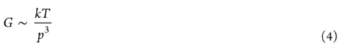

Equation (4) is the common relationship between the packing length, p, and the plateau modulus. p is described as the closest approach of monomers on different chain segments (persistence unit or entanglement segment). p is something like a screening length. For sizes smaller than p short-range interactions between units separated by small chain index differences are dominant. For distances larger than p, long-range interactions between units separated by large chain index differences are dominant. Equation (4) is based on flexible chains where LK << a, where a is the tube diameter. The tube is defined by the end-to-end distance of an entangled chain since the tube exists due to entanglements. a ~ Ne1/2 b. The volume of a chain is proportional to a3. Within this volume a fixed number, n, of other chains are present. That number is related to the occupied volume of a chain, Ne0, where 0 is the volume occupied by a monomer, Ne is the number of monomers in an entangled chain segment. n ~ a3/Ne0, and the Lin−Noolandi (LN) ansatz states that n is a fixed value for all polymers, a universal constant. A characteristic number is associated with n, a2/Ne0 = 1/p. p has units of length. From the single chain spring constant it is inferred (or can be calculated) that the plateau modulus is given by G0 ~ 3RT/a2. For Gaussian chains a2 ~ Ne, so G0 ~ RT/Ne. The equation G0 ~ 3RT/a2 has a units problem, Energy = RT = F dR. F/A =  = G so G = kT/volume. The volume of interest has to be proportional to Ne from the single chain modulus and has to be related to Ne, G0 ~ 3RT/(Ne 0). From the definition of p = Ne 0/a2 = Ne 0/(Neb2) =  0/b2, and the definition of n = a3/Ne 0, or  0 = a3/(nNe), with a2 = Neb2, so  0 = a3/(na2/b2) =ab2/n, we can obtain p = a/n with n a universal constant. So, G0 ~ 3RT/(Ne 0) = RT/(pa2) = RT/(p3n2) where n is a universal constant.

1. *Bobbili uses a 6-12 potential with a cutoff for the bead-bead interactions. Is this a short-range or a long-range interaction?*

Figure 3 shows that the 6-12 potential is intended mostly for long-range interactions. The potential will also prevent short-range chain back steps. So it has impacts on both short-range and long-range interactions but is mostly intended for long-range interactions. The bending spring constant  will prevent back steps of the chain except where  = 0. So the Leonard-Jones potential is never implemented for short-range interactions when there is a non-zero .

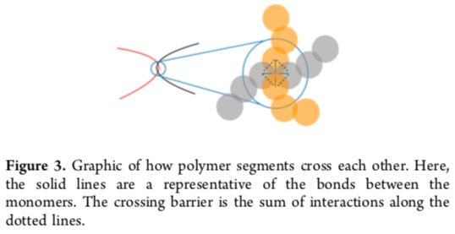

1. *Explain why Ne and ‘d’ decrease with NK in figure 12. Why is there a transition in slope?*

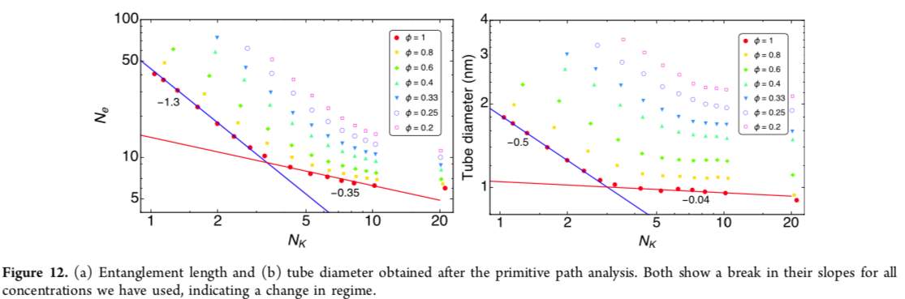

Ne = number of monomers (beads) in an entanglement strand (a chain between entanglements) and NK = number of monomers in a Kuhn unit (made up of one or more beads). Figure 11 shows that as the chains become stiffer the tube diameter becomes smaller. The tube is defined by entanglements so the entanglement density increases with chain stiffness. NK increases as a result of increasing chain stiffness. As the chains become stiffer they have more interactions between chains so shorter entanglement strands and lower Ne. This is a prediction of the models presented in the introduction. The LN model for flexible chains predicts a slope of -3 for 11(a) and -1 for 11(b) which doesn’t describe the results. Models for semi-flexible and rigid chains agree better with the simulation results. The Evears thread model agrees with the data, a more elaborate plot is used to demonstrate this.

The transition in slope occurs where LK becomes greater than the tube diameter, ‘a’, the transition from semi-flexible to rigid chains.

1. *Why does Bobbili introduce branches to his chains on page 3869?*

Bobbili introduces branches to increase the monomer volume and thereby increasing p, since p = Ne 0/a2. The increased p allows Bobbili to access the flexible chain regime where the LN model applies.