**Polymer Physics**

**Quiz 7**

**February 26, 2021**

Polycantanes are polymers composed of interlinked ring polymers (Figure 1 below left). The bond is called a *mechanical linkage* as opposed to covalent bonds. Wu Z-T, Zhou J-J *Mechanical Properties of Interlocked-ring Polymers: A Molecular Dynamics Simulation Study* Chinese J. Polym. Sci. **37** 1298-1304 (2019) simulated polycantanes in good solvent dilute solutions. Wu used molecular dynamics (Langevin) simulations and varied the size of the rings and the number of rings in a chain. They applied stretching forces to determine the mechanical properties of a single chain.

1. Wu’s Figure 1 (replotted below right) is used to support their argument that the chain size scales with *N*0.6, where *N* is *m* x *n*, *m* is the number of beads in a cyclic, and *n* is the number of cyclics in the chain (see Raicher’s Figure 1 below, left). Derive an equation (*following what was done in class*) that explains this scaling behavior.
2. Wu’s figure 1 actually shows deviation from the Flory-Krigbaum prediction. The digitized data is shown below (right) with fits that show a slope of 0.81 for the low N and about 2 for the large N. *A best fit to the low data using a fixed slope 0.6 is also shown*. **Would you expect to see deviations from Flory-Krigbaum behavior at large N or at small N and why? Can you explain the observed behavior?** (What would be the slope be for a rod? What about for a 3d object? Consider the simulation method.)

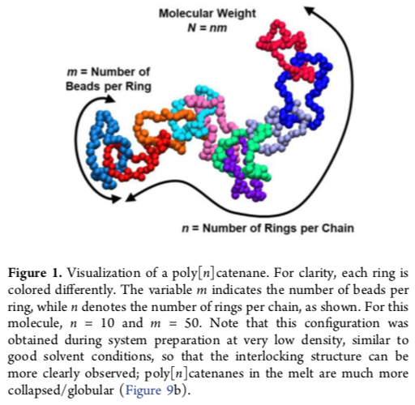 

*From Raischer et al. Data from Wu et al. Figure 1*

1. Wu’s Figure 2 (below, left top) shows the behavior of R for the cyclics as a function of the ring size m. (Top line is for *R ~ m*1, bottom line for *R ~ m*3/5.) Comment on the behavior. Does it make sense? Is a ring of 10 to 30 beads denser than a linear chain? Could this explain the low N behavior in the replot of Wu’s data above (right)? (*A chain of N = 100 has 3 to 10 rings.)*
2. Pakula T, Jeszka K *Simulation of Single Complex Macromolecules. 1. Structure and Dynamics of Catenanes* Macromolecules **32** 6821-6830 (1999) used a Metropolis Monte Carlo algorithm to obtain Figure 4 below, right top. Compare this figure with that of Wu (above right).
3. Compare the results shown in Pakula’s Figure 4 (below top right) and that shown in Pakula’s Figure 5 (below bottom left) where *P(q)* is the scattered intensity. Are these results consistent? The last graph (below bottom right), Figure 10, is from Rauscher PM, Schweizer KS, Rowan SJ, de Pablo JJ *Thermodynamics and Structure of Poly[n]catenane Melts* Macromolecules **53** 3390-3408 (2020) and is for polycantane’s in the melt (Gaussian chains) simulated using a similar algorithm to Wu. Compare, *in terms of the chain scaling regime*, this simulated scattering pattern to that of Pakula’s (below bottom left) which is made for dilute chains in a good solvent (*S(k) ~ P(q)*; *k ~q*).

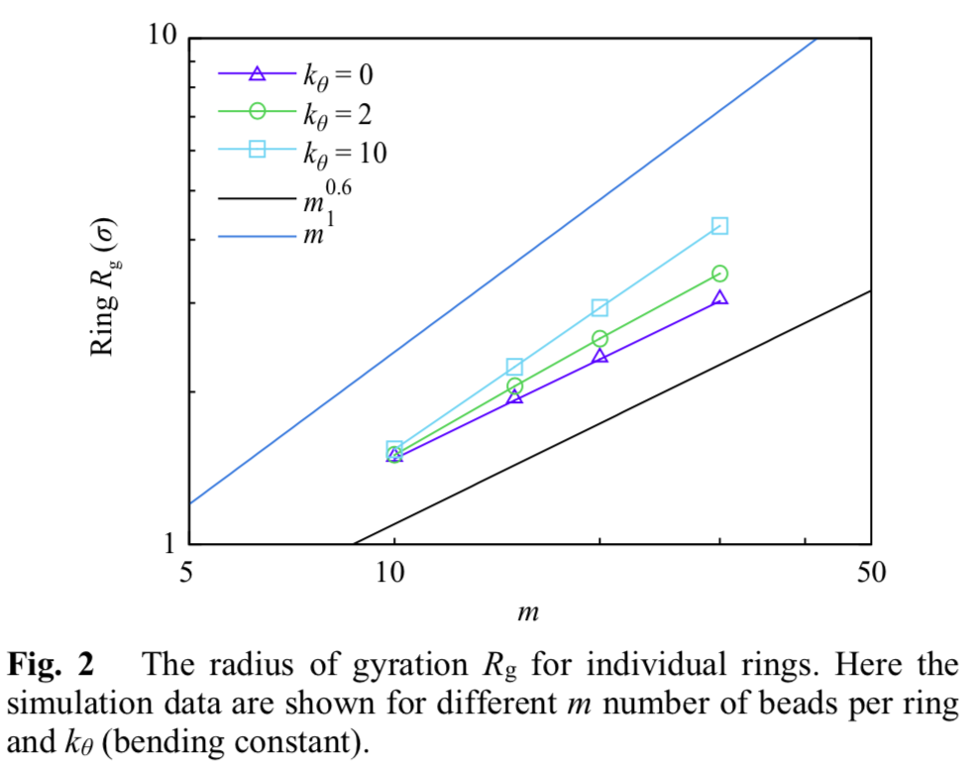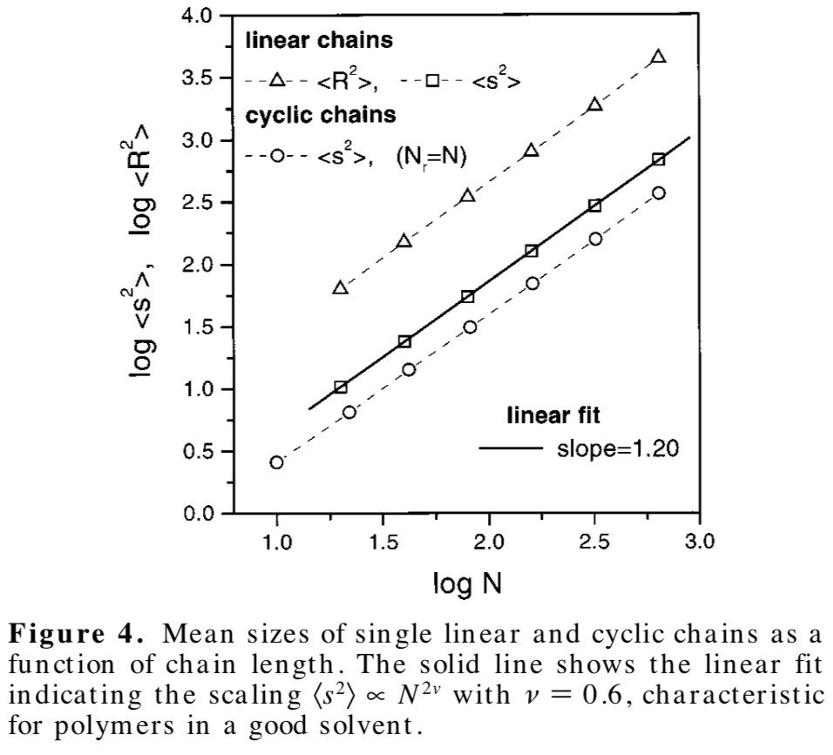

*From Wu et al. From Pakula et al.*

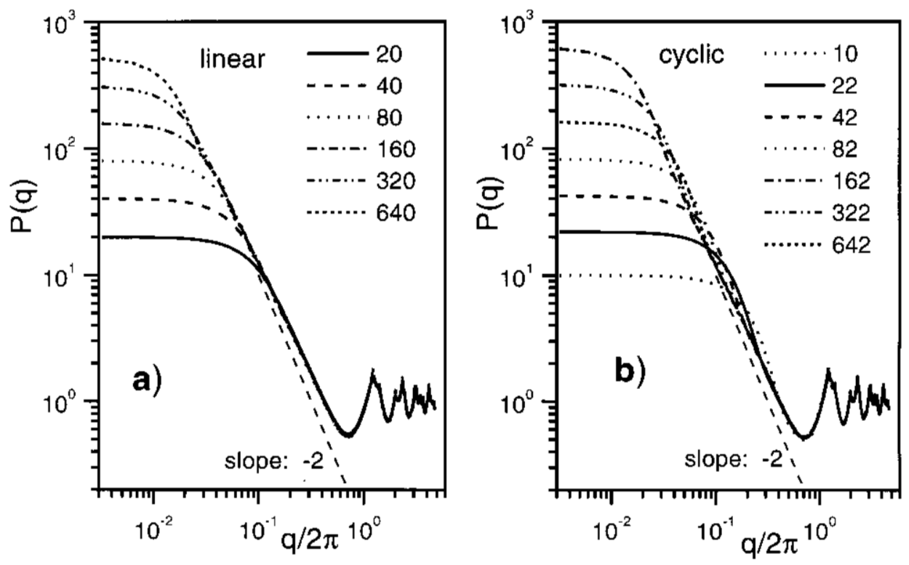 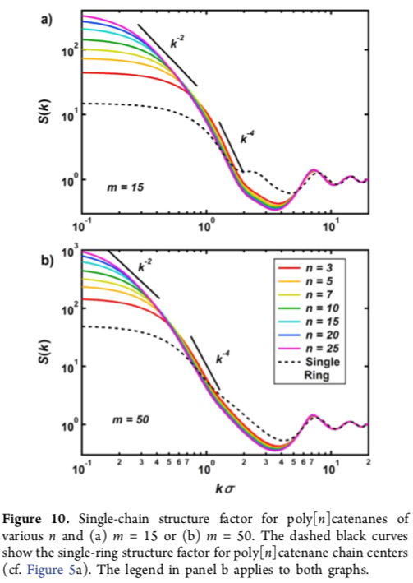

*From Pakula et al. From Raischer et al.*

**ANSWERS: Polymer Physics**

**Quiz 7**

**February 24, 2021**