**Polymer Physics**

**Quiz 9**

**March 12, 2021**

A star polymer is a polymer which starts at a central junction point and grows *f* arms. For instance, an octopus would have *f* = 8. Star polymers are of interest for viscosity enhancement and are used in synthetic automotive oil. For a star molecule to diffuse each arm of the star must relax in a coordinated fashion by Brownian motion. This leads to a dramatic impact on viscosity for a small fraction of stars in a blend with linear polymers. Kazakov AD, Prokacheva VM, Uhlik F, Kosovan P, Leermakers FAM *Computer modeling of polymer stars in variable solvent, self-consistent field (SCF) modeling and novel hybrid Monte Carlo SCF approach* Soft Matter **17** 580-591 (2021), explored simulations of star polymers using MD/coarse grain models; a new Monte-Carlo/mean field model; and a mean-field model.

1. In a mean-field approach, specific interactions between chain units are ignored and the interactions are treated as an average over all interactions. Consider a star polymer. How accurate would a mean field model be for a star considering chain segments near the core of the star and those at the ends of the arms? (consider the Daoud and Cotton model for star polymers Daoud M, Cotton JP *Star shaped polymers: a model for the confirmation and its concentration dependence* Journal de Physique **43** 531-538(1982)).
2. Kazakov goes through a description of MF and coarse grain (specific interaction) models. Summarize these two models for star polymers and give their limitations based on Kazakov’s summary.
3. In class it was mentioned that the scattering pattern from a mean-field system does not show peaks associated with correlations while a system displaying specific interactions displays a correlation peak associated with a correlation distance at ** = 2/*q*\*, where q* is the *q*-value at the peak. Kazakov indicates that a mean field model is appropriate when the interaction potentials are small. Are these two descriptions (scattering and interaction strength) consistent? Explain the relationship between these two descriptions.
4. Figure 4 shows the mean-field results for center-to-end distance as a function of the interaction parameter. Does this data show coil collapse? Explain the behavior in this plot. What is special about ** = 0.5? Would you expect this value of ** to be the same for linear and star polymers, that is should star polymers have higher, lower or the same miscibility compared to linear polymers? Think about conformational entropy. (How can Kazakov observe coil collapse without using the third virial coefficient?)

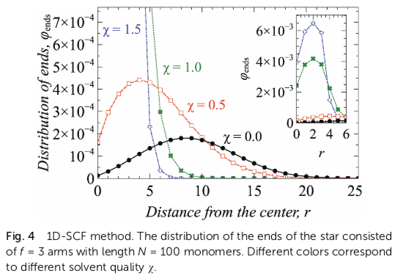

1. Kazakov defines the radius of gyration in three ways in equations (21), (23), and (25). Explain the origin of these three functions and why three different functions are necessary for their three simulations.

**ANSWERS: Polymer Physics**

**Quiz 9**

**March 12, 2021**

1. *In a mean-field approach, specific interactions between chain units are ignored and the interactions are treated as an average over all interactions. Consider a star polymer. How accurate would a mean field model be for a star considering chain segments near the core of the star and those at the ends of the arms? (consider the Daoud and Cotton model for star polymers Daoud M, Cotton JP Star shaped polymers: a model for the confirmation and its concentration dependence Journal de Physique* ***43*** *531-538(1982)).*

The mean-field model is bad for a star. In the central region the arms are crowded, the effective concentration is high, as one moves out radially the concentration drops so one might not expect to see a single scaling regime and certainly not one of the classic regimes, Gaussian, SAW, or collapse. The Daoud-Cotton model shows what one might expect,

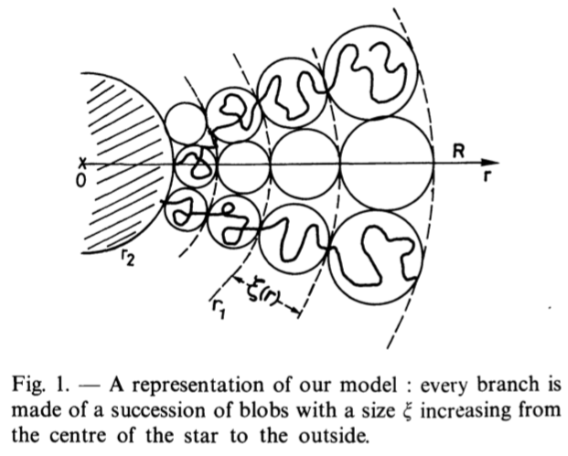

Gaussian coil collapse conditions near the core, Gaussian conditions at intermediate radial distance and good solvent conditions near the edge. This model is far over simplified. Another example is the work of Benoit in 1953 when he successfully described scattering from star polymers with an integral equation,

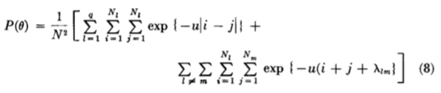

Which is made up of Gaussian chains for the first term, one summation for each of q arms in the star and the second term which reflects correlations between the arms,  being the separation distance between chains at the core of the star. While the Gaussian term is a mean field expression, the second term involves specific interactions and has a strong effect on the resulting scattering intensity. Scattering reflects the structure so the structure cannot be described with a simple mean field. It needs to have correlations between the arms.

1. *Kazakov goes through a description of MF and coarse grain (specific interaction) models. Summarize these two models for star polymers and give their limitations based on Kazakov’s summary.*

Kazakov uses the Scheutjen-Fleer self-consistent field model that assumes that particle-particle interactions do not exist, but that particles feel and average background field that impacts the density, so that density fluctuations are suppressed. The coarse grain model is a bead and spring model with long-range, Lennard-Jones 6/12 potential and short-range finite extension nonlinear elastic (FENE) potential (replacing the Hookean spring potential). He is using a packaged simulation routine in the ESPResSo package that you can basically download from the internet (<http://espressomd.org/wordpress/>). The limitations of the mean-field approach is that it ignores the strong specific interactions in the star polymer that dominate the structure and thermodynamics. The limit of the coarse grain model is that it isn’t realistic and has a large computational time so only small molecules can be considered.

1. *In class it was mentioned that the scattering pattern from a mean-field system does not show peaks associated with correlations while a system displaying specific interactions displays a correlation peak associated with a correlation distance at  = 2/q*, where q* is the q-value at the peak. Kazakov indicates that a mean field model is appropriate when the interaction potentials are small. Are these two descriptions (scattering and interaction strength) consistent? Explain the relationship between these two descriptions.*

In scattering a peak means that there is a perfect size in the material, the Fourier transform of a perfect size is a peak. So for perfect spheres or rods we see peaks associated with the structure factor *S*(*q*) at about 2/(perfect size), that is the radius of the sphere or rod. For random structures like polymer coils and most nano-materials another perfect size can arise, that is related to the organization of the material. For instance, irregular silica aggregates that have surface hydroxyl groups will organize into a disordered HCP lattice that can give rise to a peak in scattering. In this case the peak reflects 2/(lattice spacing). Since the lattice only exists over short distances, the length is called a correlation length. This gives rise to a correlation hold in density near the charged particle. For star polymers, near the core, there is a correlation length associated with ** in Benoit’s theory. Kazakov’s description is consistent with the scattering observation of a peak since for weak interactions there isn’t an obvious correlation between structures, while for strong interactions correlations are strong, leading to a peak in scattering.

1. *Figure 4 shows the mean-field results for center-to-end distance as a function of the interaction parameter. Does this data show coil collapse? Explain the behavior in this plot. What is special about  = 0.5? Would you expect this value of  to be the same for linear and star polymers, that is should star polymers have higher, lower or the same miscibility compared to linear polymers? Think about conformational entropy. (How can Kazakov observe coil collapse without using the third virial coefficient?)*



The data displays all three of the classic polymer conformations, expanded coil in black, Gaussian coil at ** = ½ and collapsed coil for larger attractive interactions. At ** = ½ the excluded volume, *B* = *V*0(1-2), goes to 0 and the chain acts as a Brownian walk with dimension 2. This is for an isolated linear chain not for a star. The star should have much lower miscibility, so a different critical ** should exist. Another interesting feature that you should note, is that the Grosberg-Khokolov model for coil collapse relies on the third virial coefficient, *C*, to observe coil collapse, while the SF-SCF mean-field simulation only has *B*. So it shouldn’t be able to see coil collapse. So there are some questions to be answered by Kazakov related to this figure. The results are too good to believe.

1. *Kazakov defines the radius of gyration in three ways in equations (21), (23), and (25). Explain the origin of these three functions and why three different functions are necessary for their three simulations.*

The three functions are based on the same definition of the radius of gyration given in class. The first is based on specific positions of beads in the bead-spring model, so there is a discrete summation over the coarse grain beads.

The MC-SCF model is based on breaking up the chain into domains within which a Monte-Carlo/Metropolis algorithm allows for equilibration of the chains with the domain. The domains are relaxed using molecular dynamics, momentum balances based on interactions in time. So the radius of gyration is calculated from the density of domains as a function of distance from the center of mass of the chain, equation (23).

For the SCF model the star is centered at the center of the simulation box so a vector r from the center is used and a radial probability is calculated. Since the area covered by a given radius increases with the surface of a sphere the density must be modified by *L(r)* that accounts for this increasing perimeter.

The three functions are necessary because of the differences in how the stars are described in the different simulation packages and programs.