**Quiz 2**

**Polymer Physics**

**February 1, 2019**

Extensional flow is a flow field that is similar to tensile elongation except for a fluid. It occurs in fiber drawing where a common metric of a polymer is the “melt strength”. Experimentally, it is difficult to achieve continuous extensional flow since it would require an exponentially increasing strain rate, i.e. fluid velocity. (You can demonstrate this by pulling a polymer stream from an extruder or taffy or gum and attempting to maintain a non-drooping fiber.) Rheometers have been constructed to produce local extensional flow at the convergence of two streams. Under continuous extensional flow the “extensional viscosity” **+ can be obtained. Three groups at Hamburg, Minnesota, and MIT published a joint paper on the impact of extensional flow on the observed overlap concentration in “dilute” solutions in 2006 (*How dilute are dilute solutions in extensional flows?* C. Clasen, J. P. Plog, W.-M. Kulicke, M. Owens, C. Macosko, L. E. Scriven, M. Verani and G. H. McKinley, J. Rheol. **50** 6, 849-881 (2006).)

1. Define the overlap concentration. Is this a static or a dynamic property?
2. For a chain of molecular weight *N* what is the overlap concentration if the chain were in a Gaussian state, expanded state (with *d*f = 5/3), a fully extended state, and a collapsed (or globular) state, and generally for an object of dimension *d*f.
3. Graessly (a polymer rheologist from the 1980s) defined the overlap concentration as *c*\* = 0.77/[**]. (Where [**] is the intrinsic viscosity.) Critique this expression. (Graessley, W. W., *Polymer chain dimensions and the dependence of viscoelasic properties on the concentration, molecular weight and solvent power*, Polymer **21**, 258–262 (1980).)
4. Clasen et al. state “*In extensionally-dominated flow fields, at conditions which satisfy the coil-stretch transition  a polymer coil becomes highly extended, leading to an increased interaction volume within which the chains may overlap, as reported by Dunlap and Leal (1987). Consequently polymer-polymer interactions are possible even at concentrations .*“

When we examined simulations of random walk polymers it was obvious that the chains are rarely symmetric. Asymmetric coils would orient immediately in any flow field where the experimental time is larger than the rotational relaxation time (a short time). Is it possible to define a static overlap concentration in any context involving flow?

1. The plot below shows one result from the Clasen et al. study. A “Boger” fluid is a viscoelastic fluid that does not display shear thinning (apparently of some importance to rheologists) that can be used to model the “*dilute*” polystyrene solutions in this study. **0 is the viscoelastic relaxation time for flow for the polystyrene of variable molecular weight and **z is the “Zimm relaxation time” for the oligomeric solvent. The ratio reflects only the polymeric component of the relaxation spectrum. c* is calculated from 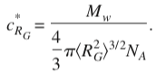. *c*/*c*\* = 100 = 1 is the nominal overlap concentration. SAOS is small amplitude oscillatory shear, i.e. a normal oscillatory shear measurement. The other measurements “*capillary thinning*” are from an extensional flow viscometer with variable concentration and molecular weight of the polystyrene. Explain this plot as best you can. Particularly try to explain what happens when these two curves cross (is this possible?).

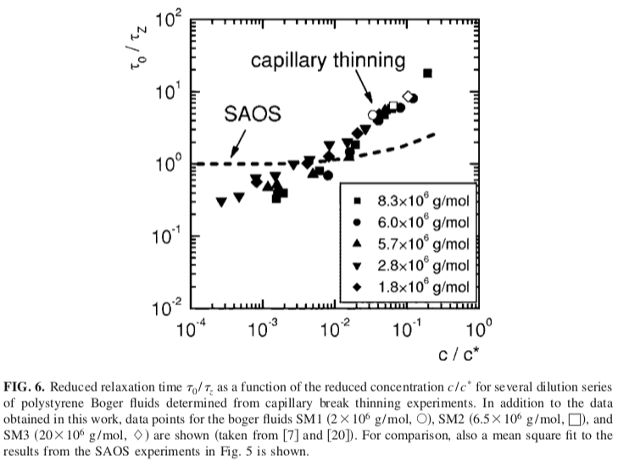

*Answers:* **Quiz 2**

**Polymer Physics**

**February 1, 2019**

1. *c*\* = M/V for the polymer coil. It is the concentration within the polymer coil. It is a static property.
2. Type c*

Gaussian *kN-*1/2

Expanded *kN-*0.8

Extended *kN-*2

Collapsed *kN*0 (doesn’t depend on N)

General *kN*1-3/*d*f

1. While [**] is calculated from V/M for the purposes of the Mark-Houwink equation, it is a dynamic property so it is not appropriate to equate it with a static property except as an approximation under quiescent conditions and with careful consideration of the possible unanticipated effects.
2. I think that it is very thin ice. There are many twists and turns to trying to relate static and dynamic properties, though this is a major goal of polymer science as the main structure/property relationship of interest.
3. For low strains the chain dynamic response is not dependent on concentration until the overlap concentration is approached (SAOS). Under extensional flow there are two power-law regimes with a transition where the extensional relaxation time equals the low-amplitude shear relaxation time. At that point the chains behave as if they are unperturbed. A lower relaxation time could indicate orientation of the elongated chains in the flow field, so the chains are acting like tubular balloons. At higher concentrations the relaxation time increases due to entanglement of the extended chains. So below the crossover the chains are not interacting and above they interact. The power-laws have to do with how the chains distort and interact. The matching point is where the reduced drag coefficient is just overcome by entanglements.

This is mostly (or entirely) conjecture. If you wanted to scientifically understand this you would need a structural study that verified these conjectures.