**Quiz 3**

**Polymer Physics**

**February 7, 2019**

Blaber, Mahmoudi, Spencer and Matsen J. Chem. Phys. **150** 014904 (2019) *Effect of chain stiffness on the entropic segregation of chain ends to the surface of a polymer melt* discuss the possible segregation of chain ends to the surface of polymer melts. They use the following equation to model the change in surface tension, **, (energy per area) with molecular weight, N,

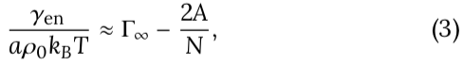

where *A* is a constant associated with the distribution of chain ends, **e(*z*), within one *R*eted from the surface.

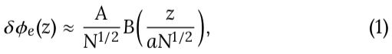

*B*() is a complicated function.

1. The experimentally verified Equation (3) is similar to the Flory-Fox equation, 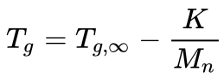. Explain the origin of equation (3) and the reason for the factor “2”. What does the first term after the equal sign correspond to?
2. Blaber et al. assume that the chain persistence length is proportional to a chain bending modulus **, . Blaber et al. propose that changes in chain stiffness can lead to greater segregation (larger “*A*”) since folding of a chain at the interface is inhibited by chain stiffness and this encourages “entropic” segregation of chain ends to the surface. The following plots show the dependence of surface tension on chain persistence (eqn. 3) from Blaber et al.’s calculations based on “self-consistent field theory”. The dashed lines are for freely jointed Gaussian chains. ** is the breadth of the surface concentration profile for end-group segregation (see plot at end of this quiz). Does the entropy proposition make sense to you? Explain. Do you believe the result for the first plot where *A* is linear in persistence? Why does **∞ increases to a plateau with chain stiffness? Why is **∞ 0 at 0 persistence?

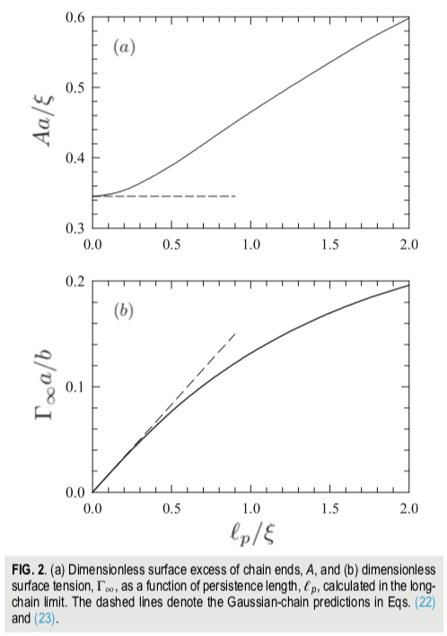 

1. In class we discussed the dependence of chain persistence length with molecular weight in the context of *C*n and *C*∞. What are *C*n and *C*∞? How does *C*n change with molecular weight. How does it change with chain index?
2. Consider Blaber’s results in the context of a changing persistence length with molecular weight. How does this impact his entropic model?
3. Blaber indicates that the “entropic” segregation drives low molecular weight species in a polydisperse sample to the surface. There is some experimental support for this proposition. Is this consistent with the dependence of persistence on molecular weight in part c?

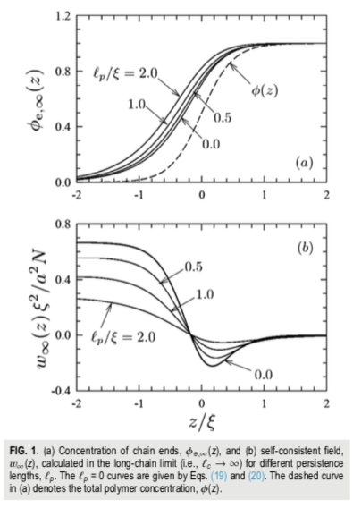



This plot shows the profile of chain ends as a function of distance from the surface “*z*”. ** is the breadth of the surface concentration profile for end-group segregation.