**Quiz 4**

**Polymer Physics**

**February 15, 2019**

Murnen et al. concerning polyelectrolytes state: “*Salt ions screen the long-range electrostatic repulsion between ionized groups on the polymer backbone, reducing chain swelling and bending rigidity. Presence of salt can also shift the ionization equilibrium reducing the charge density along the polymer backbone and altering the chain conformation.*”

*Persistence length of polyelectrolytes with precisely located charges* H. K. Murnen, A. M. Rosales, A. V. Dobrynin, R. N. Zuckermann and R. A. Segalman Soft Matter, 2013, **9**, 90–98

1. What is meant by screening and how can it impact chain rigidity?
2. Consider the second part of the statement which we did not consider in class. Ions are at equilibrium between the bound and free counter ion and this equilibrium could be shifted by counterion concentration following Le Chätelier’s Principle. Do you agree that this would change the “*charge density*” and charge distribution on the chain, i.e. “*a*”? How would the effect of a reduction in charge strength associated with a shift of the ionization equilibrium differ from Debye screening? Could the two effects be experimentally distinguished?
3. Murnen et al. made two types of polymer one had counter ion concentration dependent ionization on every monomer the second had this dependence on every other monomer with the remaining monomers ionic but not sensitive to counter ion concentration. So he could tune the “spacing” of the charge groups with pH. Is he really tuning spacing in this experiment? How is the monomer length related to the Kuhn length? How is this related to the persistence length? If the charges are separated by one or two monomers what is the impact on persistence?
4. Murnen et al. showed their neutron scattering data (right below) using a Kratky plot of *Iq*2 versus *q* where the *q*2 term accounts for chain scaling. Is that appropriate here? (Their samples are dilute polymer solutions in D2O.)
5. 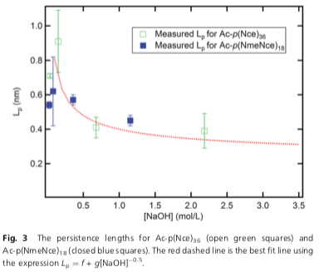 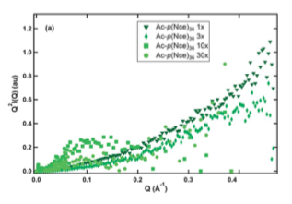

Muren uses *l*p = *f* + *g* [NaOH]-0.5 to fit his results shown as the dashed line in the left plot. f = -1.6 and g = 2.1. Explain the origin of the -1/2 power of concentration. Is it a problem that f is negative? An improved fit is found using *l*p = *f’* + *g’* (* c*p + [NaOH])-0.5 where *c*p is the polymer concentration and ** is the extent of ionization. Explain the reasoning for this modification.

**Answers: Quiz 4**

**Polymer Physics**

**February 15, 2019**

1. Debye screening is the blocking of interactions between two charged particles due to the presence of another charged particle between the two. This is similar to a crowd drowning out the sound of someone calling your name. The denser the crowd the shorter the distance that you can hear. The Debye screening length follows concentration to the –1/2 power.
2. The ionic strength could be reduced by Le Chätelier’s Principle favoring associated ions that do not have a charge effect at higher counter ion concentrations. This would reduce the persistence length similar to Debye screening of charge. The dependence would probably be 1/** rather than 1/**1/2. It would be difficult to distinguish these effects in a real experiment.
3. Generally many monomers make up a persistence unit so his spacing of charge groups is smaller than the persistence length. This means that the charge spacing probably has limited impact on the persistence length. The Kuhn length is twice the persistence length in general (for an infinite Gaussian chain). The experiment is ill posed.
4. The chains in a dilute solution have *d*f = 5/3 not *d*f = 2. This means that the Kratky plot is not the correct plot to use. He should have used a modified Kratky plot of *Iq*5/3.
5. The -1/2 power comes from the definition of the Debye screening length. It is difficult to tell if this represents the data. The fact that f is negative is not a good sign since this would represent the “bare” persistence length with no charge and should be a positive number. His improved fit accounts for counterions from the polymer. This is reasonable at low counter ion concentrations.