**Polymer Properties**

**Quiz 5**

**February 22, 2019**

The Flory-Krigbaum approach modifies the Gaussian probability describing the end-to-end distance, R, for a polymer chain first with the probability of a hard-core volumetric exclusion and then with a Boltzman probability for the energetics of chain interaction. The latter two terms have the same form so that the terms can be combined. The resulting chain energy expression contains an entropic term (the Gaussian term) reflecting the conformational entropy and an enthalpic term (the combined hard-core and energetic terms).

1. Write the F-K energy expression.
2. Entropic free energy terms involve temperature dependence, while enthalpic terms do not. However, the enthalpic term in this case contains both a temperature dependent term and a temperature independent term. From your knowledge of entropy and enthalpy explain the two parts of the enthalpic term.
3. The following empirical expression for the second virial coefficient of binary mixtures of gases was proposed by P. Neogi and AP Kudchadker in 1976 in the Proc Roy. Soc.,



based on a paper by McGlashan and Potter Proc. Roy. Soc. A, 1962 **267** 478. Tc12 is the average critical temperature for the two gasses that are mixed, and vc is an average hard core volume. The FK theory was developed at around this same time. How does this expression compare with the Flory-Krigbaum expression for the excluded volume (second virial coefficient)?

1. FK proposed that the scaling coefficient  = 3/5 = 1/df (df = 1.67). This was based on certain approximations. It was shown in class that in the absence of these approximations a numerical integral yields  = 0.581 = 1/df (df = 1.72). Simulations yield  = 0.588 = 1/df (df = 1.70) [Le Guillo, AC and Zinn-Justin, *J Phys. Rev. B.* **21** 3976-98 (1980), a paper with 1800 citations]. More recently Clisby, N PRL **104**, 055702 (2010) found,

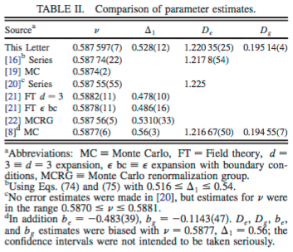

Comment on the validity of these results and pick one of these three values and justify why you prefer your value.

1. What part of the following plot of Rg versus Temperature can the FK theory explain?

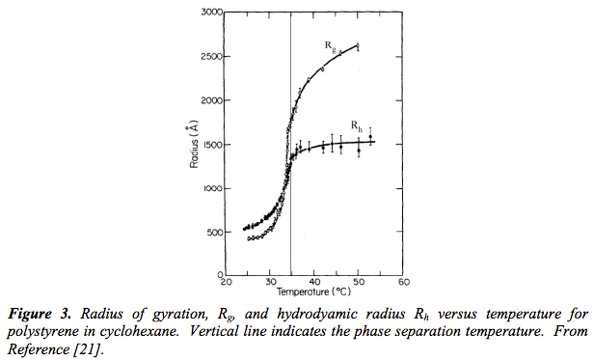

**ANSWERS: Polymer Properties**

**Quiz 5**

**February 22, 2019**

a)

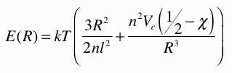

b)  = B/T. So the first term is the combinatorial entropy term for a Gaussian chain. The second term contains an enthalpic component, T, and an entropic contribution that is associated with the exclusion of chain segments from the volume occupied by other chain segments. This exclusion involves organization of the structure compared to the random state described in the first term.

c) The first two terms are almost identical to the FK excluded volume. Tc takes the place of . It would appear that expressions strongly parallel to the FK expression already existed throughout the literature.

d) The FK result is based on an assumption that the small perturbation theory results in large enough of a perturbation that you can ignore the power 3 term compared to the power 5 term of (R/R0). This approximation contradicts the assumption that exclusion is a small perturbation. The direct integral seems to be a reasonable approach. That yields a value close to that of the simulations which all seem to converge on 1.70 at high molecular weights. The simulations are subject to limitations due to finite processing time. The direct integral would appear to be the best value, 1.72. For finite molecular weights a value of 1.70 might be more representative.

e) FK can reproduce this curve for temperatures greater than or equal to the theta temperature.