**Take-Home Quiz**

**Quiz 7 Polymer Properties**

**March 1, 2019**

A popular topic in Polymer Science is single molecule nanoparticles (SMNP). This field would like to be the next carbon nanotube. SMNPs combine polymer chemistry and nanoscience. For instance, Mourran et al. (2016) published a paper on “*swollen microgels*” where they distinguish SMNPs from colloids by the fact that the gels display the polymeric behavior of chain swelling and collapse.

*“Concerning the open structure of microgels, one may consider them as a homologue in the row of linear molecules brush (comblike) molecules hyperbranched and arborescent molecules and finally microgels, characterized by radial distribution of the cross-link density.”*

Mourran’s microgels have uniform cross-link density. They use AFM to explore the molecular structure (a now common but infamous approach) as seen in their TOC graphic:

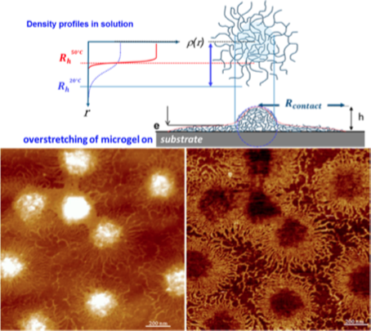 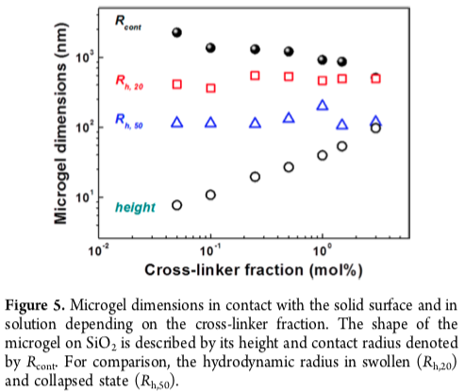

1. First, with 10 nm (100Å) resolution do you think that you can see polymer chains using an AFM, as is implied by the comparison between the top sketch and the bottom right AFM image? Consider Brownian motion of free polymer chains and the time scale of an AFM image (hours). Try to make a realistic sketch of a weakly crosslinked polymer gel nanoparticle without the “*aid*” of the AFM image. SANS results with atomic resolution in the literature do not agree with the “*Octopus-like structure*” shown here.
2. The “Pickering effect” was discovered twice in 1903 and in 1908, the latter by Pickering who made it stick, and involved the stabilization of oil/water mixtures by solid particles that can act as a surfactant to stabilize droplets (e.g. proteins in milk). Janus particles have relatively recently been used as Pickering agents. It has been proposed that SMNPs could behave as Pickering agents that could be controlled by temperature or salinity or pH. Explain how this might work in terms of our understanding of coil behavior with temperature or other thermodynamic conditions (**).
3. Explain this statement by Mourran: “*the network expands until the elasticity of the chains counteracts the expansive excluded volume repulsion*” Use equations. (You could refer to P. J. Flory “*Polymer Chemistry*” rubber elasticity chapter.)
4. NIPAm (the polymer used by Mourran) displays LCST behavior. Compare the curves in Mourran’s Figure 1 with the curves we saw in class for *R*H vs *T*. Explain the differences and similarities. Also comment on the quality of this study.

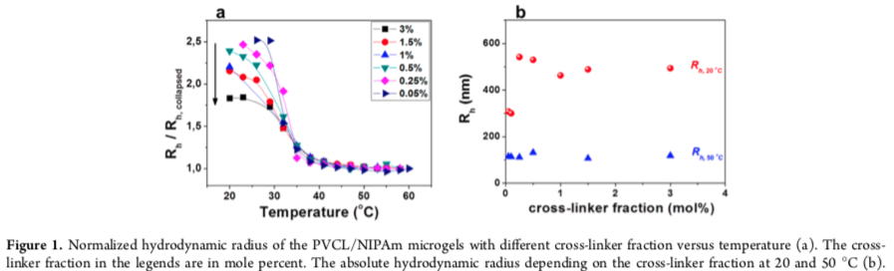

1. One of the main conclusions of Mourran’s study is that SMNPs at interfaces display different structure depending on the crosslink density as shown in Figure 5 above. Based on the modulus equation from rubber elasticity does Figure 5 make sense?

***When Colloidal Particles Become Polymer Coils* A. Mourran, Y. Wu, R. A. Gumerov, A. A. Rudov, I. I. Potemkin, A. Pich, and M. Möller *Langmuir* 2016, 32, 723−730.**