050429 Quiz 5 Polymer Properties

The concept of excluded volume began with an extremely simple physical model based on common sense. If we consider an ideal gas composed of non-interaction spheres the ideal gas law applies, P/RT = n/V = φ, where the system concentration is given by φ. For a non-ideal gas with hard core interactions we consider the virial expansion in φ, P/RT = φ + A₂ φ² + A₃ φ³ +… A₂ has units of volume per number and represents binary interactions (squared φ). A₂ increases the observed pressure so effectively reduces the available volume. The lost volume is called the excluded volume.

a) Show that for spheres the excluded volume is given by 4V₀ (V₀ is the atomic volume and divide by 2 for 2 atoms). Also, calculate the volume excluded for a rod of length L and radius a. Does excluded volume for a rod vary with aspect ratio, A = L/(2a)?
 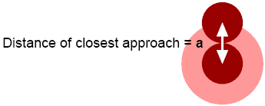 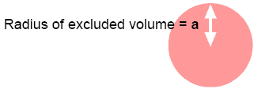.

b) In polymers, P can be related to the osmotic pressure, π, and φ is related to the concentration. The second virial coefficient is given by V_{excluded}/2 where V_{excluded} is the excluded volume for the entire chain of length N, summed for each mer unit. Give an expression, using the interaction parameter χ, for the excluded volume of a polymer chain. By equating this expression with that for a sphere, give the scaling of R_{sphere} with N_{polymer}.

c) Write an expression for the probability of an end to end distance R for a polymer chain that displays excluded volume using the interaction parameter χ. Where is the excluded volume fraction in this expression?

d) Sketch a plot of R_{g} and R_{h} versus temperature for a polymer coil near the θ temperature. Why does R_{g} differ from R_{h}? Give the Flory-Krigbaum expression for coil size. Does the Flory-Krigbaum expression for coil size agree with this plot?

e) In a plot of log intensity versus log q show a Gaussian chain with persistence noting R_{g}, l_{p} and the scaling regime; the same coil in a good solvent noting the same regions and regions that are intransigent (don't change) to solvent goodness; and a coil that displays thermal blobs (intermediate R_{g}). Explain how the thermal blob can structurally accommodate changes in χ with temperature.

