**Polymer Physics Question 1**

Layered nanocomposites are common in the polymer literature but, so far, fairly rare in application. Volkswagen recently funded a study, published this week, Rolle K, Schilling T, Westermeier F, Das S, Breu J, Fytas G *Large Tg Shift in Hybrid Bragg Stacks through Interfacial Slowdown* <https://dx.doi.org/10.1021/acs.macromol.0c02818> where samples of monolayer and bilayer intercalated polymer in clay were used as shown in the graphic below.

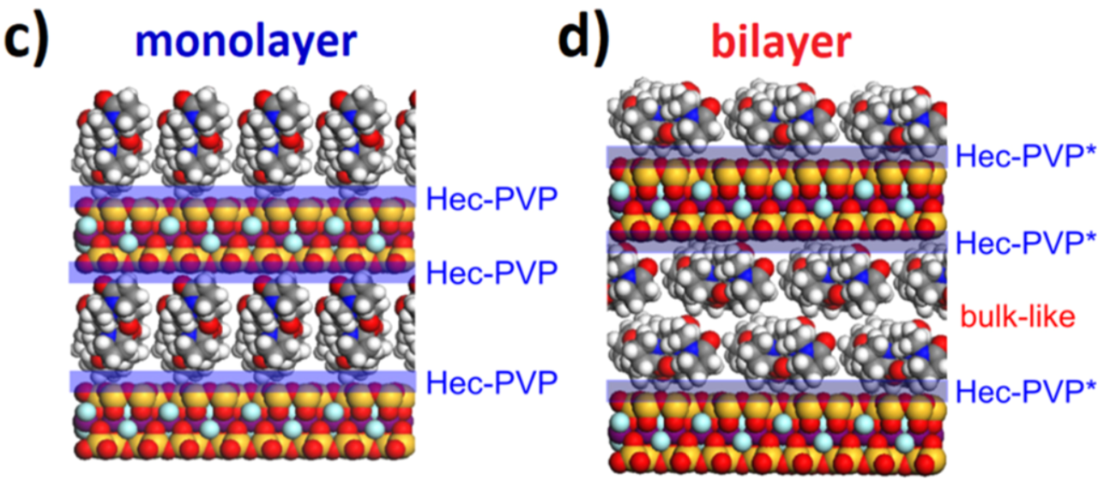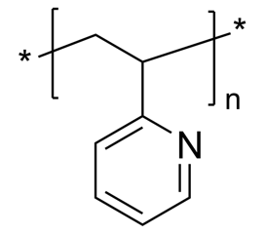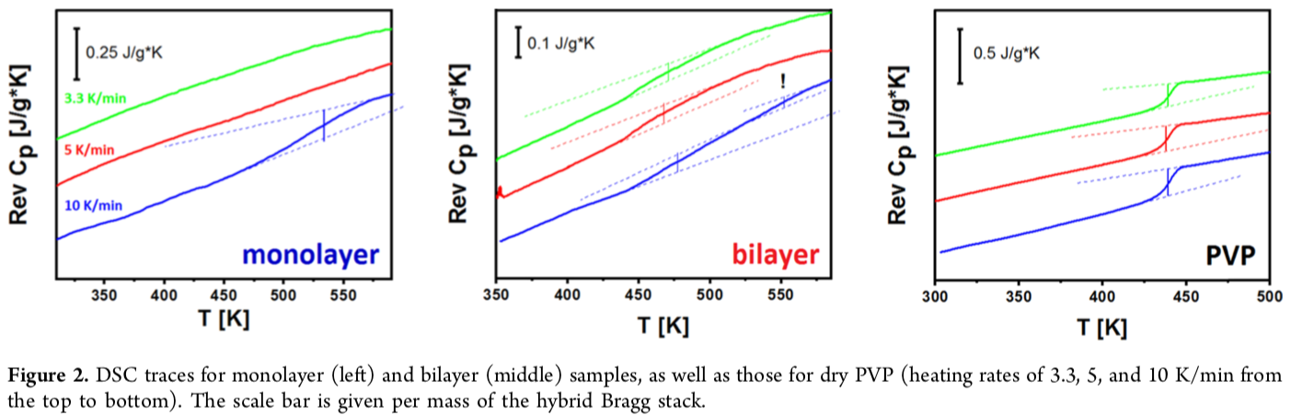

1. In the DSC traces of Figure 2, evidence is given for a single thermal regime in the monolayer sample and two thermal regimes in the bilayer sample. The monolayer thermal regime is referred to as *irreversibly adsorbed* (also called *Guiselin brush* or *bound rubber* for elastomer nanocomposites) and the other, that appears in the bilayer, *bulk-like*. Examine the plots of figure 2 and explain how the one and two regime models are supported.
2. Rolle studied P2VP polymer (shown above) intercalated in a synthetic clay mineral named fluorohectorite (Hec). The polymer has a “*contour length*” of 90nm (360 monomers) with *R*g = 13nm. The galley height for the monolayer is 1.3nm and for the bilayer 2nm. The lateral size of the Hec sheets is 340nm. What is the cause of the large shift in *T*g? Make a cartoon to support your reasoning. Can your cartoon indicate a reason for the observation of two thermal regimes in the bilayer samples?
3. Rolle obtained XPCS data (like dynamic light scattering data for X-rays) which resulted in the following decay curves and relaxation times. The data is taken at a diffraction peak associated with motion of the Hec layers. Explain what *g*2(*t*) is and how it can be used to obtain **.

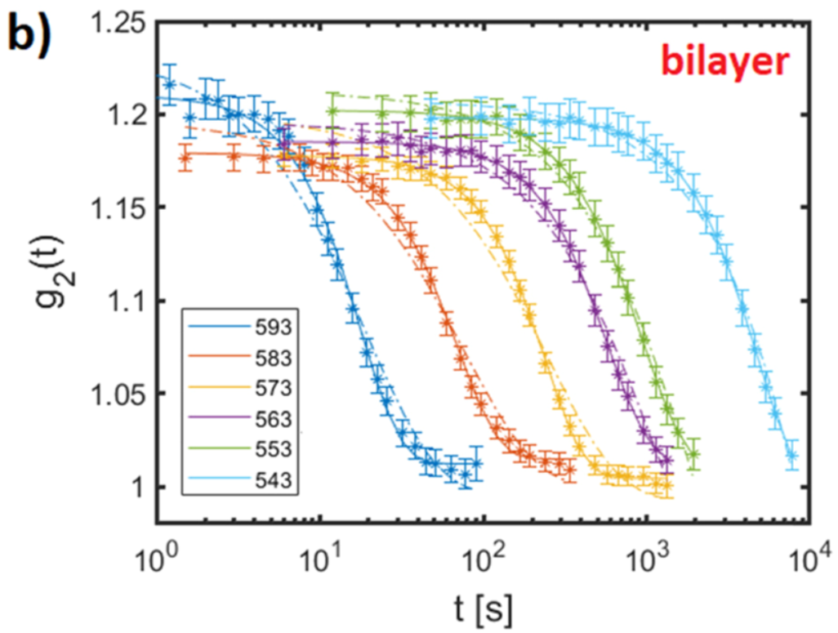 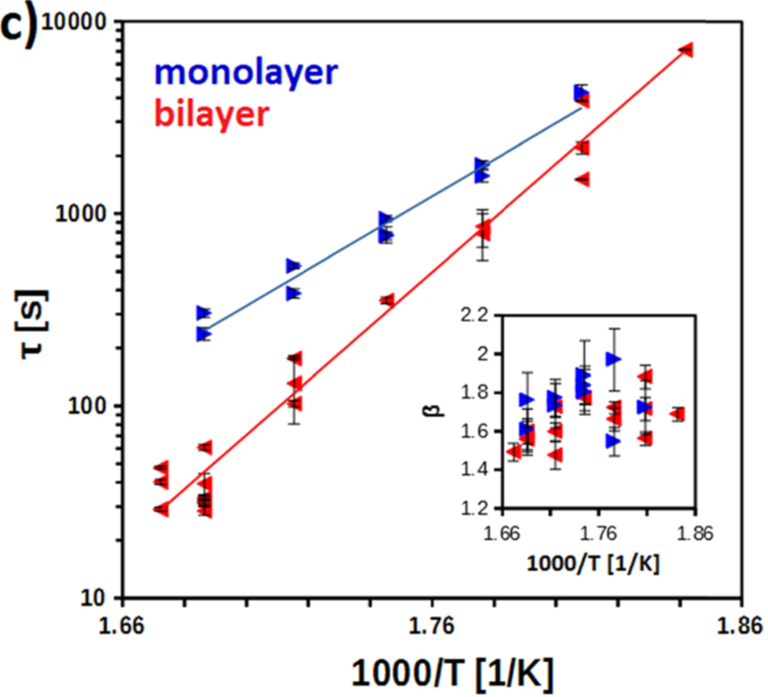

1. Why is ** plotted against 1000/*T*? What can be obtained from this plot? On what assumptions does it rely? Do you think that the assumptions are appropriate for these clay layers? Rolle uses the following equation  with ** given as an inset to the **-plot above.
2. From the **-plot what can you say about the activation energy for motion in the two cases? Does the difference in ** values correlate with the shifts observed in *T*g?

**Polymer Physics question 2**

Polymer chains are in some ways like strings or hair and can become self-knotted. This was first noticed with nucleic acids which are rigid helical polymers that are large enough to be imaged optically or with SEM in some cases. For synthetic polymers, observation of knots are more difficult so the simplest route is to perform simulations. Zhu H, Tian F, Sun L, Wang S, Dai L *Revisiting the Non-monotonic Dependence of Polymer Knotting Probability on the Bending Stiffness* Macromolecules **54** 1623-1630 (2021) propose a new model for the probability of knotting as a function of persistence length, *L*p.

1. Give a function that defines *L*p, and show that *L*p is half the Kuhn length, *L*K.
2. Zhu performs Metropolis Method Monte Carlo simulations to generate knots using a bead model with a bending potential 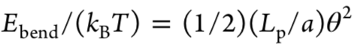 and a hard core potential with *E*pair = ∞ for *r* ≥ *a* and *E*pair = 0 for *r* > *a*. ‘*a*’ is both the diameter of the chain and the distance between beads. Does Zhu use short-range and/or long-range interactions in his model? Explain. Why is ** squared in the first equation for bending energy?
3. Give a general description of the Metropolis Method Monte Carlo simulation algorithm.
4. Zhu gives the following plot of knotting probability versus persistence length which shows an increase in knotting with increasing persistence up until *L*p ~ 5*a*. Bobbili SV and Milner ST *Simulation Study of Entanglement in Semiflexible Polymer Melts and Solutions* Macromolecules **53** 3861-3872 show in figure 12 below, that the contour length of an entangled strand (*N*e is the number of monomers in an entangled strand) decreases with increasing Kuhn length (*N*k is the number of monomers in a Kuhn segment). This means that the number of entanglements (or the entanglement probability) increases with chain stiffness. Bobbili and Milner also observe a decrease in the reptation tube diameter (which is determined by *N*e) with increasing chain stiffness as well as a transition at moderate Kuhn lengths.

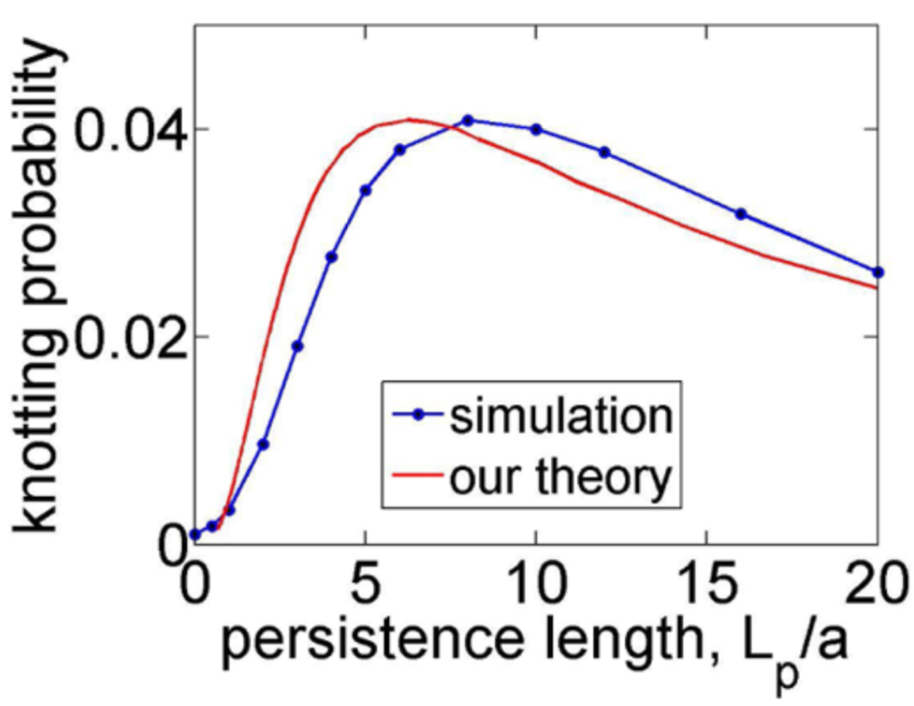 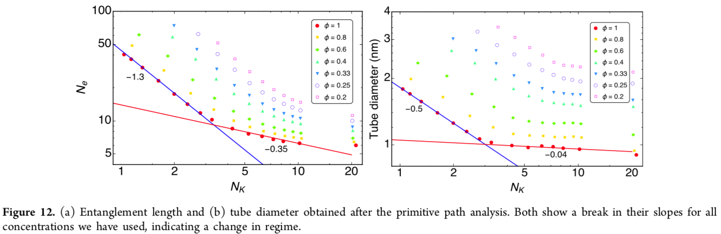

In both cases the observed behavior is the opposite of the behavior you might expect for hair, strings, or shoelaces which intuitively seem to entangle or knot when they are more flexible. Think of cooked or uncooked spaghetti. *Explain the difference between polymers and spaghetti that leads to this opposite and counter-intuitive behavior.*

1. Bobbili and Milner used a molecular dynamics (MD) simulation in their study with the 6-12 potential and bending potential shown below. Give a short outline of an MD simulation algorithm.

