**Question 1. Polymer Physics.**

S Chandran et al. (*Processing Pathways Decide Polymer Properties at the Molecular Level* Macromolecules 2019 DOI: 10.1021/acs.macromol.9b01195) discuss the general problem of linking molecular orientation during processing with properties in processed polymers. They choose three types of processing: spin coating, stretched polymer fibers, and flow-induced crystallized polymers.

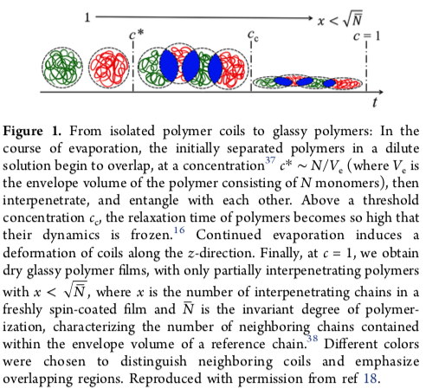

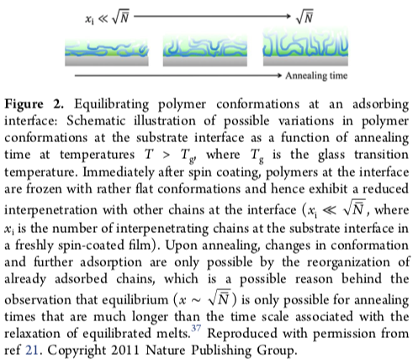

a) Figure 1 shows Chandran et al.’s impression of a polymer that dries on a surface from a solution. Concentration increases during drying. Explain the transition between the first and second cartoon. Define *c*\* and explain how you thing it would impact the chain structure during drying. Would you expect a difference in surface tension between the left and center solutions in Figure 1?

b) The second to third cartoon in Figure 1 relates to a transition in chain dynamics. Sketch a plot of log of the zero-shear rate viscosity versus log of the shear rate for a high molecular weight polymer melt and identify the dynamic relaxation time. Show how the shape of this curve would change with dilution. And use these viscosity curves to explain the meaning of *c*e in Figure 1.

c) Explain the origin of the term √N in Figure 1.

d) In Figure 2, x is the number of interpenetrating chains at the substrate interface. Why is this value important and what is the relevance of √N to this value?

e) Paint is partially a polymer in a solvent that is applied under shear to a surface. From your answers to parts a to d, explain what you would expect the final polymer conformation would be in the dried paint. How would this conformation impact the performance of paint?

**Question 2. Polymer Physics.**

Polymer networks and elastomers are normally produced by introduction of a crosslinking agent such as elemental sulfur into a polymer melt containing reactive functional groups such as double bonds in polybutadiene. Reaction leads to multifunctional crosslink sites that produce a molecular network so that the entire sample is a single molecule. Single chain nanoparticles (SCPNs) are chains that are crosslinked within a single chain, intrachain crosslinking, but not between different chains, interchain crosslinking, as in a rubber. Arbe et al. (*Mesoscale Dynamics in Melts of Single-Chain Polymeric Nanoparticles* Macromolecules

2019, 52, 6935-3942.) reports on studies of melts of such SCPNs.

a) Figure 5 shows the dynamic rheology curves for an SCPN and the linear chain from which it was made (Precursor or “Prec” in the graph). Define *G*”, *G*’, and tan **.

b) What does a value of tan ** > 1 mean in terms of the material properties.

c) Explain how the behavior you mention in part “b” can be frequency dependent.

d) What are the meanings of **d and **e in the second plot below?

e) Why would **d be significantly different between the linear and SCPN samples while **e is comparable between the two samples?

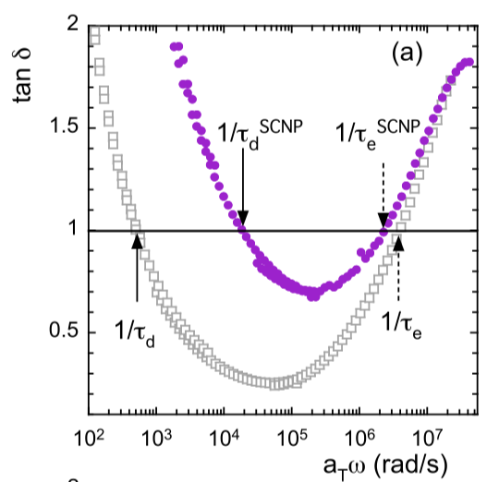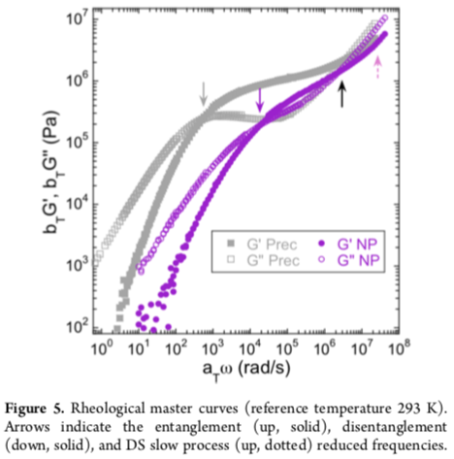

**Question 3. Characterization.**

The Fourier Transform (FT) involves deconvolution of a summation of sin waves from a decay or noise pattern. In polymer characterization the FT is used in FTIR, NMR, and in diffraction/scattering making it a common mathematical tool for characterization.

a) Explain how a FT could be used to understand variation in the Dow Jones average with time. The DJ average is an average of the top 500 stock prices on the New York Stock Exchange.

b) Describe what an interferometer is by sketching the device and the interferogram that results. How is a FT used with the interferogram?

c) How is an interferometer used in an FTIR? What component does it replace compared to a dispersive IR instrument?

d) How are FTs used in NMR? Explain what ** is in an NMR data plot.

e) In scattering, the scattering vector, |***q***| = 4/ sin **, is used to describe the spatial period of density oscillations, *d* = 2 /|***q***|. How is a FT used to relate real space, *d*-space, and inverse space, *q*-space, in scattering/diffraction?