**Question 1 Polymer Physics.**

Gote and collaborators at Pune developed a heterogeneous catalyst that produces disentangled ultra-high molecular weight polyethylene (*dis*-UHMWPE) of 13 x 106g/mol. They demonstrate that the polymer is disentangled by its high melting point (141-144 °C) with a melting point of 135°C on second heating and through oscillatory rheological measurements in the linear viscoelastic limit which display a rise in plateau modulus at elevated temperature.

a) Why might Gote be interested in producing disentangled UHMWPE? Explain what an entanglement is and why it might be of importance to polymer properties. Specify 4 properties that are directly impacted by entanglements. (You might want to compare oligomer and polymer behavior for materials such as wax and polyethylene or low molecular weight organics and polystyrene.)

b) Biological polymers such as DNA are often of enormous molecular weight. Are they entangled? Explain the consequences in terms of their biological function.

c) What does a change in melting point indicate about polymer crystals? How can the melting point for the same polymer change? Do you think that this is a good measure of the presence of entanglements? Explain why or why not.

d) Comment on the DSC curves presented by Gote in Figure 5 below. Estimate the relaxation time for a chain of *dis*-UHMWPE form these curves? Is this a reasonable number for a chain of more than 10 million g/mole?

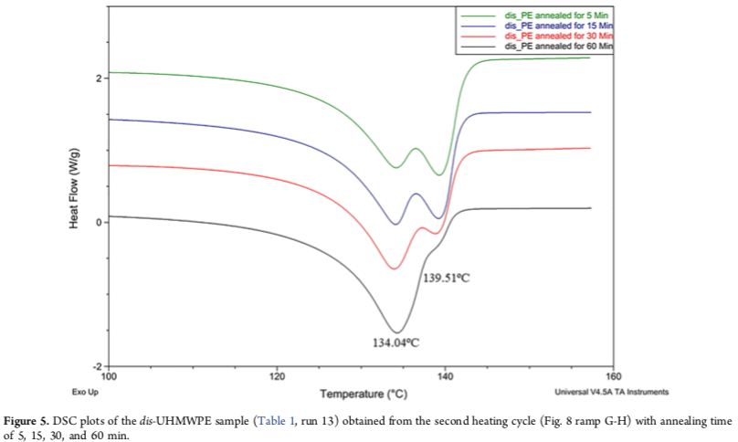

e) Figure 6 shows the increase of the plateau modulus with time at 190°C. How is the plateau modulus related to entanglements (give an equation)? What is your estimate for the relaxation time form this plot? Is it similar to the value from the DSC measurement? Explain why it is the same or why it is different. (*You might want to comment on what happens to polyethylene at 190°C for two days as an aside*.)

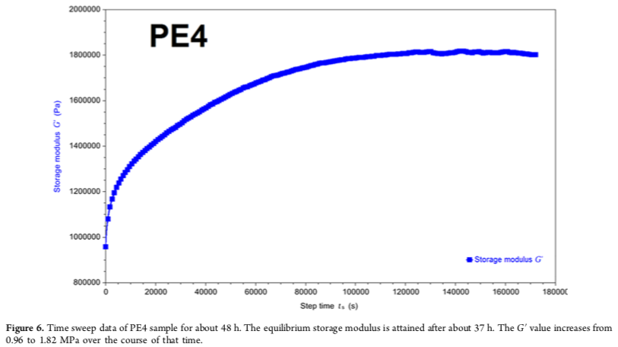

Gote RP, Mandal D, Patel K, Chaudhuri K, Vinod CP, Lele AK, and Chikkali SH, *Judicious Reduction of Supported Ti Catalyst Enables Access to Disentangled Ultrahigh Molecular Weight Polyethylene,* *Macromolecules* **51**, 12, 4541-4552 (2018).

**Question 2 Polymer Physics**

Katsumata, Dulaney, Kim and Ellison recently published a paper discussing the relationship between *Tg*, viscosity (**), and diffusion coefficient (*D*) comparing bulk and confined conditions.

a) Consider the size scale related to these three parameters in the bulk. Are they related to the same size scale? In this context, comment on the possibility of a relationship between these three parameters.

b) Katsumata indicated that the WLF equation is used to describe the relationship between *Tg* and ** in the bulk. Explain the relationship between the Arrhenius equation, the Vogel-Fulcher Equation, and the WLF equation. How is *Tg* used in the WLF equation to describe **. Does this explain how your answer to part “a” can be overcome?

c) Katsumata further indicated that the Stokes-Einstein (SE) relationship is used to connect *D* and **. Give the Stokes- Einstein relationship and explain how it connects different size scales.

d) Katsumata states the following:

*The SE equation is not valid for all conditions, and the deviation from this relationship is known as the “breakdown in the SE relationship”. The breakdown of the SE relationship is often explained by a dynamic heterogeneity argument. As temperature decreases toward Tg, the polymer becomes more spatially heterogeneous with domains that are estimated to be ∼3 nm with the time scales of the “slow” and “fast” regions differing by a range of 1−5 orders of magnitude. In this study, it is hypothesized that confining interfaces could cause deviations from well-established bulk correlations based on the WLF and SE equations and that these deviations could be a function of the interfacial interactions.*

Critically comment on the concept of “dynamic heterogeneity”. Do you believe that dynamic heterogeneity exists? What evidence can you give to support your belief. (Consider the size of a polymer molecule, the distance between entanglements, and the size scales for part a, and ~3nm.)

e) Figure 4 below shows *Tg* as a function of film thickness (top row) demonstrating a nano-confinement effect at low film thickness for two geometries and two polymers. The lower plots show the measured self-diffusion coefficient and a dashed curve calculated from the WLF equation using *Tg* from the top plots. The last two examples display a deviation from WLF behavior that Katsumata indicates supports a breakdown in the SE relationship. *Tg* is measured by changes in film thickness with temperature and *D* is measured by the spread of a fluorescently tagged polymer. Do you see support for breakdown in the Stokes-Einstein relationship? Explain.

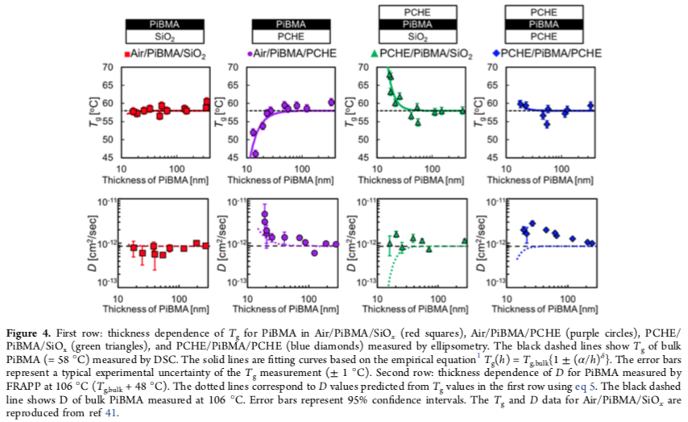

Katsumata R, Dulaney AR,  Kim CB, Ellison CJ, *Glass Transition and Self-Diffusion of Unentangled Polymer Melts Nanoconfined by Different Interfaces, Macromolecules* **Article ASAP,** DOI: 10.1021/acs.macromol.8b00475 (2018).

**Characterization Question 1**

Rubbers, gels, human tissue and other similar soft materials do not display a linear relationship between stress and strain so the Young’s modulus cannot be determined using the method common for metals and ceramics. For soft materials the Mooney-Rivlin plot is used to determine the parameters C1 and C2.

1. Explain why a linear relationship exists between stress and strain for metals and ceramics but not for materials such as gels and elastomers.
2. Give the Mooney-Rivlin equation and explain how it relates to the Mooney-Rivlin plot shown below in Figure 1 from Sombatsompop et al (cited below).

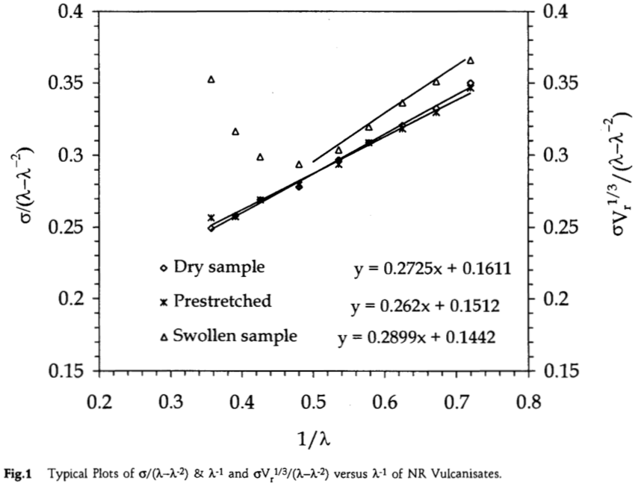

1. *C1* is the modulus of the natural rubber (NR) elastomer. What feature in Figure 1 is related to *C1* and how is *C1* related to the molecular weight between crosslinks, *Mc*?
2. In Figure 1, why do the triangle points curve upwards at low 1/?
3. For a gel the molecular weight between crosslinks (or the crosslink density, *s*) can also be determined from the swelling ratio using the Flory-Rehner equation given by Sombatsompop in equation (7). Explain how the terms in equation (7) are obtained (f is the functionality typically 4, *Vs* the molar volume of solvent, *Vr* the volume fraction of rubber). Explain the origin of equation (7) in terms of a force balance and define the parameter **.



Sombatsompop N, *Practical use of the Mooney-Rivlin equation for determination of degree of crosslinking of swollen NR vulcanisates.*, *J. Sci. Soc. Thailand* **24** 199-204 (1998).