1) As the concentration of a polymer in solution increases the overlap concentration is reached, c*. Another measure of polymer chain interaction with increasing concentration is the entanglement concentration, ce. For neutral polymers in solution ce ~ 10c* but for such polymers under certain highly deformational flow conditions c* > ce.

1. Explain how c* can be theoretically calculated giving the necessary equations (if possible).
2. Explain how c* can be experimentally measured by describing such an experiment and giving the necessary equations (if possible).
3. Explain how ce can be theoretically calculated giving the necessary equations (if possible).
4. Explain how ce can be experimentally measured by describing such an experiment and giving the necessary equations (if possible).
5. In the following plot from Clasen et al. 0 is the terminal relaxation time from an extensional flow experiment, z is the calculated relaxation time for a Rouse chain. Explain the behavior in this plot (for a start what do values of 1 mean on each of the two axis). For instance, does the behavior support an identity between c* and ce, and why might the observed behavior occur? [*How dilute are dilute solutions in extensional flows?*C. Clasen, J. P. Plog,, W.-M. Kulicke, M. Owens, C. Macosko, L. E. Scriven, M. Verani and G. H. McKinley, J. Rheol. **50** 849-881 (2006); *Structure and linear viscoelasticity of flexible polymer solutions: comparison of polyelectrolyte and neutral polymer solutions* R. Colby, Rheo. Acta **49** 425-442 (2010)].

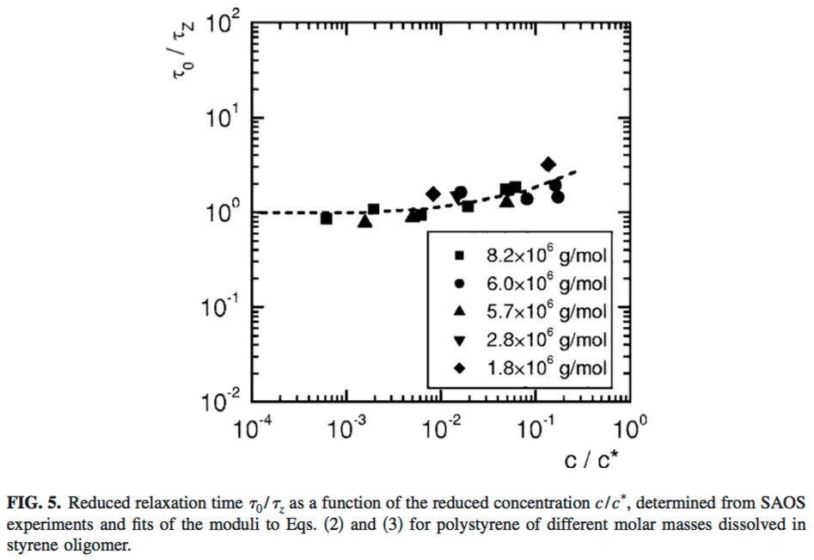

2) The growth rate of polymer crystals is most rapid at a temperature between the glass transition and the melting point.

1. Sketch a plot of the rate of crystallization versus temperature and give an equation or equations that explains this behavior.
2. What thickness would you expect for crystals formed at the temperature of maximum crystallization rate? (Give an equation.)
3. Crystals formed at this temperature of maximum growth rate do not melt at this crystallization temperature but at a higher temperature. Why is this the case? (You might want to first consider a condition where the temperatures of crystallization and melting are identical and why they might deviate from this condition.)
4. A polymer chain in the melt has a certain chain conformation that gives rise to a relationship between the radius of gyration and the chain mass. How would this relationship change in a semicrystalline polymer for chains that pass through amorphous and crystalline phases? Explain you reasoning. [*Small-angle neutron scattering studies of molecular clustering in mixtures of poly- ethylene and deuterated polyethylene* J. Schelten, G. D. Wignall, D. G. H. Ballardand, and G. W. Longman, Polymer **18** 1111-1120 (1977).]
5. The following micrographs from Pradhan et al. show high density polyethylene crystallized in supercritical propane. The solvent is removed in the absence of surface tension under supercritical conditions so that no structural perturbation occurs. Explain the change in morphology as a function of polymer concentration based on your understanding of crystallization behavior in polymers. Crystallization for these samples occurred at room temperature in all cases. The scale bar is 30 micron in all micrographs. [*Morphologies of Microporous Polyethylene and Polypropylene Crystallized from Solution in Supercritical Propane*, D. Pradhan and P. Ehrlich, J. Polym. Sci. Part B Polym. Phys. **33** 1053-1063 (1995).]

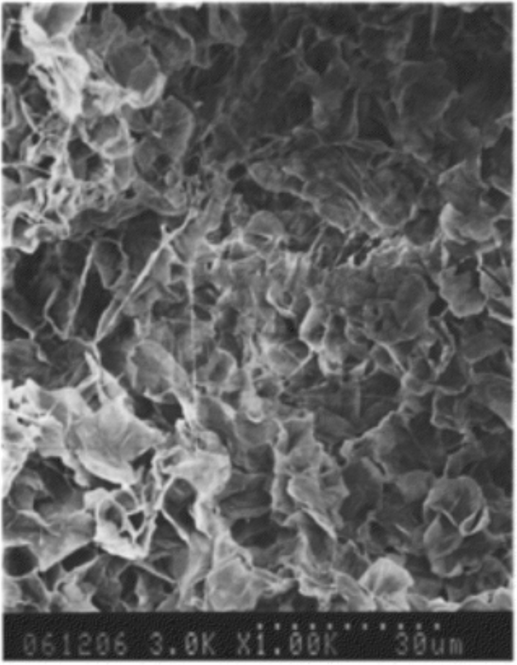 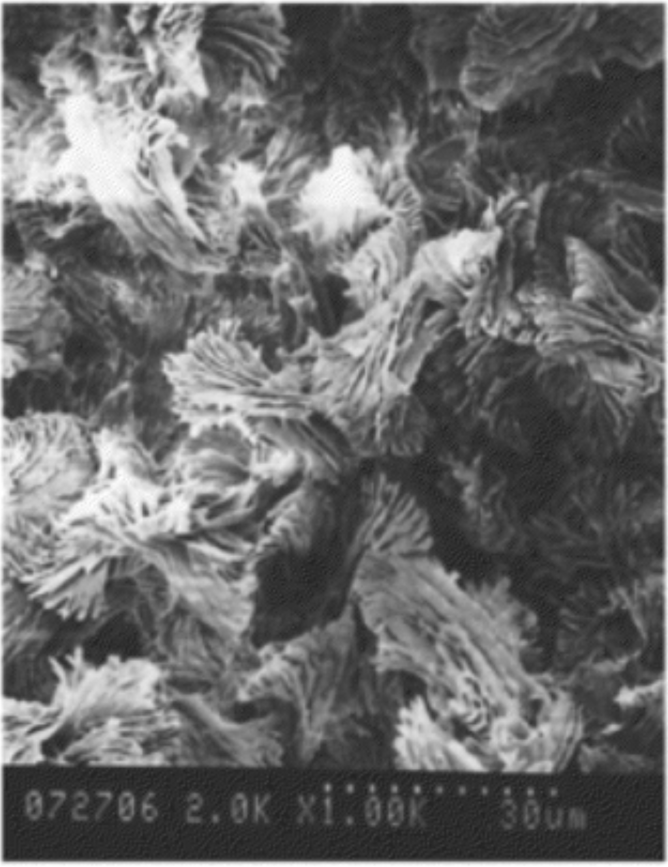 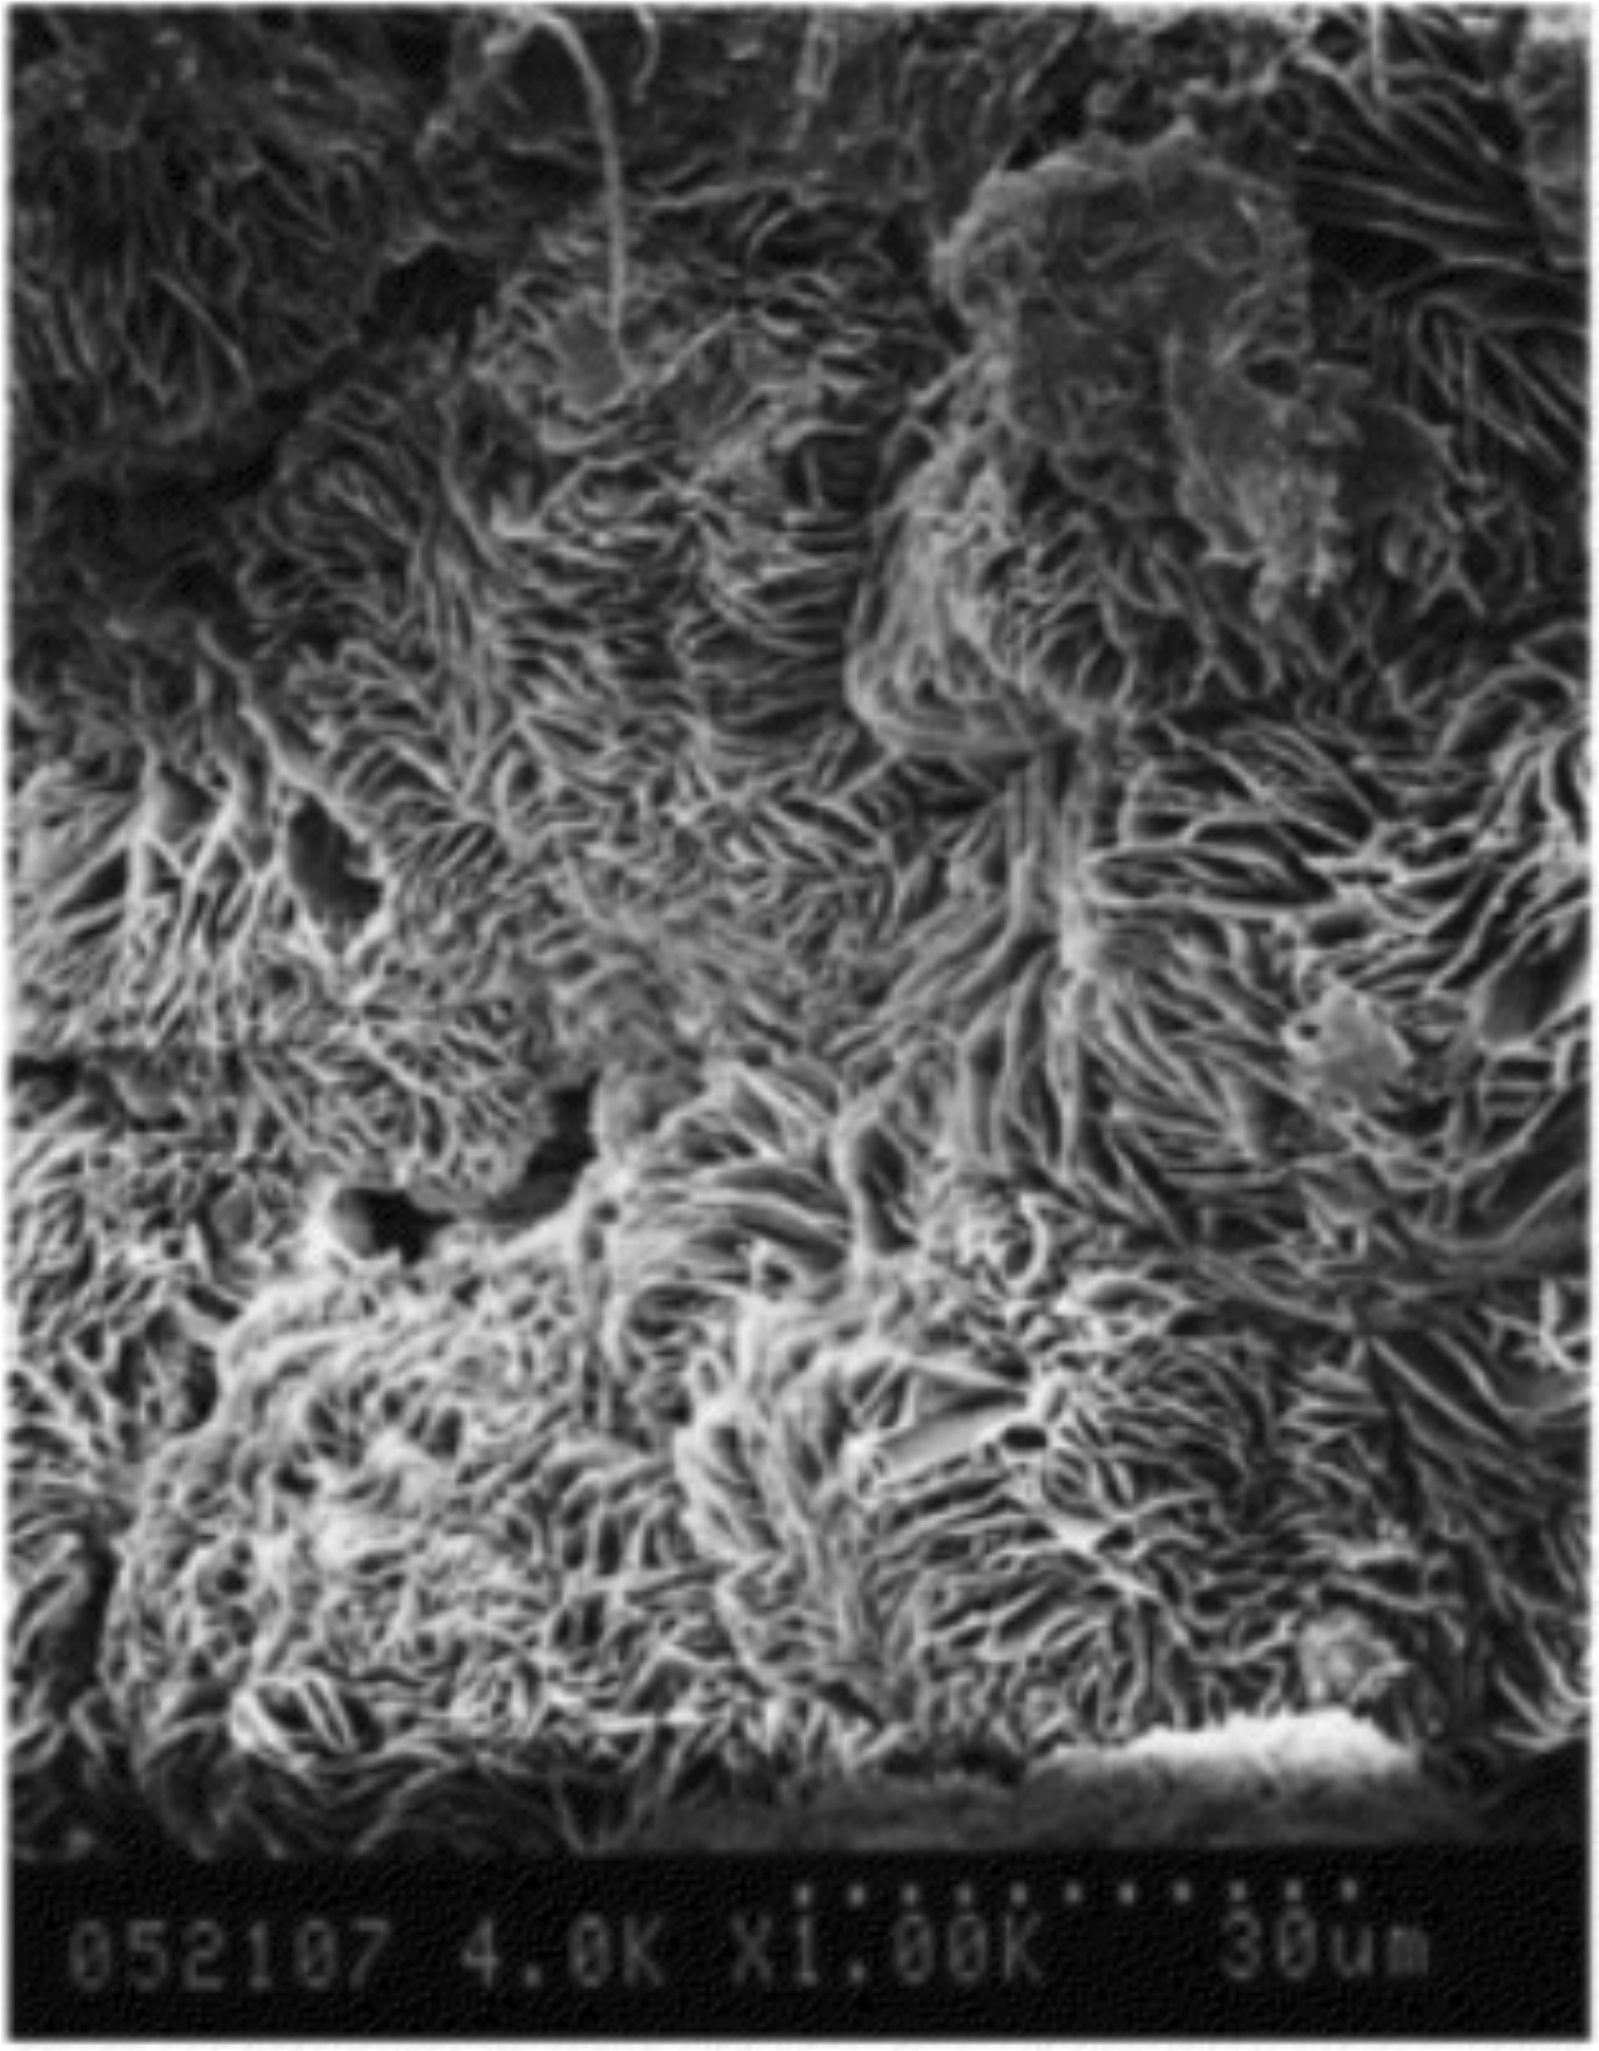

5% HDPE 23% HDPE 35% HDPE