**Polymer Physics Question 1**

Polymers are unlikely to mix since the entropy of mixing is generally low. The entropy of mixing is also low for polymer solutions. Generally, a negative enthalpy of mixing is required to ensure miscibility. If this is associated with specific interactions between polymers or between a polymer and a solvent, these interactions are often overcome at high temperature leading to LCST behavior. On the other hand, if polymers have self-interactions such as hydrogen bonding in proteins these interactions can lead to phase separation on cooling if other, stronger interactions exist with a solvent. This can lead to UCST behavior. Beaudoin G, Lasri A, Zhao C, Liberelle B, De Crescenzo G, Zhu X-X, *Making Hydrophilic Polymers Thermoresponsive: The Upper Critical Solution Temperature of Copolymers of Acrylamide and Acrylic Acid* Macromolecules **54** 7963-7969 (2021) synthesized copolymers of polyacrylamide and polyacrylic acid which, similar to proteins, can hydrogen bond between polymers. Under certain pH the polymers can display a UCST in water.

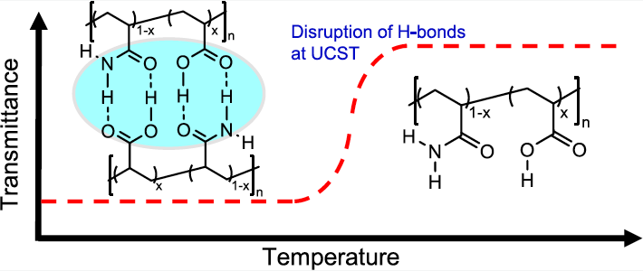 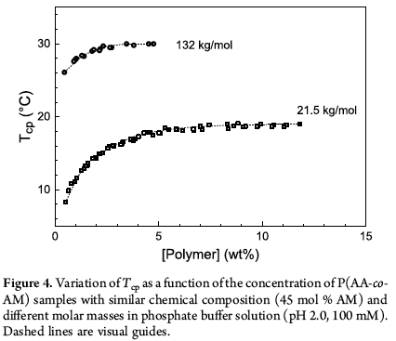

1. Give the Flory-Huggins equation for a polymer solution and a definition of the Flory-Huggins interaction parameter that allows for specific interactions. Explain how LSCT and UCST behavior can be created using these parameters. Define non-combinatorial entropy.
2. Figure 4 shows the binodal curve as measured by the cloud point for two copolymers of different molecular weight. What functionality do you expect for the critical point with molecular weight? Do these curves follow that functionality?
3. Figure 4 doesn’t show the spinodal curve. What is the spinodal curve and how would you obtain the spinodal curve?
4. What is the overlap concentration *c*\*? Define *c*\* in terms of the chain molecular weight. How would *c*\* impact Figure 4? How should the cloud point behave below *c*\*? What happens to a chain if it phase separated below *c*\*?
5. For a chain below *c*\* how does the coil size depend on the interaction parameter and the temperature?

**Polymer Physics Question 2**

Polymers are viscoelastic materials with a native relaxation time, **. In a mechanical measurement a strain is applied at a rate, *t*\* = 1/**’. The Wissenberg number, *Wi*, is defined as **/*t*\*. Yang H, Wu S, Chen Q, How to *Choose a Secondary Interaction to Improve Stretchability of Associative Polymers?* Macromolecules **54** 8112-8121 (2021) Consider the brittle to ductile transition for polymers through introduction of multiple relaxation times. One relaxation time, the Rouse time, relates to the chains, and secondary relaxation times associated with ionic interactions (strong) and hydrogen bonding (weak). The number and type of these relaxation time has a dramatic impact on the mechanical properties.

1. For a material displaying only Rouse relaxation and with *Wi* > 1, the elongation, *λ* = *N*bb1/2, where *N*bb is an average number of Kuhn segments per network strand. Define Rouse relaxation, explain the origin of the ½ power law, and explain why this elongation is reached with *Wi* > 1. How would the material behave at a slower extension rate with *Wi* < 1?
2. Is the Rouse time appropriate for entangled polymer chains such as in a melt? The chains in this study are rather stiff and have molecular weights of about 10 kg/mol. Is the Rouse time appropriate for these chains in the melt? Why?
3. Figure 2 shows the linear visco-elastic spectra for several of the samples prepared by Yang. Explain the origin of the 2 and 1 power-law regimes. What does the plateau regime in *G*’ indicate? What does the peak in *G*” indicate? Explain the high frequency behavior.

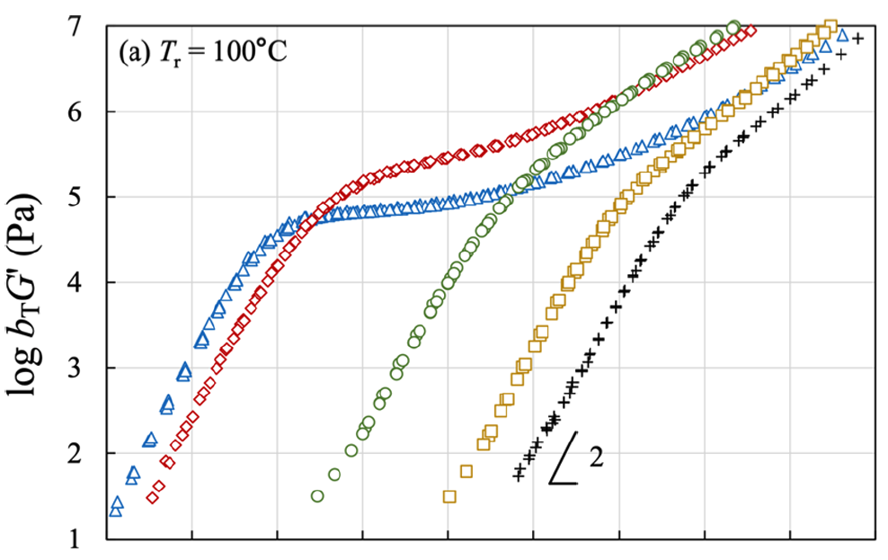 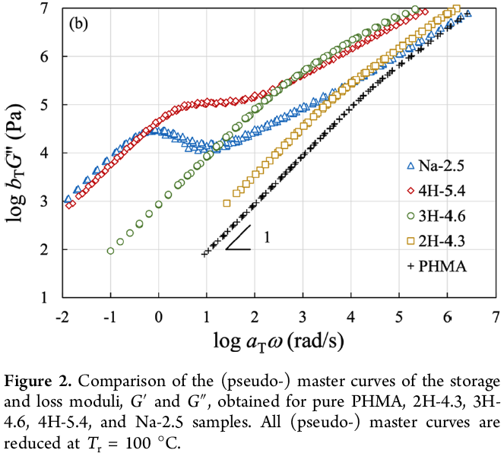

1. In Figure 2, PHMA has no stickers per chain, the H samples have 5.4, 4.6 and 4.3 weak hydrogen bonding stickers per chain and the Na-2.5 has 2.5 strong ionic stickers per chain. Explain the behavior of the curves with regard to the presence of these network forming bonds. Is the relaxation time for the ionic and hydrogen bonds shorter or longer than the Rouse relaxation time?
2. Equation (4) is the Williams-Landel-Ferry (WLF) equation.



Explain how this equation is used to produce Figure 2. How is this equation related to the Arrhenius equation?