**Thermodynamics Question 1**

One form of the Gibbs-Thompson Equation (GTE) describes the shift in melting point for nano-crystals as a function of their size and can be adapted to describe the shift in melting point for confined fluids such as at an AFM tip as a function of a fluid filled gap’s height, *h*, Fig. 2 below. Scalfi L, Coasne B, Rotenberg B, *On the Gibbs-Thomson equation for the crystallization of confined fluids.* J. Chem. Phys. **154** 114711 (2021) present a new derivation of the GTE for confined fluids and use the derivation to simulate crystallization in confined pores and gaps using a Monte Carlo method.

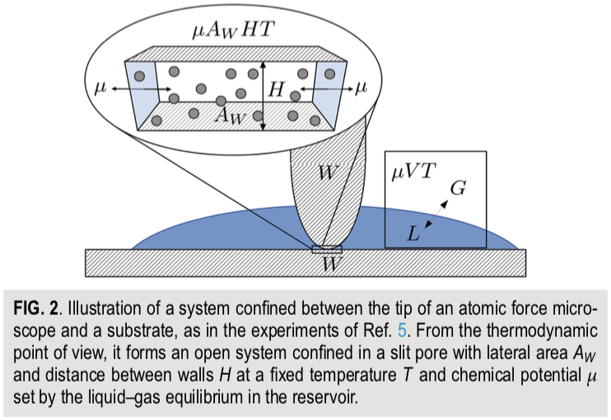 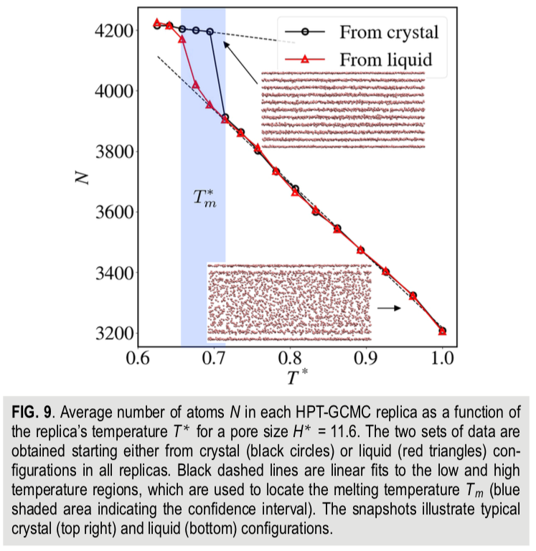

1. The normal derivation of the GTE involves simply writing an expression for the Gibbs free energy that includes volumetric and surface terms, considering equilibrium for small particles (spheres) and solving for the particle size. **Derive the GTE** in this way for a planar crystal with infinite width and height *H* (Scalfi uses “*h*” for the enthalpy per particle). Scalfi’s GTE includes two surface energies, that of the liquid and that of the solid. **How do you accommodate this in your derivation**?

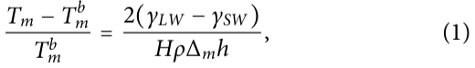

1. Scalfi gives the following thermodynamic potential (2) and internal energy (3) for the fluid/solid between the gap,





Use the thermodynamic square or other means to **explain the origin of these two expressions**. **What kind of free energy** is * *?

1. The son of Herman von Helmholtz (Robert von Helmholz) derived the Gibbs-Thompson equation from the Oswald-Freundlich Equation (OFE) using the integrated Clausius-Clapeyron Equation (CCE) for his PhD dissertation in 1885 (things were simpler then).

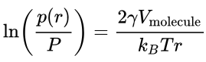 OFE

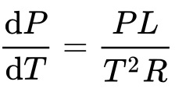 CCE

For this reason, the OFE or Kelvin Equation is sometimes referred to as the GTE. **Obtain the GTE from the OFE using the integrated CCE. Also, give (don’t derive) the Ostwald-Freundlich Equation** which describes the relationship between the supersaturated mole fraction, *x*, and nanoparticle size, *r*, for crystallization from solution.

1. Scalfi used Monte Carlo Simulations with the Metropolis method to determine the melting point, Figure 9 where *N* is the density and *T*\* is a reduced temperature. He used a 6-12 potential with a cutoff of 2.5 ** where ** is the atomic size. Monte Carlo steps involved translation, deletion or insertion. The starting state could be liquid or crystal structures and resulted in the densities shown in Figure 9. **Give an algorithm** for a typical Metropolis simulation of this type. **How would you determine** if the simulation had reached equilibrium?
2. In Figure 9 Scalfi shows that the crystalline structure exists at the interface with the AFM tip and the stage (which is the same material in the simulation) even in the (bulk) amorphous state (lower structure). Derive expressions comparing the **free energy barrier,** *G****\**, and phase size,** ***r\****, for surface (heterogeneous) and bulk (homogeneous nucleation). Can this explain the observed behavior?

**Thermodynamics Question 2**

Seede R, Ye J, Whitt A, Trehern W, Elwany A, Arroyave R, Karaman I, *Effect of composition and phase diagram features on printability and microstructure in laser powder bed fusion: Development and comparison of processing maps across alloy systems* Add. Man. **47** 102258 (2021) consider four nickel super alloys that are used for laser powder-bed-fusion (LPBF) additive manufacturing (AM) (3d printing). In this process a layer of metal powder is deposited followed by melting of a structural layer using a laser to form a solid metal layer. The process is repeated for successive layers. After many layers are deposited the excess metal powder is removed and a 3d part has been created. Control of the crystalline phases and their structure during the AM process is important to the final properties. Seede considers four super alloys Ni-20% Cu, Ni-5% Al, Ni-5% Zr, and Ni-8.8% Zr. Figure 1 shows the phase diagrams for these four alloys.

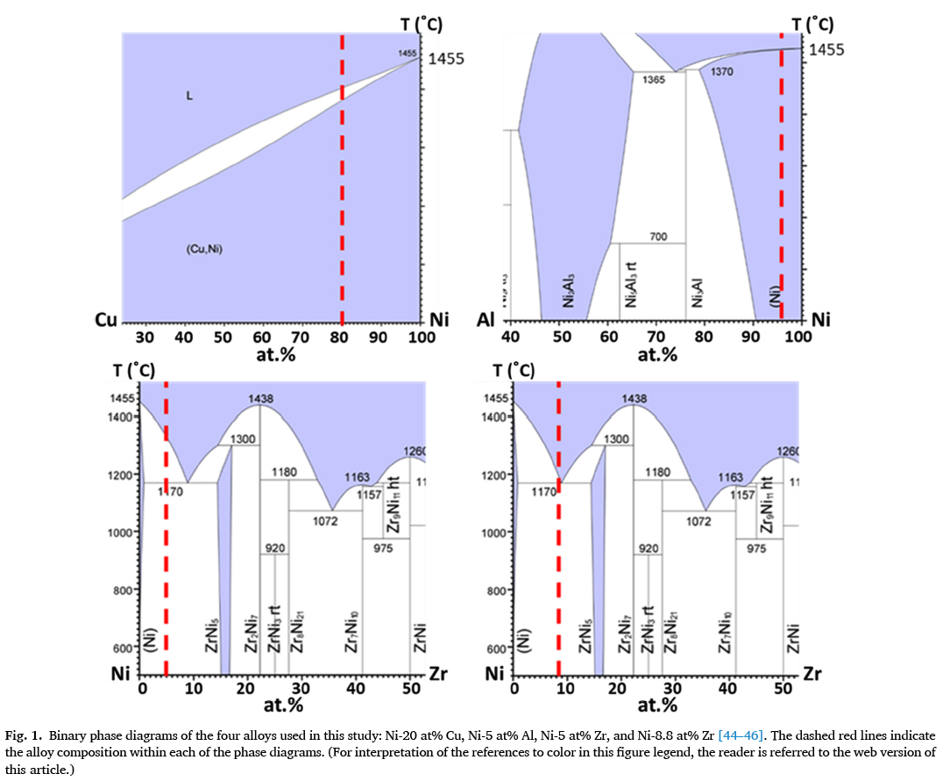

1. For Ni-20% Cu **what type of system** is this? How would you determine the **composition and amounts** of the phases present if the temperature and composition were in the white region of the phase diagram? For such a system if you observed spherical domains in a matrix phase, **what is the state and composition of the spherical domains and of the matrix phase**?
2. For Ni 8.8% Zr **what type of phase region** is this? **What is the triple point called**? **Write the reaction** that occurs at this point and **write the Gibbs phase rule** that shows that this condition only occurs at a point on the phase diagram. If the sample were quenched from the liquid to the melt sketch a cartoon of the structure that would result including which parts would be Ni rich and which would be Zr rich.
3. For Ni 5% Zr consider two thermal regimes, a slow cool to the bottom of the phase diagram and a quench to the bottom. Sketch a cartoon showing the resulting structure including accurate phase amount and labeled compositions of the phases.
4. There are several intermetallic phases that exist in these phase diagrams. Explain what an intermetallic is and why it forms. List the location of all of the intermetallic phases in these phase diagrams.
5. Seede presents the following processing maps for LPBF AM. In these maps keyholing is the presence of voids between previous powder grains that remain in a solid part. Balling indicates beading of the powder. Both are defects that are detrimental to the product. Explain **why the boundary between the orange and white regions are linear** in these plots **why the linearity fails** and **why balling and keyholing are observed**. **Why is the phase diagram important** to an analysis of these processes?

