**Polymer Physics Question 1**

Cai, Panyukov and Rubinstein (Macromolecules **44** 7853-63 (2011) *Mobility of Nonsticky Nanoparticles in Polymer Liquids*) discuss microrheology techniques involving the observation of the thermal motion of spherical nanoparticles in polymer solutions, gels, or melts.

1. Cai mentions that all of these techniques utilize the Stokes-Einstein (SE) relationship that defines the diffusion coefficient in terms of the temperature and the particle radius, *R*. Give Stokes law and the SE equation. Explain the physical basis for the SE equation.
2. Cai finds the that motion of a particle depends on the size of the particle, *d*, relative to the mesh size or correlation length, **, and the tube diameter, *a*, with ** < *a*. Make a sketch of a polymer melt or a polymer in a semi-dilute solution and in this sketch define the mesh size and the tube diameter.
3. For particles smaller than ** thermal motion of the particle is diffusive. Write an expression for the mean square distance traveled, <*r*2>, as a function of time, *t*, for ordinary diffusive motion.
4. For particles ** < *d* < *a* the thermal motion of the particle is ballistic. Write an expression for the mean square distance traveled, <*r*2>, as a function of time, *t*, for ballistic motion. Why do you think the particle motion is ballistic for this size particle?
5. In addition to spatial dimensions, particle motion is defined by several relaxation times including the relaxation time of an entanglement, **e, and the reptation time, **rep.

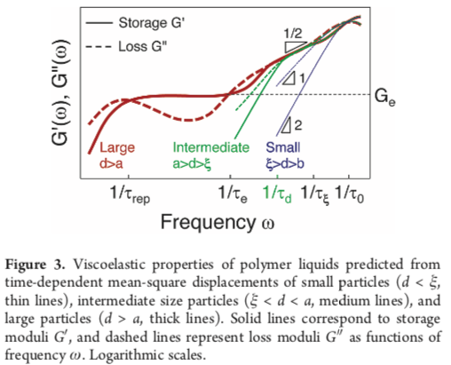

Define the reptation time using the tube model and explain the difference between **e and **rep. Figure 3 shows the particle size required to probe different parts of the viscoelastic spectrum. Mark on this graph where you expect to see liquid (L) and where you expect to see solid (S) properties.

**Polymer Physics Question 2**

C. G. Lopez (*Scaling and Entanglement Properties of Neutral and Sulfonated Polystyrene* Macromolecules **52** 9409-15 (2019) ) reported on the structural and viscous properties of polyelectrolyte solutions in the limit of a charge chain (no salt) and an uncharged chain (high salt content).





N

N

-0.8

-2

1. Explain why the charged state of a polyelectrolyte would change with added salt using the concept of the Debye screening length.
2. ** in the right figure is 1/*d*f where *d*f is the mass-fractal dimension. Give an expression for the overlap concentration, *c*\*, as a function of the molecular weight, *N*, for the three structures shown in the right figure.
3. Explain the plot shown to the left, Figure 3.
4. At about *N* = 40 there is an intersection of the two lines and the values for c* for the DI water sample (charged) seem to follow the line for high salt (uncharged) for *N* < 40. Explain the significance of *N* = 40 with reference to the cartoon molecules shown to the right.
5. Lopez found that the entanglement concentration, *c*e, is only weakly impacted by charge screening (salt content) while *c*\* has the strong dependence shown in Figure 3 (*top line - high salt; bottom line - no salt*). Explain the difference between *c*e and *c*\* and why *c*e might not depend strongly on the state of charge on the chain.