1) Unidad, Richter, and Fetters [*Macro.* **48** 6638 (2015)] draw connections between the packing length, p, and certain rheological transitions they have found in polymer melts. Unidad describes three regimes seen in Figure 1 below: 1.) Rouse behavior for M < Mc; 2.) Reptation with constraint release and contour fluctuations between Mc and Mr; and 3.) Pure reptation behavior for high molecular weights M > Mr.

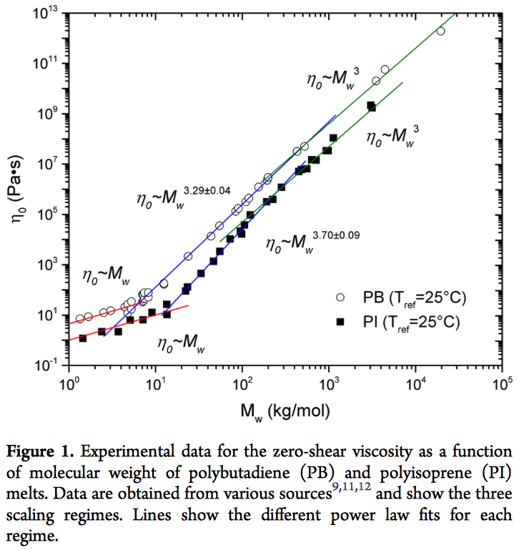

1. Give an equation that defines the packing length.
2. The entanglement molecular weight, Me, is determined by the plateau modulus,

G0 = RT/Me. Derive this equation from the Gaussian probability function and explain why Me is related to the plateau modulus.

1. Unidad relates Mc and Mr from Figure 1 with Me using, Mc = Me[p*/p]0.65 and Mr = Me[p*/p]3.9, where p is the packing length, and p* is a constant of about 12 Å. What happens to the behavior seen in Figure 1 as p approaches p*? Can p be larger than p*? Explain.
2. Unidad describes the tube diameter, a, as “the end-to-end distance of an entanglement strand” citing Doi and Edwards. Explain this definition of the tube diameter. What happens to the tube at long times, t > entanglement. How is entanglement affected by Mw?
3. Three parameters on the order of 1 nm are used to describe local polymer structure, the tube diameter, a, the packing length, p, and the Kuhn length, lK. Explain what the Kuhn length is and how it relates to the persistence length, lP.

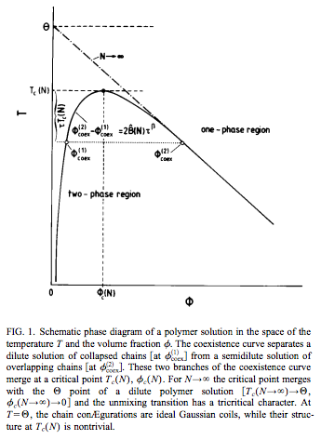2) The figure below by Wilding, Müller, and Binder shows a phase diagram for a polymer solution.

1. Give an equation that describes the behavior of Figure 1.
2. How are the critical temperature and critical composition determined from the equation of part a?
3. Give an equation for the overlap concentration, *. How would * impact the phase diagram shown in Figure 1?
4. Explain what the caption means when it mentions that the chain in the collapsed state is Gaussian while in solution it is an expanded coil. Why is the structure “non-trivial” at the critical point?
5. Is it possible to have a thermodynamically stable ***dilute*** polymer solution below the theta temperature? Why does the theta temperature “have a tricritical character”?