**Qualifier Questions Beaucage Spring 2018**

1) Karatrantos et al. (Krantrantos A, Clarke N, Composto RJ, Winey KI Soft Matter 9 3877-44 (2013)) calculated the entanglement length for a polymer melt in the presence and absence of nano-rod filler particles similar to carbon nanotubes in order to calculate shifts in the plateau modulus with filler loading. Karatrantos used diffusive particle dynamics (DPD) which is a coarse grain approach to simulate the system.

1. The Einstein-Smallwood equation is usually used to model the increase in modulus for spherical nanoparticles added to polymer as a function of volume fraction. Give this linear function.
2. How is the entanglement length related to the plateau modulus?
3. How would you expect the entanglement length to be effected by a filler particle? Is this a local phenomenon?
4. In the filled elastomer field the “bound rubber” fraction is the fraction of polymer chains that are immobilized by the filler. Is the approach of Krantrantos consistent with the concept of bound rubber?
5. Kratrantos finds the following behavior of the entanglement length, *N*e, of the filled polymer normalized by the entanglement length of the polymer in the absence of filler as a function of filler volume fraction. Is this behavior consistent with the experimentally observed Einstein-Smallwood behavior?

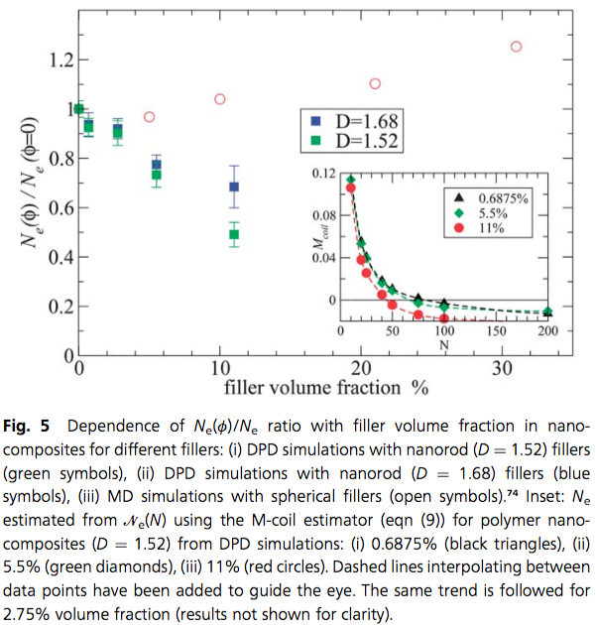

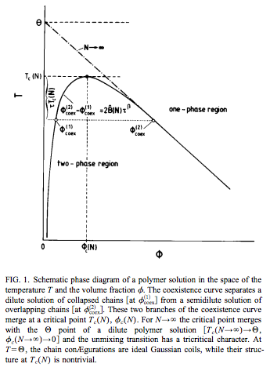2) The figure below by Wilding, Müller, and Binder shows a phase diagram for a polymer solution.

1. Give an equation that describes the behavior of Figure 1.
2. How are the critical temperature and critical composition determined from the equation of part a?
3. Give an equation for the overlap concentration, *. How would * impact the phase diagram shown in Figure 1?
4. Explain what the caption means when it mentions that the chain in the collapsed state is Gaussian while in solution it is an expanded coil. Why is the structure “non-trivial” at the critical point?
5. Is it possible to have a thermodynamically stable ***dilute*** polymer solution below the theta temperature? Why does the theta temperature “have a tricritical character”?

**Characterization question**

Hookean elastic behavior is commonly observed for metals and ceramics. Elastomers and gels display Mooney-Rivlin behavior.

1. Sketch a plot of tensile stress versus strain for a Hookean elastic material and an elastomer.
2. Sketch a Mooney-Rivlin plot for an elastomer.
3. Explain the difference between these two materials that leads to this different behavior.
4. Sketch the shear stress versus shear strain for these same two materials.
5. Explain the difference between part a and part c.