**Question 1**

**Thermodynamics**

A first-order transition is characterized by a discontinuity in state functions such as the enthalpy which results in a heat of transition, for example the heat of vaporization or fusion. Neophytou A, Chakrabarti D, Sciortino F *Topological nature of the liquid–liquid phase transition in tetrahedral liquids* Nat. Phys. https://doi.org/10.1038/s41567-022-01698-6 (2022) propose a first order transition between two liquid states for tetrahedrally-associated molecules (like water) due to topological differences between the two “phases”. An example of topological difference of this type is the difference between a pile of string and a pile of string with knots, below, where LDL is a low-density liquid with no knots and HDL is a high-density liquid with knots.

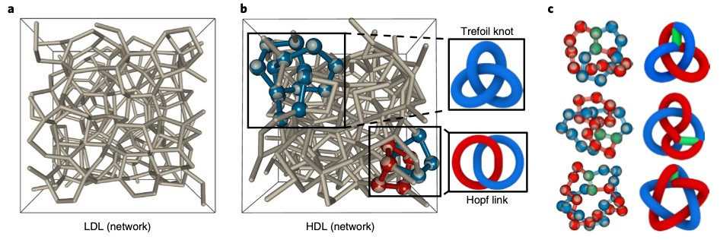

Neophytou quantifies the transition with several topological intrinsic parameters shown below.

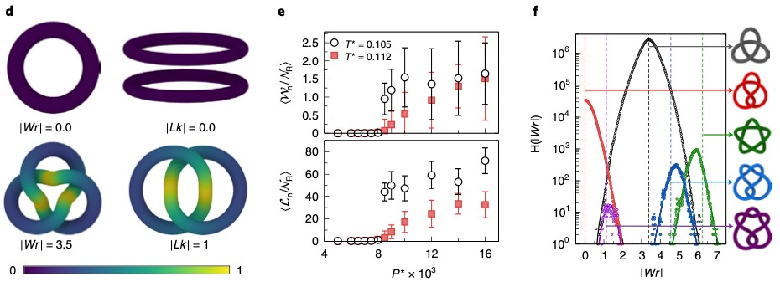

The last figure shows the distribution of various topological features.

1. Define a state parameter. Is a topological feature such as a knot in a shoelace a state parameter? Would Hess’ Law (and the *First Law of Thermodynamics*) apply to a topological feature such as a knot in a shoelace?
2. Make an argument that the transition being observed is a second-order transition. Define what parameter is considered that has a discontinuous second derivative.
3. If I throw computer cables on the floor, then try to pick them up I generally find that they are entangled. It requires significant energy to disentangle the cables though the pile will appear almost identical before and after disentanglement. Is this a first-order transition? How is this different from Neophytou’s proposition for water molecules (tetrahedrally-associated molecules)?
4. Is Neophytou’s system ergotic? Has it reached equilibrium? How would you define equilibrium in this case?
5. Consider the LDL and HDL “states”. Do these two states have different entropies if calculated using the Boltzman equation?

**Question 2**

**Thermodynamics**

One form of the Gibbs-Thompson Equation (GTE) describes the shift in melting point for nano-crystals as a function of their size and can be adapted to describe the shift in melting point for confined fluids such as at an AFM tip as a function of a fluid filled gap’s height, *h*, Fig. 2 below. Scalfi L, Coasne B, Rotenberg B, *On the Gibbs-Thomson equation for the crystallization of confined fluids.* J. Chem. Phys. **154** 114711 (2021) present a new derivation of the GTE for confined fluids and use the derivation to simulate crystallization in confined pores and gaps using a Monte Carlo method.

1. The normal derivation of the GTE involves simply writing an expression for the Gibbs free energy that includes volumetric and surface terms, considering equilibrium for small particles (spheres) and solving for the particle size. **Derive the GTE** in this way for a planar crystal with infinite width and height *H* (please note that Scalfi uses “*h*” for the enthalpy per particle). Scalfi’s GTE includes two surface energies, that of the liquid and that of the solid. **How do you accommodate this in your derivation**?

1. Scalfi gives the following thermodynamic potential (2) and internal energy (3) for the fluid/solid between the gap,





Use the thermodynamic square or other means to **explain the origin of these two expressions**. **What kind of free energy** is * *? (Helmholz or Gibbs and explain why.)

1. The son of Herman von Helmholtz (Robert von Helmholz) derived the Gibbs-Thompson equation from the Oswald-Freundlich Equation (OFE) using the integrated Clausius-Clapeyron Equation (CCE) for his PhD dissertation in 1885 (things were simpler then).

OFE

CCE

For this reason, the OFE or Kelvin Equation is sometimes referred to as the GTE. **Obtain the GTE from the OFE using the integrated CCE. Also, give (don’t derive) the Ostwald-Freundlich Equation** which describes the relationship between the supersaturated mole fraction, *x*, and nanoparticle size, *r*, for crystallization from solution.

1. Scalfi used Monte Carlo Simulations with the Metropolis method to determine the melting point, Figure 9, shown above, where *N* is the density and *T*\* is a reduced temperature. He used a 6-12 potential with a cutoff of 2.5 ** where ** is the atomic size. Monte Carlo steps involved translation, deletion or insertion. The starting state could be liquid or crystal structures and resulted in the densities shown in Figure 9. **Give an algorithm (give the steps that are involved in the program in a flow chart)** for a typical Metropolis simulation of this type. **How would you determine** if the simulation had reached equilibrium?
2. In Figure 9, shown above, Scalfi shows that the crystalline structure exists at the interface with the AFM tip and the stage (which is the same material in the simulation) even in the (bulk) amorphous state (lower structure). **Derive** expressions comparing the **free energy barrier,** *G****\**, and phase size,** ***r\****, for surface (heterogeneous) and bulk (homogeneous nucleation). Can this explain the observed behavior?