**Homework 5 Solar Power for Africa**

Oluwasun et al. compare the effectiveness of biogas production from pig dung and photovoltaics in Nigeria. (Oluwaseun, A. T.; Mgbachi, C. A.; Okelola, M. O.; Ajenikoko, G. A. *A Comparative Analysis of Renewable Energy Using Biogas and Solar Photovoltaic Systems: A Case Study of Ajaba, In Osun State* Control Theory and Informatics **7**, 7-13 (2018).) They use *MatLab*® to estimate the energy production from these two alternative energy sources.

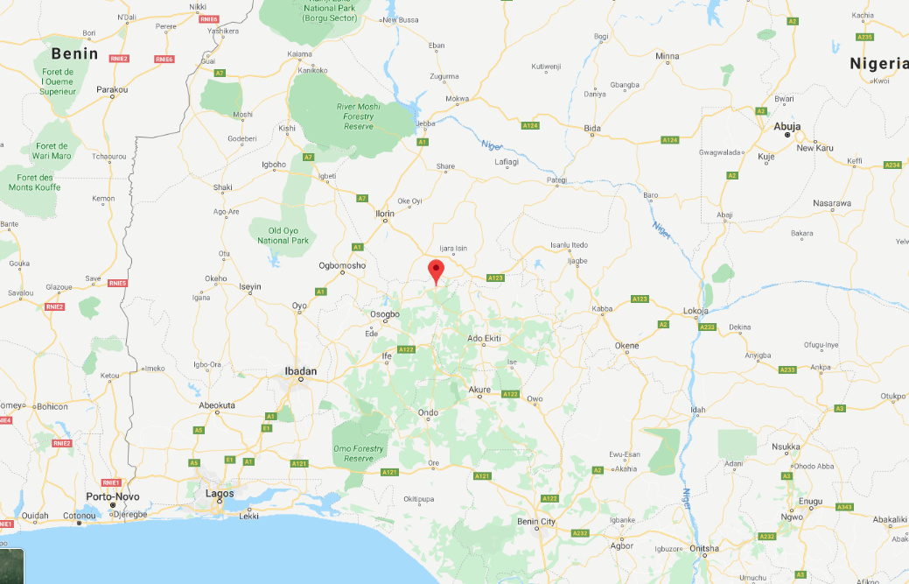

Figure 1. Location of proposed site in Osun State, Nigeria.

a) The analysis seems to be biased towards biogas. For instance, the following plot is shown.

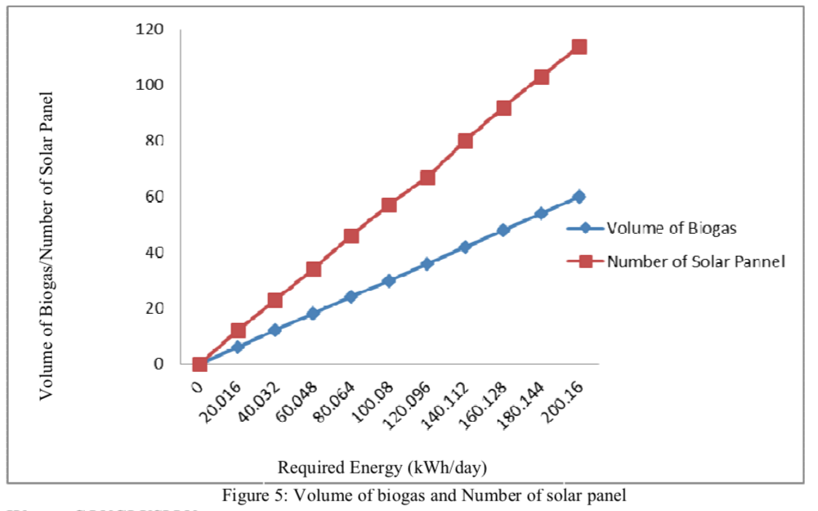

Comment on the use of a single y-axis scale for volume of biogas and for number of solar panels. What would be a parameter that could give a fair comparison between these technologies? (Notice that the axis has no units.)

b) This is the conclusion statement in the paper:

“*From the result, it was deduced that generating energy from biogas is more effective and reliable for the community compared to solar energy. The results also revealed that the biogas energy generated more energy and performed better as compared to the solar energy for the community area.*”

Look through the paper and see if you can find any evidence that supports “*more effective*” and “*more reliable*”. Make a counter argument for photovoltaics in terms of effectiveness and reliability.

c) What kind of data/information would you collect if you wanted to support your argument that PV is more effective and reliable?

d) The paper gives no evidence for the statement that biogas generated “*more energy and performed better*”. Design an experiment (or simulation or calculation) where you could obtain a fair comparison of the energy production for a PV/battery system versus a biogas system. Is dung provided for free, is there labor involved? What about capital costs etc.

e) Design an experiment to determine which system performs better. This will require a reasonable list of measures of performance. That is, things that can be quantified on an equal basis for the two approaches.

f) Biogas production from pig dung has the added benefit that it removes a waste stream from the local environment, while it may also displace a source of agricultural fertilizer. PVs will take up land which could displace agricultural production unless it involves unused space such as rooftops. Give a qualitative assessment of the social and environmental impacts of the two technologies for the stakeholders (those impacted) in the community and the region. For instance, are there political considerations, economic considerations, will the technology displace other energy sources, what is the impact on charcoal production or diesel fuel sales etc. Which approach would be easier to organize funding. There are many NGOs (foreign funding sources) involved in PV electrification for microgrids, but few interested in biogas from pig dung. Government interest in biogas might be at a lower level. The local community might be happy to remove a source of agricultural waste such as pig dung from the environment.

These are a few ideas, try to come up with a brief but coherent discussion of the social and environmental impacts. This could involve a list or table or a flow chart of the stakeholders and the positive and negative impacts.