**HW 12 Solar Power for Africa**

**November 17, 2020**

An article in the Guardian (British Newspaper https://www.theguardian.com/environment/2019/nov/20/to-eat-or-not-to-eat-10-of-the-worlds-most-controversial-foods?CMP=Share_iOSApp_Other) listed at number 2 in a list of the 10 most controversial foods (after avocados, Tesco is the British Krogers but better):

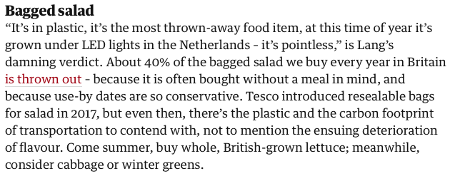

a) The Guardian assessment of vertical farming is in stark contrast to the presentation of Dickson Despommier (<https://youtu.be/b1wQ2LXeF-k>). Despommier’s language is similar to language used to describe the Haber Process for nitrogen fixation for fertilizers (and explosives),

 at high T & P with metal catalyst (1909) Nobel Prize (1918).



Detractors from the Haber Process state that:



It seems there is always a positive and negative to technical innovations when they are successful. *Make a comparison between the Haber Process and vertical farming in terms of human survivability on Earth at current population growth levels and the potential impact on food production.*

b) A difference with the Haber process is that vertical farming could create natural forests and green space since it could displace less effective flat-land farming. Consider a drive from Cincinnati to Columbus which is almost entirely either urban/suburban housing or corn and soy monoculture. *How could vertical farming impact this landscape and what impact could it have on the stake holders (anyone who is possibly impacted by this technological innovation). First list the stake holders, then consider the impact on each group. Consider both positive and negative impacts and a broad spectrum of stake-holders, e.g. climate change affects many not living in Ohio, forests are the primary tool to sequester carbon.*

c) TerraFarm is a company in Los Angeles that is similar to 80 Acres in Cincinnati but a few years older and having a larger capital investment. They currently have a contract with Walmart Superstores to provide organic salads and other greens. TerraFarm (Local Roots brand) provides shipping container LED hydroponic vertical farms that are attached to the Superstores. Crops are manufactured on site and picked on demand. The map below shows some of the current locations for these enhanced Walmart Superstores. Similar arrangements are underway in Cincinnati by 80 Acres with Trader Joe’s and Jungle Jim’s. *Comment on the potential for implementation of this technology in Ohio where the growing season for vegetables is less than 1/3 that of the San Joaquin Valley (top blue pointers in the map of southern and central California).*

 

d) Make a very crude back of the envelope assessment of the cost to use 80 Acre technologies to grow tomatoes. First sketch a vertical farm that is two stories high with climbing tomato vines using hydroponics and LED lighting (see picture above taken in Ivorydale last spring at 80 Acres, 2 UC students shown in foreground). *Make a crude estimate of the number and power of LED lights (450 nm wavelength) and the power they would require to run for 12 hours per day. Only considering the LED lighting as an operating cost, what area of solar panels would be needed with 10 hours of sunlight per day to run this tomato factory? How does this compare with the footprint of a conventional flat-land farm that needs to be at least 20 times larger due to lower productivity and crop losses due to weather and pests? (Consider a 1000 square foot area for the vertical farm.)*

e) 80 Acres is involved in implementation of vertical farming in Central America to provide vegetables for areas impacted by climate change driven drought, particularly Honduras (currently the largest source for US immigration). There are at least two possible applications to consider: **A)** short term disaster relief, and longer-term displacement of agriculture due to climate change, such as in Honduras, the Somali region of Ethiopia, Southern Somalia and coastal Kenya, northern Nigeria etc. (many examples even many in the US);

**B)** replacement/supplementation of conventional farming in the developing world to enhance productivity to feed exponential population growth mostly in urban centers such as Dar es Salaam and Lagos (projected to have populations of 60 million and 80 million people by 2050). *Comment on the realistic potential of vertical farming in the developing world as a mechanism to prevent mass starvation and wars over food supplies.*