**HW 13 Solar Power for Africa**

**November 24, 2020**

Western Sahara is an unrecognized country that was colonized by Morocco in 1975, in what is called the Green March involving a coordinated invasion by 350,000 unarmed people followed by a military occupation. The population of Western Sahara is currently about 600,000. A strong independence movement supported by Algeria has fought for independence since then. Morocco has built the second [largest wall](https://goo.gl/maps/dJB77PHJtqUeXwsZ7) across the Sahara Desert to separate rebels from their colonial assets. Western Sahara has phosphate mines (coincidentally this fertilizer mineral was mentioned by Liz from 80Acres as running out in 30 years). Within this political situation Morocco has sought to take advantage of the enormous wind and solar potential in Western Sahara by building the [Wind Park Akhfennir](https://goo.gl/maps/31qKCRof7UcdxKnq7) and major solar energy installations. The intent is to export power to Spain and Europe. This week, after a non-violent blockade of the North-South highway connecting Morocco to Mauritania by rebels in Western Sahara, Morocco violated a 30 year UN truce and send troops into Western Sahara initiating a war.

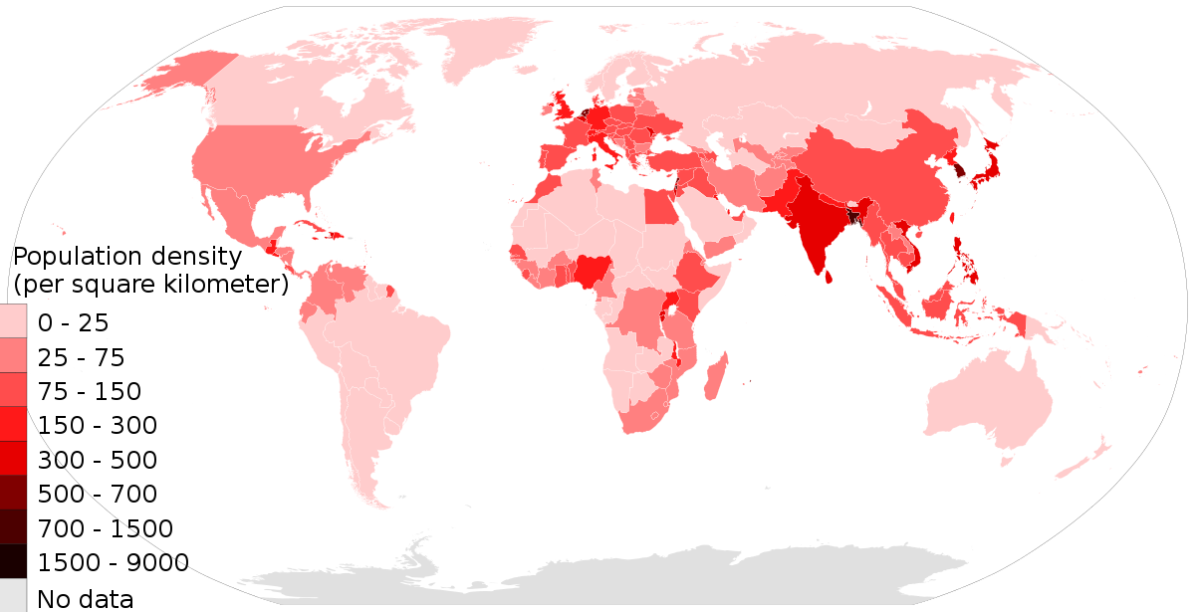 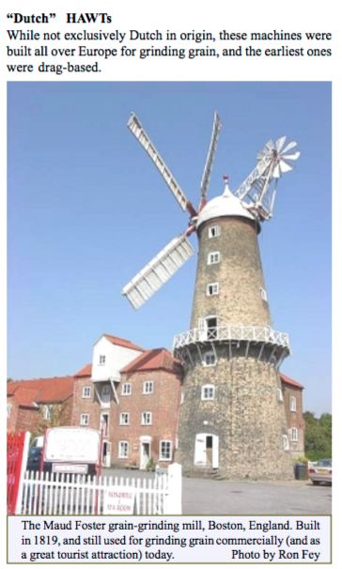 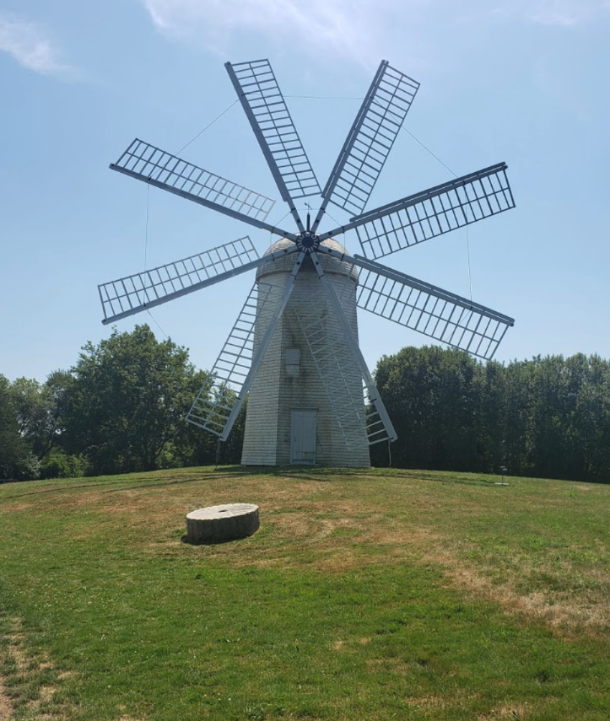

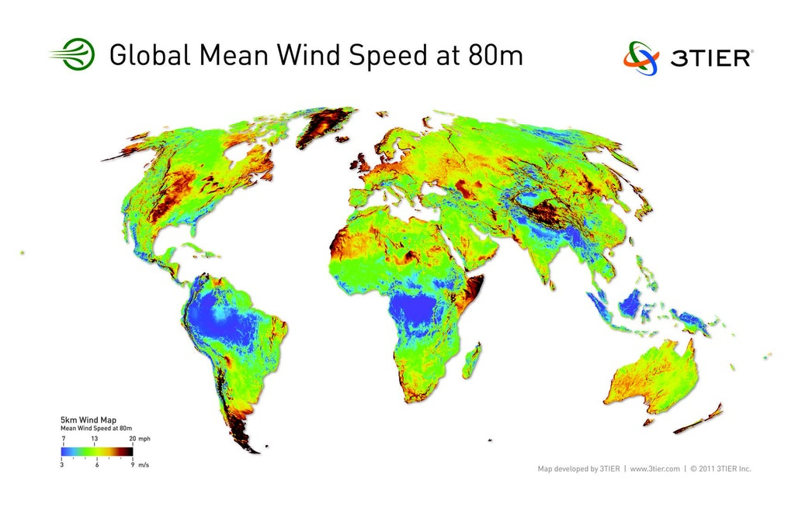

Wind Population Dutch US

1. The webpage has a number of background articles and videos on Western Sahara. Considering the map shown above, it is interesting that the two regions with the greatest potential for wind power in Africa are in Western Sahara and in Somalia. Western Sahara has the advantage that it is within range for electrical transmission to Europe. After looking at the information on the webpage comment on how the technical issues of wind power are not the main stumbling block to implementation in Africa.
2. The Sahara region is a desert but 10,000 years ago it was a grassland and historically had forests and rivers. In computer simulations it has been found that increases in the albedo (absorption of sunlight) could transition the Sahara to a green grassland with rivers (see articles on webpage). Give your thoughts on this potential side benefit to solar panels and wind power in Western Sahara. 2 paragraphs.
3. The use of technology to shape the environment is sometimes called climate engineering. It has been proposed as a means to deal with global warming. Comment on some of the possible pitfalls to painting the Sahara Desert black with solar panels to generate energy and to engineer the climate. (see BBC comments to the Science Article on the webpage)
4. Two wind-mills are shown above that differ in the number of blades. How does a windmill compare with an electricity generating wind turbine? How would you determine the optimum number of blades for a windmill and for an electrical wind turbine?