Homework 1 Solar Power Africa Due August 29, 2022

There are six videos (actually, 9 if you are counting). You can skim through these if you want, watch enough to answer the questions, hopefully have a discussion with your group.

Documentary Movie about mostly about East Africa Parts 1,2,3,4 (15 min each)
https://www.eng.uc.edu/~beaucag/Classes/SolarPowerForAfrica/Linktovideo.html
Recent “short” video about the situation in Ethiopia through which the students travel in part 1.
This is a bit long, it is nice because the history lesson is accurate and it shows how complex even the last 50 years have been for all of the African countries, each has a different story.
https://www.youtube.com/watch?v=z0cYHw-joZI

The students in the first movie do not travel to West Africa. Lagos is about 4,000 miles from Dar Es Salaam in East Africa.
Just skim through the first video. The point is the future of Africa from a business perspective.
https://www.youtube.com/watch?v=HbsdLI8kaWc
Second video shows how people get electricity in the middle of Lagos with an unreliable and expensive grid. This could be why they are eager to have solar power.
https://www.youtube.com/watch?v=gBUWB8atYoY

Cape Town Tourist Video. Cape Town is about 4,000 miles from Addis Ababa and 3,000 miles from Lagos. (All of Africa is currently extremely cheap if you are spending USD.)
https://www.youtube.com/watch?v=FwKxfuJsG60
Townships in Cape Town
https://www.britannica.com/video/179596/look-life-townships-film-Cape-Town-2009

10% of the world live on less than $1.90 per day (one cup of rice $0.22; one cup of beans $0.30)
(41% of Sub-Saharan Africa live on less than $1.90/day)
Chinese businesspeople have just completed an interstate highway and rail system in Ethiopia as well as a streetcar/subway system in Addis. 15 years ago, Addis was clogged with herds of cattle and goats that blocked traffic. There was only one stoplight, and it didn’t’ work because people stole the bulb.

- From the videos and from your experience, what is your impression of how you could interact with people in the developing world, particularly in Africa? There are four approaches to interactions with Africa that I can think of, 1) ignore; 2) altruistic aid; 3) business opportunity; 4) visit and learn, similar to the students in the film. Discuss the advantages and disadvantages of each of these approaches.
- Comments about the videos. Did anything strike you? Was this worth the time you put into it?
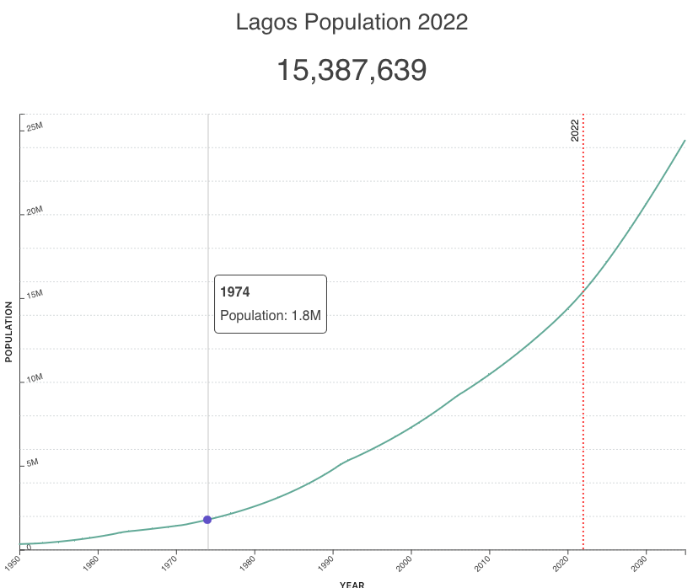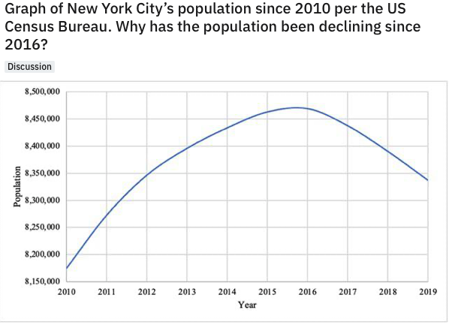
This is much higher rate of growth than in the developed world. Similar exponential growth is seen across Africa. What does this mean about the future?

