**Homework 11 Solar Power for Africa 2021 Due Wednesday November 9**

This week we heard from Patrick Sherwin from GoSun Company (https://www.gosun.co). Consider some of the problems with forming a startup business like GoSun, particularly the “gap” between initial success and long-term market entry. Below are three business models for solar cookers for application in the developing world.

<https://www.teachamantofish.org.uk/assets/images/assets/uploads/Solar-Cooker-Business-Guide.pdf>

<https://solarcooking.fandom.com/wiki/Business_development>

<https://solarcooking.fandom.com/wiki/Category:Solar_food_drying>

1. Consider the budget at the end of the first webpage. The sheet indicates a profit of $700 on about a $1,500 investment which includes 10 hours of labor. What happens if only half of the 500 cookers are sold? Is this budget in touch with reality?

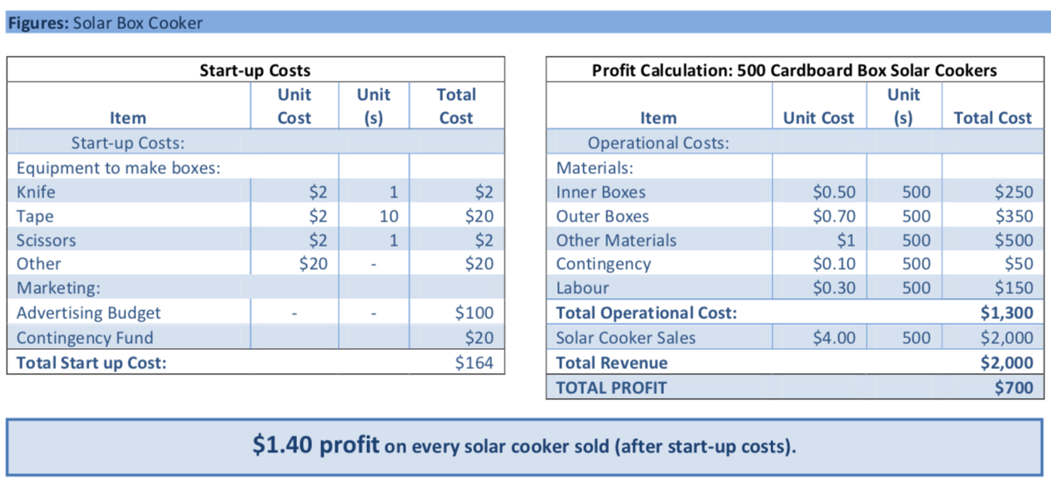

1. What is missing from this business plan? How would you consider the marketability, competition, demand, impact on other players in the economy? Who are the stakeholders? What is the motivation of the people involved in this endeavor? Who would be put out of work by implementation of solar cooking and how would they be accommodated?
2. The second webpage explains several marketing plans for simple solar cookers. A list of solar bakeries is given <https://solarcooking.fandom.com/wiki/Solar_restaurants_and_bakeries>

Consider these companies in the context of the “gap” for a startup company, that is between the initial eager investors and purchasers and long-term market impact and use by “normal” people.

1. The last webpage discusses hybrid solar dryers for instance to produce dried mangos. Do you think that this is an innovative technology? Comment on these business concepts for solar energy.