Homework 13 Solar Power for Africa 2021 Due Wednesday November 23

We heard a talk from a Chemical Engineer, Madi Powell, from 80 Acres Farm on Tuesday this week (next week) about vertical farming in Cincinnati/Hamilton OH (https://www.80acresfarms.com). There is also a large hybrid, hydroponic, greenhouse, LED system in Kentucky called App Harvest (https://www.appharvest.com) founded by Jonathan Webb (https://www.youtube.com/watch?v=zVpDZ0PiAzs). In Ethiopia an Israeli group called Fair Planet (https://www.fairplanet.ngo) is involved in the introduction of drip irrigation to farming in Africa. Finally, robotic farming was mentioned in class (https://www.smallrobotcompany.com). Consider also aquaponics
(https://aquaponics.com/aquaponics-in-schools/aquaponics-information/).

All of these innovations in agriculture promise to address some of the concerns brought up by Dickson Despommier (https://youtu.be/1clRcxZS52s ;
https://www.youtube.com/watch?v=b1wQ2LXeF-k).
With the world reaching 8 billion people yesterday (Wednesday November 15, 2022
https://www.scientificamerican.com/article/the-world-population-just-hit-8-billion-and-heres-how-it-will-continue-to-grow/) we are quickly running out of space to grow food. Chemical Engineers were pioneers in developing the technology of synthetic fertilizers which has enabled the world to reach 8 billion people. Some of these new technologies will also be pioneered by Chemical Engineers and you may play a role in a new “green revolution”.
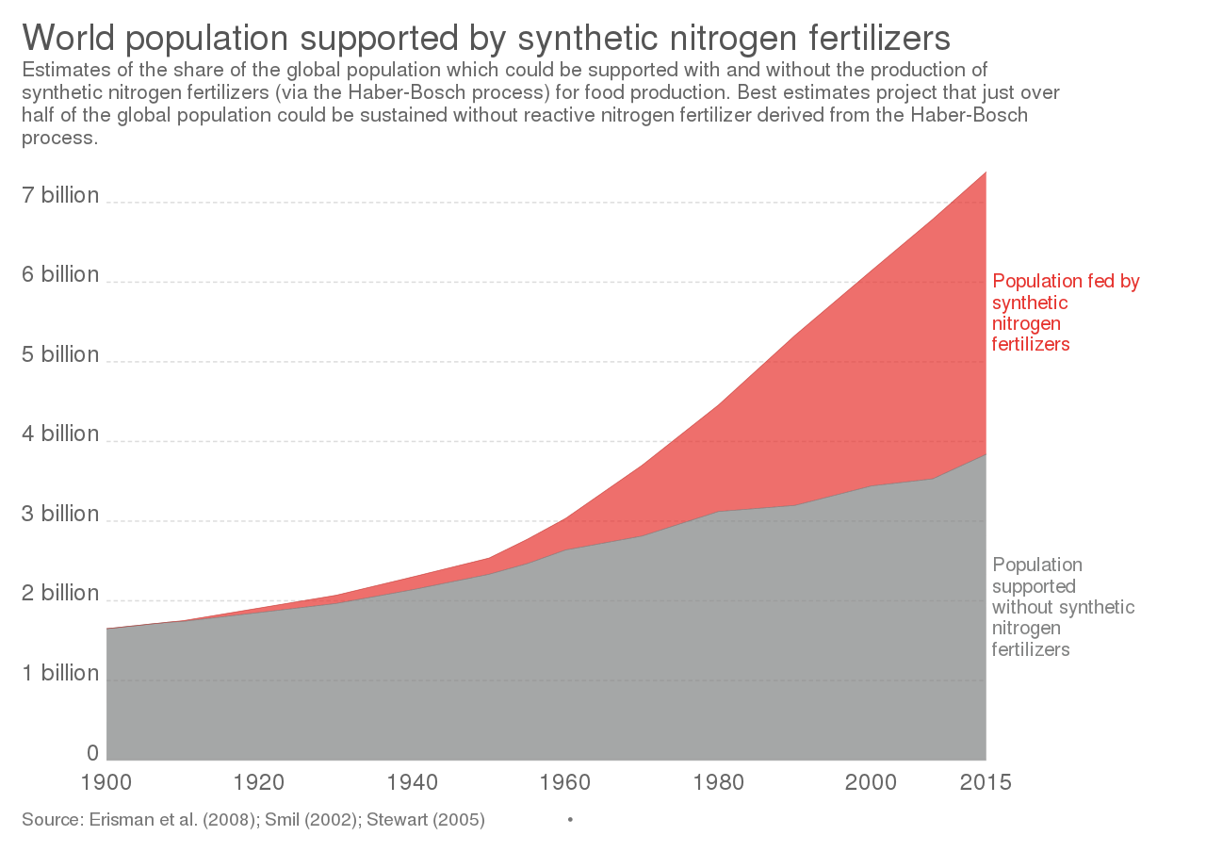
- Make a list of the food you ate today. From this list indicate which could be grown by the technologies of 80 Acres, App Harvest, Fair Planet, or the dreams of Dickson Despommier. For example, could these technologies economically grow corn, a cow, a banana? What are the limits to these technologies. How could changes in your eating routine improve the potential of these technologies?
- Compare the technology of 80 Acres and App Harvest. Both are successful businesses growing at more than 10x for 5 years. How do their businesses and markets differ? Why are both businesses thriving in the Cincinnati tri-state region (what is special about this area)?
- Explain the potential of drip irrigation for arid regions of the world. What are the similarities between the work of Fair Planet and the two vertical farming companies we looked at? What other technologies could be adopted in the developing world.
- Comment on the potential of robotic farming both in the context of vertical farms, and in the developing world. What advantages do robots have in a place where the living wage is $2 per 12-hour day.
- Dickson Despommier has a vision for the future. Give some encouraging comments and some critique of his ideas for the future of agriculture. Is this an area that you would like to contribute to as a Chemical Engineer?

