Homework 12 Solar Power for Africa Due Monday November 13

We heard a talk from a UC Chemical Engineering grad, Anne Wissemeier, who now works for 80 Acres Farm on Thursday last week about vertical farming in Cincinnati/Hamilton OH (https://www.80acresfarms.com). There is also a large hybrid, hydroponic, greenhouse, LED system in Kentucky called App Harvest (https://www.appharvest.com) founded by Jonathan Webb (https://www.youtube.com/watch?v=zVpDZ0PiAzs). In Ethiopia an Israeli group called Fair Planet (https://www.fairplanet.ngo) is involved in the introduction of drip irrigation to farming in Africa. Finally, robotic farming was mentioned in class (https://www.smallrobotcompany.com). Consider also aquaponics
(https://aquaponics.com/aquaponics-in-schools/aquaponics-information/).

All of these innovations in agriculture promise to address some of the concerns brought up by Dickson Despommier (https://youtu.be/1clRcxZS52s ;
https://www.youtube.com/watch?v=b1wQ2LXeF-k).
With the world reaching 8 billion people last year (Wednesday November 15, 2022
https://www.scientificamerican.com/article/the-world-population-just-hit-8-billion-and-heres-how-it-will-continue-to-grow/ and https://www.worldometers.info/world-population/#google_vignette) we are quickly running out of space to grow food. Chemical Engineers were pioneers in developing the technology of synthetic fertilizers which has enabled the world to reach 8 billion people. Chemical Engineers also played a role in the “green revolution” involving GMO crops (2000 critique of GMO green revolution https://nature.berkeley.edu/srr/Alliance/lessons_from_the_green_revolutio.htm ).
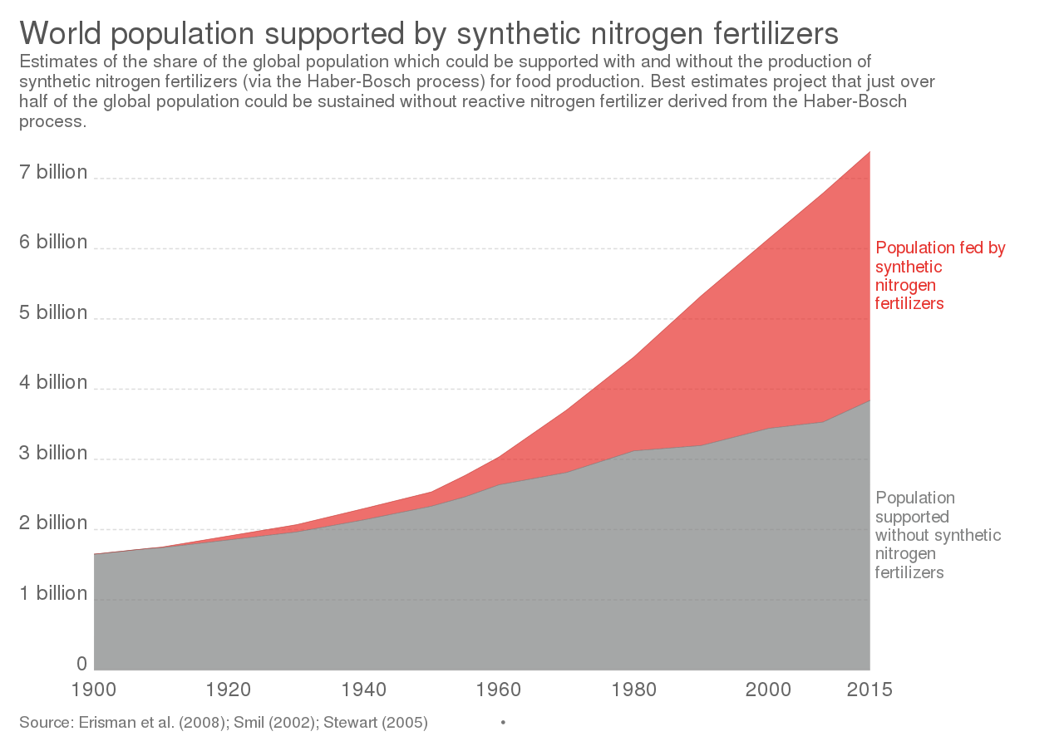
- Compare the technology of 80 Acres and App Harvest. Both are successful businesses growing at more than 10x for 5 years. How do their businesses and markets differ? Why are both businesses thriving in the Cincinnati tri-state region (what is special about this area)?
- Consider the points of the 2000 article on GMOs (2000 critique of GMO green revolution https://nature.berkeley.edu/srr/Alliance/lessons_from_the_green_revolutio.htm ). Try to apply similar criticism to the vertical farming industry. Where can it go wrong?
- Explain the potential of drip irrigation for arid regions of the world. What are the similarities between the work of Fair Planet and the two vertical farming companies we looked at? What other technologies could be rapidly adopted in the developing world.
- Comment on the potential of robotic farming both in the context of vertical farms, and in the developing world. What advantages do robots have in a place where the living wage is $2 per 12-hour day.
- Make a list of the food you ate today. From this list indicate which could be grown by the technologies of 80 Acres, App Harvest, Fair Planet, or the dreams of Dickson Despommier. For example, could these technologies economically grow corn, a cow, a banana? What are the limits to these technologies. How could changes in your eating routine improve the potential of these technologies?

