**Homework 7 Solar Power for Africa**

**Due Tuesday October 13, 2020**

Z. F. Li and K. Sumathy published a paper on a methanol/activated carbon absorption refrigerator (*Int. J. Energy Res.* **23** 517-527 (1999)). They include the Clapeyron diagram shown below (x axis should be 1/T).

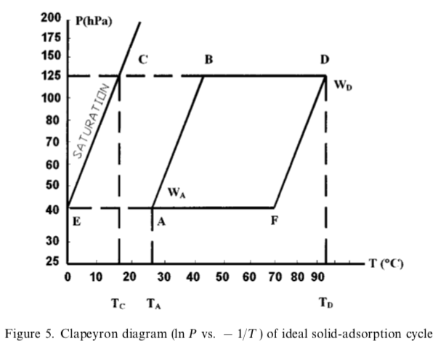 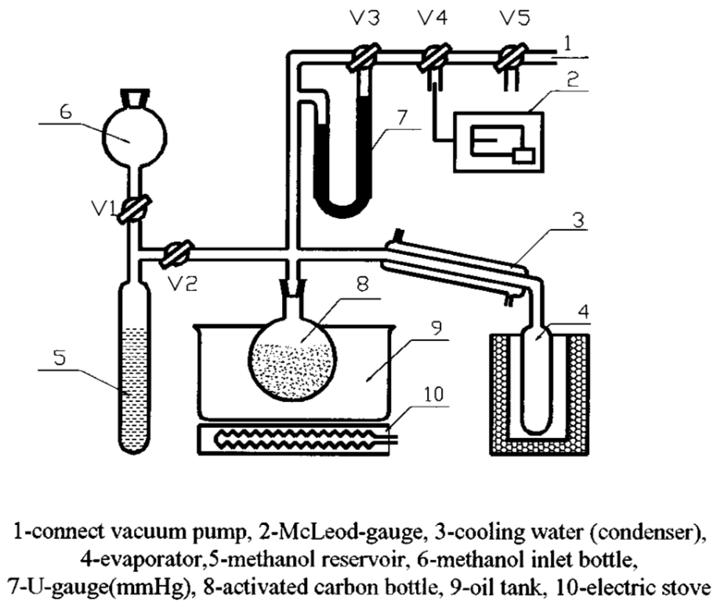

1. Li and Sumathy arrive at a coefficient of performance (COP) of about 0.5. *T*E was -10 °C and *T*D was 110°C in Figure 5. For these temperatures (not those shown in figure 5) what is the COP for a Carnot cycle under these conditions.
2. Why does the solar absorption refrigerator have a lower COP than a Carnot cycle? List some issues with the device that could explain the reduction in performance. Some are listed in the paper.
3. The refrigerator produces 5 kg of ice per day for 17 kg of activated carbon and a 1 m2 solar collector with 18 kJ/m2 solar irradiance per day. Compare this with a PV solar panel whose efficiency is about 15%. The heat of fusion for ice is 334 J/g and a commercial freezer has a COP of about 0.85 for this temperature range.
4. Most of the design studies that are published for absorption refrigerators anticipate home use of the device, while most existing applications are for moderate- to small-scale communal or commercial applications such as at a diary or a winery. Explain why you think the applications are not in the areas of intended use by the researchers. What does this say about researchers?