Diffraction Gradient – 120 lines/mm

Diffraction Gradient – 20 lines/mm
Diffraction Gradient – 80 lines/mm

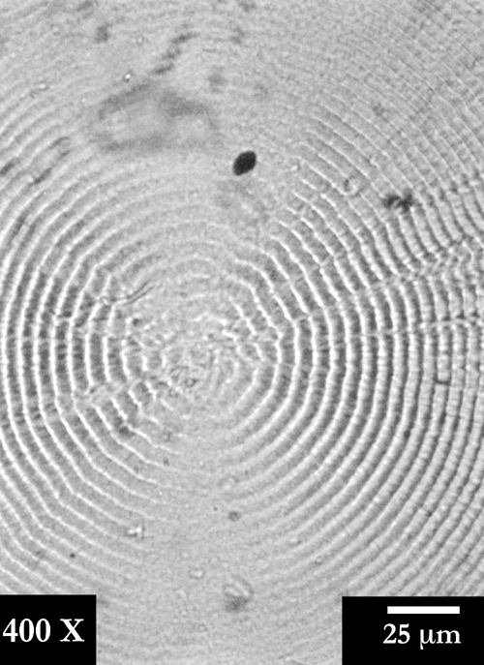

Diffraction Gradient – 80 lines/mm
Micrograph - PHB

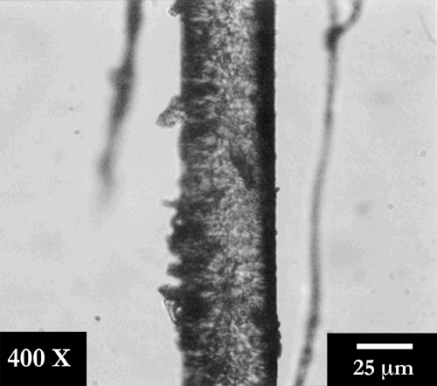
Rachel Gahn’s Hair
Dr. Beaucage’s Hair

Jennifer Conley’s Hair
Tim Johnson’s Hair

